recap_prev_multi_346912
N | speeds | x0s | domain | width
----------------------------------------------------------------------------------------------------------------------------------
3 | [2.5, 2.0, 1.5] | [10.0, 0.0, -10.0] | [-20,38] | 58
4 | [3.0, 2.5, 2.0, 1.5] | [15.0, 5.0, -5.0, -15.0] | [-25,45] | 70
6 | [4.0, 3.5, 3.0, 2.5, 2.0, 1.5] | [25.0, 15.0, 5.0, -5.0, -15.0, -25.0] | [-35,60] | 95
9 | [5.5, 5.0, 4.5, 4.0, 3.5, 3.0, 2.5, 2.0, 1.5] | [40.0, 30.0, 20.0, 10.0, 0.0, -10.0, -20.0, -30.0, -40.0] | [-50,82] | 132
12 | [7.0, 6.5, 6.0, 5.5, 5.0, 4.5, 4.0, 3.5, 3.0, 2.5, 2.0, 1.5] | [55.0, 45.0, 35.0, 25.0, 15.0, 5.0, -5.0, -15.0, -25.0, -35.0, -45.0, -55.0] | [-65,105] | 170

N=3: speeds [2.5,2.0,1.5], x0=[10,0,-10], domain ~[-20,40] — exact match to preliminary paper.

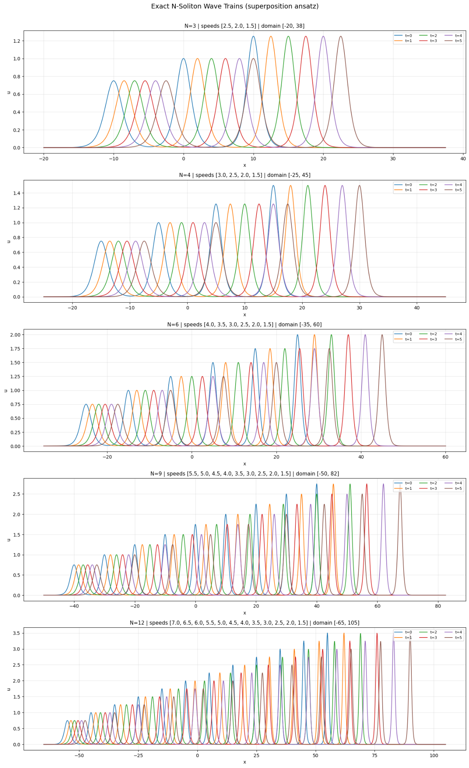

Output shape: torch.Size([3, 1])
Total parameters: 12,951 (same as baseline)

======================================================================
N = 3 | speeds = [2.5, 2.0, 1.5]
domain = [-20.0, 37.5] | width = 57.5
======================================================================
Points — PDE: 19,166 | Data: 383 | IC: 500 | BC: 200
/usr/local/lib/python3.12/dist-packages/torch/autograd/graph.py:824: UserWarning: Attempting to run cuBLAS, but there was no current CUDA context! Attempting to set the primary context... (Triggered internally at /pytorch/aten/src/ATen/cuda/CublasHandlePool.cpp:181.)
return Variable._execution_engine.run_backward( # Calls into the C++ engine to run the backward pass
Adam 0 | Total=0.430482 PDE=0.007225 IC=0.146471 Data=0.188774
Adam 1000 | Total=0.019520 PDE=0.003524 IC=0.006310 Data=0.009554
Adam 2000 | Total=0.000186 PDE=0.000149 IC=0.000010 Data=0.000026
Adam 3000 | Total=0.000073 PDE=0.000059 IC=0.000003 Data=0.000011
Adam 4000 | Total=0.000111 PDE=0.000054 IC=0.000017 Data=0.000029
Adam 5000 | Total=0.000029 PDE=0.000021 IC=0.000002 Data=0.000006
Adam 6000 | Total=0.000027 PDE=0.000019 IC=0.000004 Data=0.000004
Adam 7000 | Total=0.000181 PDE=0.000044 IC=0.000055 Data=0.000081
Adam 8000 | Total=0.000141 PDE=0.000028 IC=0.000049 Data=0.000064
Adam 9000 | Total=0.000054 PDE=0.000019 IC=0.000016 Data=0.000018
Adam 10000 | Total=0.000040 PDE=0.000016 IC=0.000010 Data=0.000013
Adam 11000 | Total=0.000131 PDE=0.000032 IC=0.000041 Data=0.000056
Adam 12000 | Total=0.000031 PDE=0.000016 IC=0.000005 Data=0.000006
Adam 13000 | Total=0.000097 PDE=0.000050 IC=0.000018 Data=0.000018
Adam 14000 | Total=0.000139 PDE=0.000019 IC=0.000047 Data=0.000068
>> L2 after Adam : 2.7163%
LBFGS 0 | Total=0.00003387
LBFGS 200 | Total=0.00000243
LBFGS 400 | Total=0.00000243
LBFGS 600 | Total=0.00000243
LBFGS 800 | Total=0.00000243
LBFGS 1000 | Total=0.00000243
LBFGS 1200 | Total=0.00000243
LBFGS 1400 | Total=0.00000243
LBFGS 1600 | Total=0.00000243
LBFGS 1800 | Total=0.00000243
>> L2 after L-BFGS : 0.1580%

======================================================================
N = 4 | speeds = [3.0, 2.5, 2.0, 1.5]
domain = [-25.0, 45.0] | width = 70.0
======================================================================
Points — PDE: 23,333 | Data: 466 | IC: 583 | BC: 200
Adam 0 | Total=0.800698 PDE=0.003523 IC=0.249303 Data=0.381989
Adam 1000 | Total=0.014323 PDE=0.004994 IC=0.002208 Data=0.007056
Adam 2000 | Total=0.002571 PDE=0.001255 IC=0.000224 Data=0.001012
Adam 3000 | Total=0.001134 PDE=0.000617 IC=0.000141 Data=0.000315
Adam 4000 | Total=0.000555 PDE=0.000222 IC=0.000127 Data=0.000176
Adam 5000 | Total=0.000080 PDE=0.000064 IC=0.000002 Data=0.000013
Adam 6000 | Total=0.002181 PDE=0.000729 IC=0.000567 Data=0.000691
Adam 7000 | Total=0.000242 PDE=0.000148 IC=0.000028 Data=0.000048
Adam 8000 | Total=0.000680 PDE=0.000409 IC=0.000093 Data=0.000117
Adam 9000 | Total=0.000488 PDE=0.000273 IC=0.000078 Data=0.000116
Adam 10000 | Total=0.000265 PDE=0.000090 IC=0.000074 Data=0.000091
Adam 11000 | Total=0.000110 PDE=0.000047 IC=0.000029 Data=0.000034
Adam 12000 | Total=0.000088 PDE=0.000049 IC=0.000013 Data=0.000020
Adam 13000 | Total=0.000068 PDE=0.000044 IC=0.000010 Data=0.000013
Adam 14000 | Total=0.000102 PDE=0.000031 IC=0.000033 Data=0.000037
>> L2 after Adam : 5.4282%
LBFGS 0 | Total=0.00035372
LBFGS 200 | Total=0.00000355
LBFGS 400 | Total=0.00000355
LBFGS 600 | Total=0.00000355
LBFGS 800 | Total=0.00000355
LBFGS 1000 | Total=0.00000355
LBFGS 1200 | Total=0.00000355
LBFGS 1400 | Total=0.00000355
LBFGS 1600 | Total=0.00000355
LBFGS 1800 | Total=0.00000355
>> L2 after L-BFGS : 0.2279%

======================================================================
N = 6 | speeds = [4.0, 3.5, 3.0, 2.5, 2.0, 1.5]
domain = [-35.0, 60.0] | width = 95.0
======================================================================
Points — PDE: 31,666 | Data: 633 | IC: 791 | BC: 200
Adam 0 | Total=2.333704 PDE=0.013066 IC=0.810983 Data=0.895732
Adam 1000 | Total=0.070773 PDE=0.009599 IC=0.025282 Data=0.035853
Adam 2000 | Total=0.006712 PDE=0.003317 IC=0.000536 Data=0.002773
Adam 3000 | Total=0.004120 PDE=0.001730 IC=0.000741 Data=0.001613
Adam 4000 | Total=0.001506 PDE=0.000990 IC=0.000073 Data=0.000422
Adam 5000 | Total=0.001386 PDE=0.000958 IC=0.000104 Data=0.000281
Adam 6000 | Total=0.000838 PDE=0.000448 IC=0.000128 Data=0.000254
Adam 7000 | Total=0.001322 PDE=0.000301 IC=0.000400 Data=0.000617
Adam 8000 | Total=0.003240 PDE=0.000826 IC=0.000948 Data=0.001412
Adam 9000 | Total=0.000681 PDE=0.000158 IC=0.000207 Data=0.000316
Adam 10000 | Total=0.000206 PDE=0.000126 IC=0.000025 Data=0.000053
Adam 11000 | Total=0.000682 PDE=0.000313 IC=0.000145 Data=0.000208
Adam 12000 | Total=0.000640 PDE=0.000283 IC=0.000134 Data=0.000200
Adam 13000 | Total=0.000826 PDE=0.000152 IC=0.000257 Data=0.000401
Adam 14000 | Total=0.000579 PDE=0.000106 IC=0.000193 Data=0.000277
>> L2 after Adam : 2.1138%
LBFGS 0 | Total=0.00021949
LBFGS 200 | Total=0.00003017
LBFGS 400 | Total=0.00003017
LBFGS 600 | Total=0.00003017
LBFGS 800 | Total=0.00003017
LBFGS 1000 | Total=0.00003017
LBFGS 1200 | Total=0.00003017
LBFGS 1400 | Total=0.00003017
LBFGS 1600 | Total=0.00003017
LBFGS 1800 | Total=0.00003017
>> L2 after L-BFGS : 0.4935%

======================================================================
N = 9 | speeds = [5.5, 5.0, 4.5, 4.0, 3.5, 3.0, 2.5, 2.0, 1.5]
domain = [-50.0, 82.5] | width = 132.5
======================================================================
Points — PDE: 44,166 | Data: 883 | IC: 1,104 | BC: 200
Adam 0 | Total=0.965961 PDE=0.001715 IC=0.408579 Data=0.503081
Adam 1000 | Total=0.321892 PDE=0.014060 IC=0.141014 Data=0.166728
Adam 2000 | Total=0.256602 PDE=0.023858 IC=0.103834 Data=0.128608
Adam 3000 | Total=0.108308 PDE=0.033854 IC=0.025595 Data=0.048783
Adam 4000 | Total=0.050202 PDE=0.023815 IC=0.003642 Data=0.022507
Adam 5000 | Total=0.037479 PDE=0.018366 IC=0.004531 Data=0.014547
Adam 6000 | Total=0.024128 PDE=0.015825 IC=0.001125 Data=0.006831
Adam 7000 | Total=0.016820 PDE=0.007224 IC=0.002562 Data=0.007032
Adam 8000 | Total=0.008525 PDE=0.005569 IC=0.000501 Data=0.002454
Adam 9000 | Total=0.016919 PDE=0.005264 IC=0.004423 Data=0.007223
Adam 10000 | Total=0.013621 PDE=0.009531 IC=0.001355 Data=0.002609
Adam 11000 | Total=0.016883 PDE=0.004129 IC=0.005317 Data=0.007425
Adam 12000 | Total=0.018190 PDE=0.003356 IC=0.006702 Data=0.008122
Adam 13000 | Total=0.006849 PDE=0.003013 IC=0.001598 Data=0.002213
Adam 14000 | Total=0.006660 PDE=0.002148 IC=0.001861 Data=0.002644
>> L2 after Adam : 3.9235%
LBFGS 0 | Total=0.00206964
LBFGS 200 | Total=0.00038998
LBFGS 400 | Total=0.00017150
LBFGS 600 | Total=0.00010930
LBFGS 800 | Total=0.00010930
LBFGS 1000 | Total=0.00010930
LBFGS 1200 | Total=0.00010930
LBFGS 1400 | Total=0.00010930
LBFGS 1600 | Total=0.00010930
LBFGS 1800 | Total=0.00010930
>> L2 after L-BFGS : 0.9754%

======================================================================
N = 12 | speeds = [7.0, 6.5, 6.0, 5.5, 5.0, 4.5, 4.0, 3.5, 3.0, 2.5, 2.0, 1.5]
domain = [-65.0, 105.0] | width = 170.0
======================================================================
Points — PDE: 56,666 | Data: 1,133 | IC: 1,416 | BC: 200
Adam 0 | Total=1.254428 PDE=0.002657 IC=0.538181 Data=0.519084
Adam 1000 | Total=0.586132 PDE=0.021214 IC=0.257867 Data=0.306684
Adam 2000 | Total=0.428604 PDE=0.025739 IC=0.191237 Data=0.211557
Adam 3000 | Total=0.348066 PDE=0.021542 IC=0.153820 Data=0.172666
Adam 4000 | Total=0.257846 PDE=0.015319 IC=0.114250 Data=0.128203
Adam 5000 | Total=0.228455 PDE=0.014742 IC=0.098444 Data=0.115240
Adam 6000 | Total=0.183650 PDE=0.018927 IC=0.074981 Data=0.089661
Adam 7000 | Total=0.169978 PDE=0.026098 IC=0.059219 Data=0.084030
Adam 8000 | Total=0.142406 PDE=0.017868 IC=0.044489 Data=0.079927
Adam 9000 | Total=0.128896 PDE=0.019367 IC=0.036249 Data=0.073269
Adam 10000 | Total=0.106329 PDE=0.021652 IC=0.024171 Data=0.060456
Adam 11000 | Total=0.066036 PDE=0.015356 IC=0.011093 Data=0.039547
Adam 12000 | Total=0.075108 PDE=0.019123 IC=0.014305 Data=0.041650
Adam 13000 | Total=0.069872 PDE=0.015575 IC=0.016244 Data=0.038030
Adam 14000 | Total=0.063317 PDE=0.013993 IC=0.011859 Data=0.037441
>> L2 after Adam : 30.4374%
LBFGS 0 | Total=0.96849060
LBFGS 200 | Total=0.17720288
LBFGS 400 | Total=0.05492482
LBFGS 600 | Total=0.03723761
LBFGS 800 | Total=0.03226690
LBFGS 1000 | Total=0.03056176
LBFGS 1200 | Total=0.02987241
LBFGS 1400 | Total=0.02930644
LBFGS 1600 | Total=0.02886039
LBFGS 1800 | Total=0.02852863
>> L2 after L-BFGS : 42.1502%

=======================================================
N | L2 Adam (%) | L2 Final (%)
-------------------------------------------------------
3 | 2.7163% | 0.1580%
4 | 5.4282% | 0.2279%
6 | 2.1138% | 0.4935%
9 | 3.9235% | 0.9754%
12 | 30.4374% | 42.1502%
=======================================================

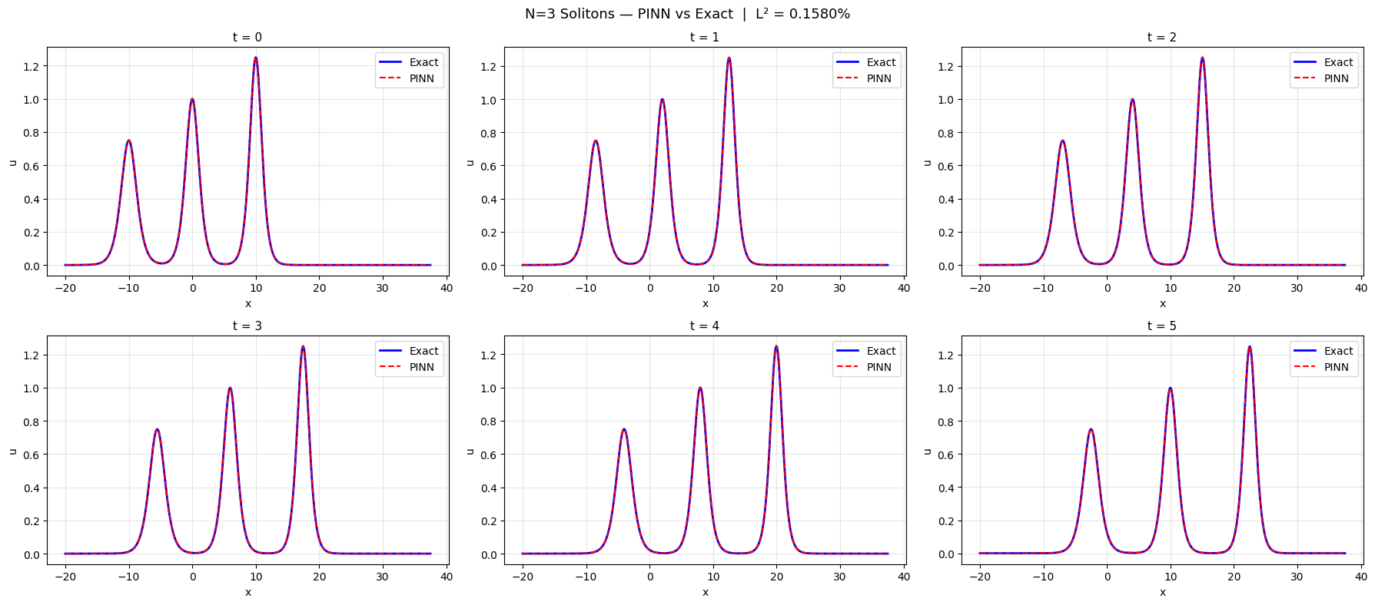
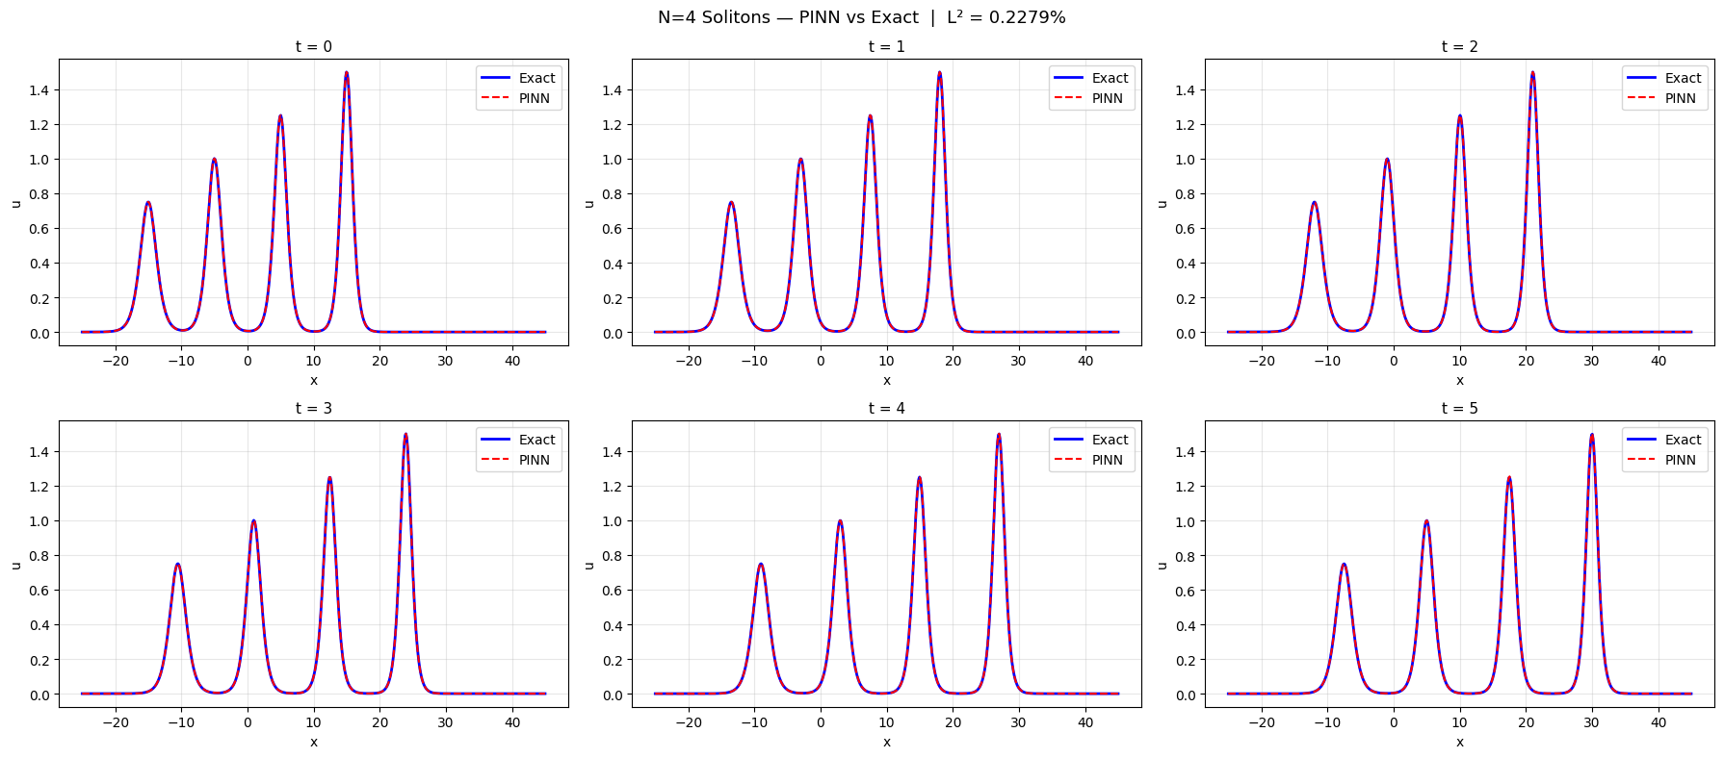
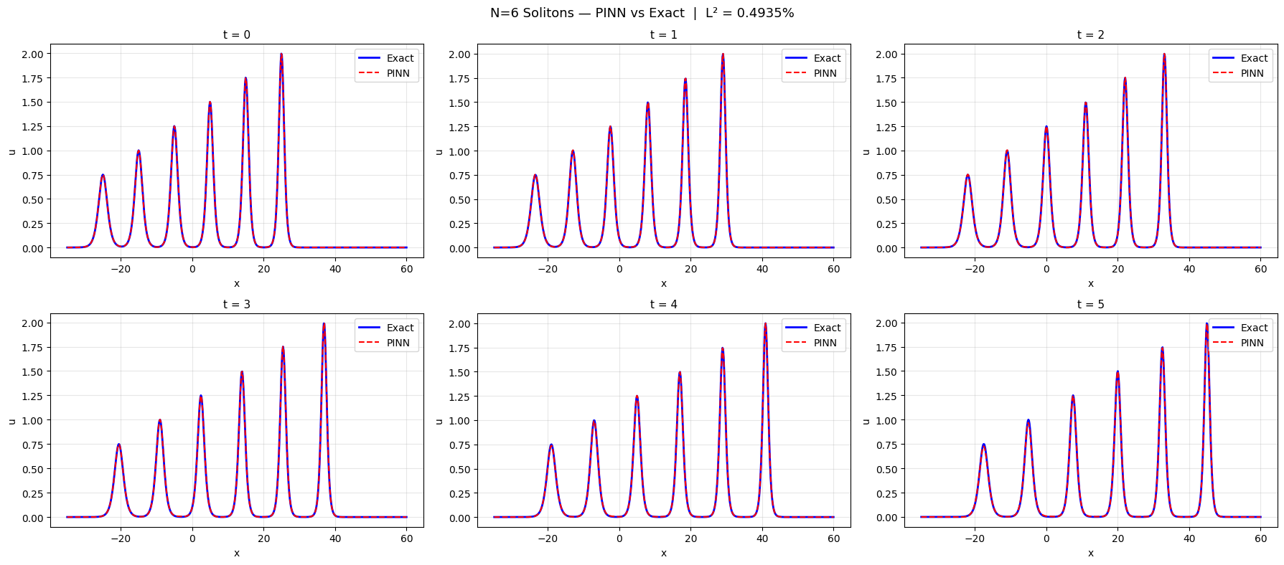
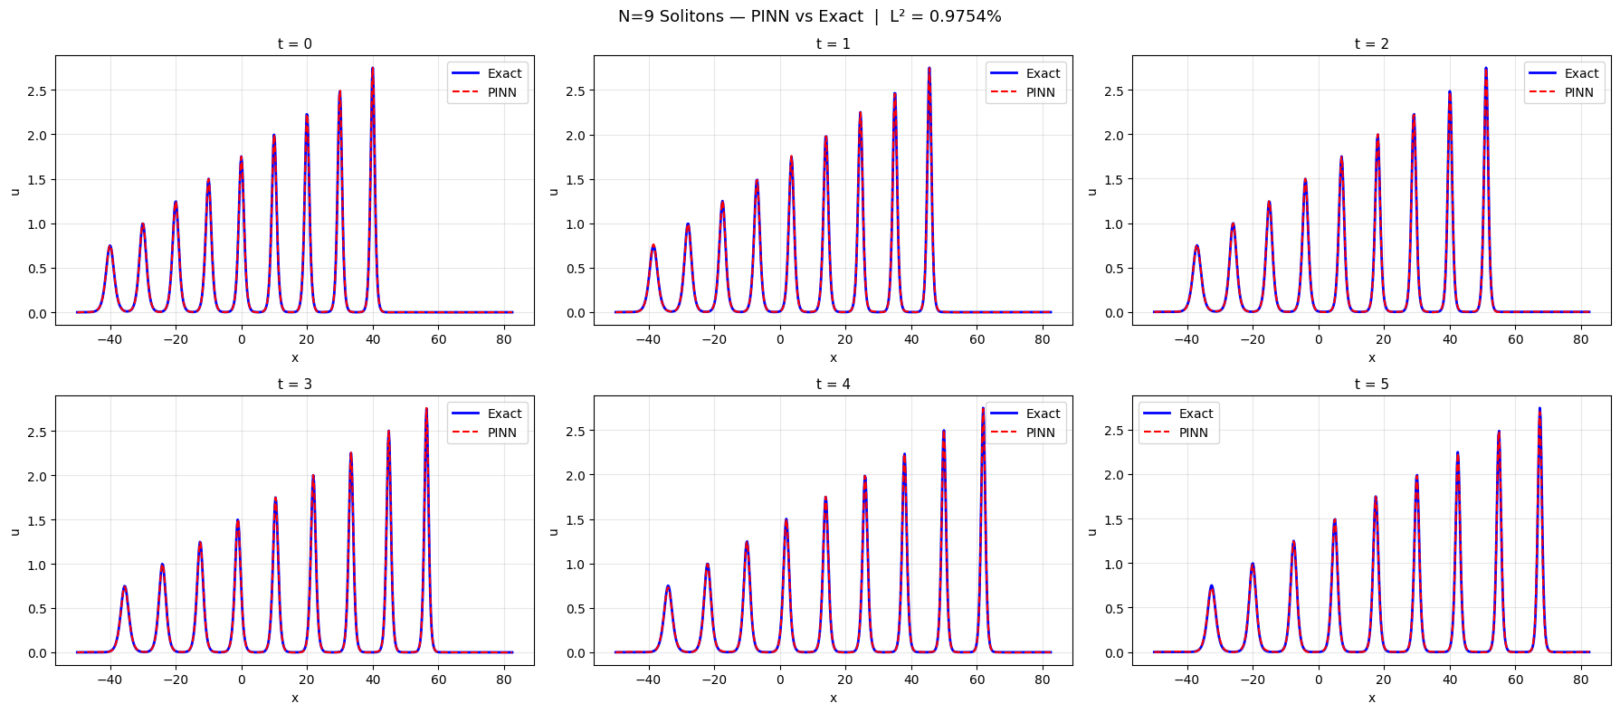
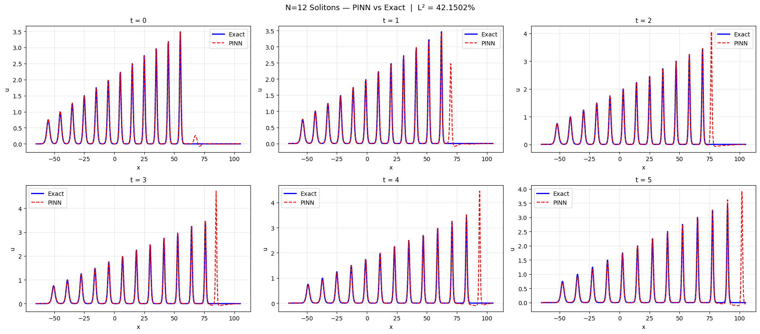

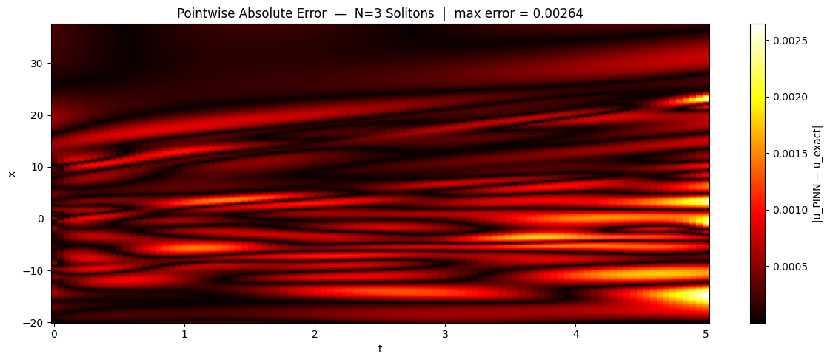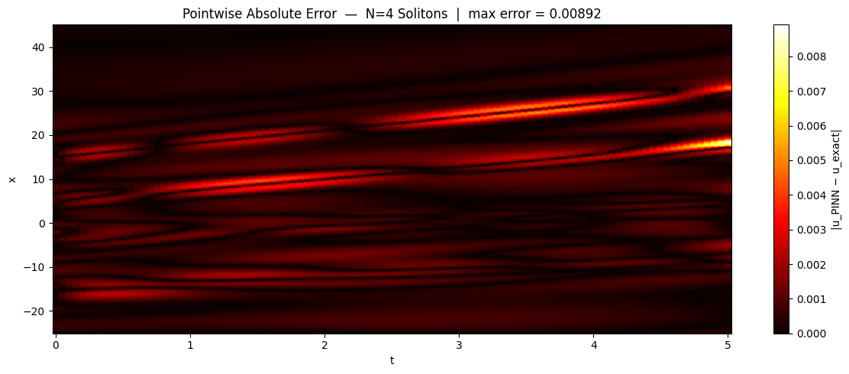
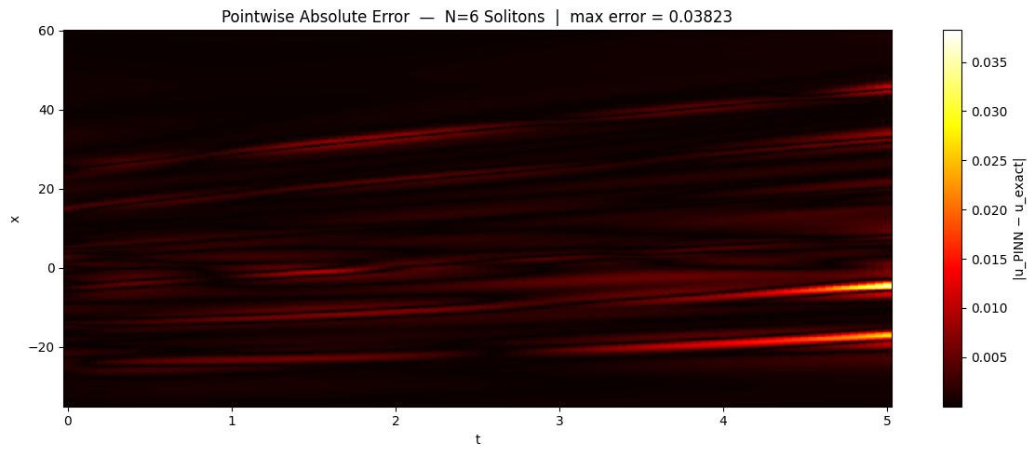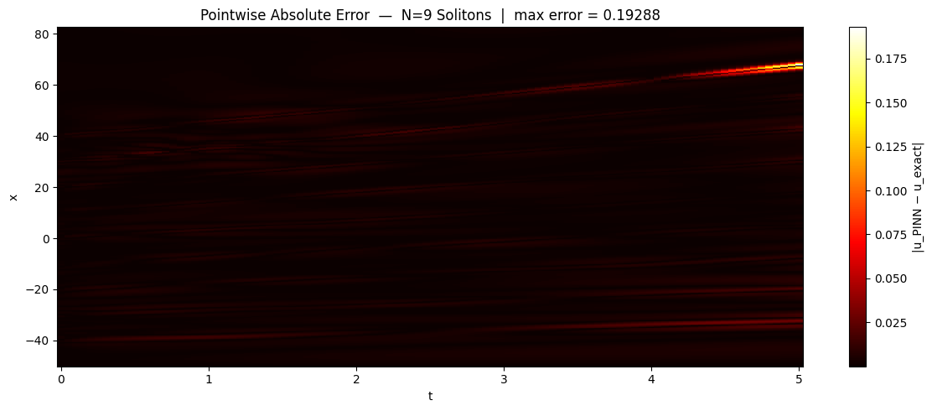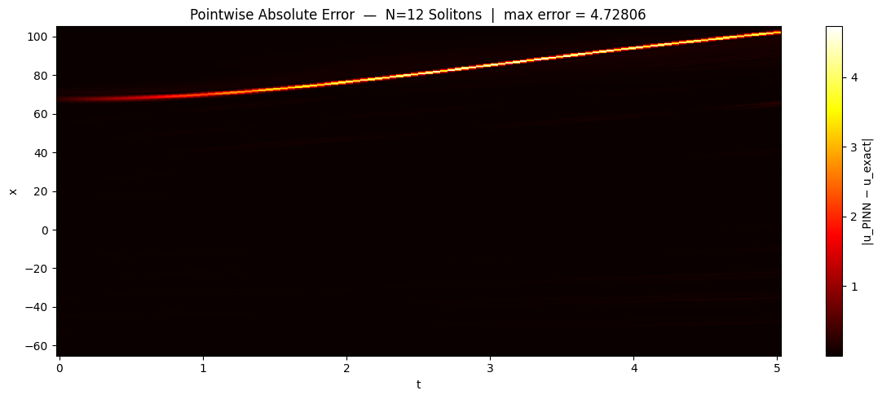
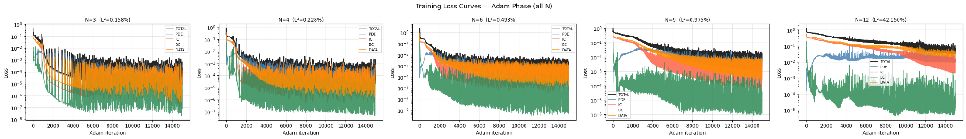

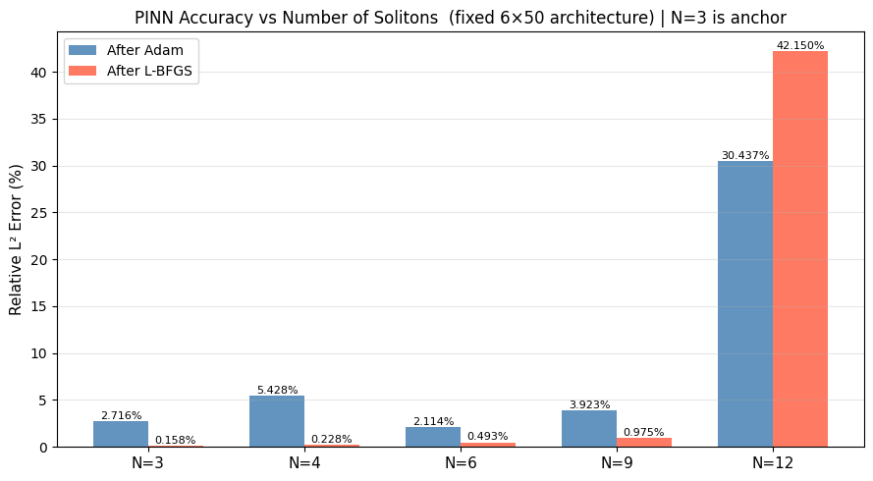

========================================================================
N | Speed range | Domain | L2 Adam | L2 Final
------------------------------------------------------------------------
3 | 1.5 – 2.5 | [-20, 38] | 2.7163% | 0.1580% <- anchor
4 | 1.5 – 3.0 | [-25, 45] | 5.4282% | 0.2279%
6 | 1.5 – 4.0 | [-35, 60] | 2.1138% | 0.4935%
9 | 1.5 – 5.5 | [-50, 82] | 3.9235% | 0.9754%
12 | 1.5 – 7.0 | [-65, 105] | 30.4374% | 42.1502%
========================================================================

N=3 anchor: expected L2 Final ≈ 0.18% (preliminary result in our earlier run).
Deviation from 0.18% at N=3 indicates run-to-run variance (seed fixed at 99).

work division
Soham’s part done:
- Width sweep at the boundary N values. Train 6×100 (double the width) at N=9 and N=12 to test whether the N=12 wall is a capacity ceiling. Optionally also 6×75 at N=12 as a middle data point. Keep everything else identical to the existing runs: same Adam (15k iter, lr=1e-3) + L-BFGS (2k iter) schedule, same domain, same collocation count (scaled with domain width as before), same data points. Record final Adam loss, final L-BFGS loss, L² error after each phase, training time. The interpretation: if 6×100 drops N=12 from 33% to under 5%, the 6×50 was capacity-limited and there's a soft ceiling around 9-10 features. If 6×100 doesn't help, it's an optimization problem and width isn't the fix.
- Collocation density sweep. Run at N=9 with 5k, 10k, 20k, 40k, 80k collocation points. Run at N=12 with 20k, 40k, 80k, 160k. Use 6×50 architecture for direct comparison with single-soliton results. Plot error vs collocation count on the same axes style as the single-soliton saturation curve (Figure 11 in the previous paper). The question is whether saturation happens at the same density as single-soliton (~5000 in a 30×5 domain = density of ~33 per unit area) or at a different density for multi-soliton. If N=12 saturates at low density and adding more points doesn't help, that's evidence for an optimization-side bottleneck.
- Data-point saturation at N=12. Sweep N_data over 0, 100, 200, 500, 1000, 2000 with 6×50 architecture, all other settings at the N=12 baseline. The logic from Saha's mail: if more data rescues N=12, the network can represent the solution but training couldn't find it without supervision (optimization problem). If more data doesn't help, the network can't represent it at all (capacity problem). Plot error vs N_data.
- Wave speed variation in multi-soliton. Run a 3-soliton case with c = 4, 2, 1 (instead of the current 2.5, 2, 1.5). Same 6×50 architecture, same domain extended if needed so c=4 doesn't hit the right boundary. The single-soliton c=4 case failed at 29.5% error due to steeper gradients. The question is whether the fastest soliton in a train inherits the same sharpness ceiling, or whether neighbouring slower solitons change the failure mode.

Nirek's part done:
- Per-soliton error breakdown on the existing N=12 run. Pure analysis, no retraining. Load the trained N=12 checkpoint. For each of the 12 solitons, compute the L² error in a window of ±3 units around that soliton's centre at each timestep, then integrate over time. Produce a bar chart with x-axis = soliton index 1-12 and y-axis = local L² error. Also annotate the existing pointwise error heatmap to label which soliton is which. The output answers Saha's direct question: are all 12 solitons degraded roughly equally (uniform under-capacity), or are some captured cleanly while others are completely missed (optimization getting stuck in a partial basin)? Independent of any retraining work, can be done immediately.
- Noise robustness at N=9. Train four models at N=9 with Gaussian noise added to the data points at σ = 0%, 1%, 5%, 10% of the soliton amplitude. Use the existing 6×50 architecture and standard Adam + L-BFGS schedule. Record both after-Adam and after-L-BFGS L² errors so the L-BFGS-hurts-under-noise finding from the single-soliton paper can be tested in the multi-soliton regime. Produce a comparison table directly mirroring Table 3 from the single-soliton paper. The hypothesis worth testing: with 9 simultaneous features, each needing its own data anchoring, does noise hurt proportionally more than in the single-soliton case? If yes, that's a new multi-soliton-specific finding. Self-contained, doesn't depend on any other experiment.
- IC substitution at multi-soliton. Train three models at N=3, N=6, N=9 with the IC loss term removed entirely (PDE + BC + data only). Use 400 data points scattered across the domain. Use 6×50 architecture. Compare final L² error against the with-IC baselines at the same N. Saha's prediction: the IC substitution result from single-soliton (where 200 scattered points fully replaced the IC) won't hold here, because a multi-soliton IC encodes discrete information (number of peaks, individual amplitudes, positions) that sparse scattered points may not constrain. Confirming this is a clean negative result for the report. Also self-contained.

Coordination notes:
All experiments use the same results template: architecture, N, hyperparameters, final Adam loss, final L-BFGS loss, L² error after each phase, training time, plots generated. This makes report assembly clean regardless of who finishes when.
Nirek's three experiments are fully independent of each other and of yours — he can run them in any order on his own timeline. Your four experiments have some internal dependencies (Task 1's result might inform whether Task 3 needs to be repeated at 6×100) but are independent of Nirek's work.
If anyone finishes early, the wave-speed multi-soliton experiment (currently on Soham's list) is the natural stretch task to pick up.

width sweep results

width=50: 12,951 parameters
width=75: 28,801 parameters
width=100: 50,901 parameters

======================================================================
N=9 | width=100 | 6x100 architecture
domain=[-50.0, 82.5] | speeds=[5.5, 5.0, 4.5, 4.0, 3.5, 3.0, 2.5, 2.0, 1.5]
======================================================================
PDE: 44,166 | Data: 883 | IC: 1,104 | BC: 200
params: 50,901
/usr/local/lib/python3.12/dist-packages/torch/autograd/graph.py:865: UserWarning: Attempting to run cuBLAS, but there was no current CUDA context! Attempting to set the primary context... (Triggered internally at /pytorch/aten/src/ATen/cuda/CublasHandlePool.cpp:330.)
return Variable._execution_engine.run_backward( # Calls into the C++ engine to run the backward pass
Adam 0 | Total=0.993150 PDE=0.012777 IC=0.451158 Data=0.436798
Adam 1000 | Total=0.357284 PDE=0.013583 IC=0.164612 Data=0.178443
Adam 2000 | Total=0.160266 PDE=0.007245 IC=0.087369 Data=0.065647
Adam 3000 | Total=0.026609 PDE=0.008766 IC=0.006994 Data=0.010784
Adam 4000 | Total=0.006729 PDE=0.001497 IC=0.001774 Data=0.003456
Adam 5000 | Total=0.022576 PDE=0.004181 IC=0.007503 Data=0.010886
Adam 6000 | Total=0.000909 PDE=0.000442 IC=0.000175 Data=0.000290
Adam 7000 | Total=0.002541 PDE=0.000481 IC=0.000870 Data=0.001188
Adam 8000 | Total=0.015345 PDE=0.012768 IC=0.001081 Data=0.001197
Adam 9000 | Total=0.019480 PDE=0.003818 IC=0.006346 Data=0.009015
Adam 10000 | Total=0.000888 PDE=0.000239 IC=0.000267 Data=0.000379
Adam 11000 | Total=0.008928 PDE=0.001858 IC=0.002887 Data=0.004177
Adam 12000 | Total=0.009236 PDE=0.002260 IC=0.002915 Data=0.004061
Adam 13000 | Total=0.000419 PDE=0.000208 IC=0.000083 Data=0.000127
Adam 14000 | Total=0.001560 PDE=0.001094 IC=0.000175 Data=0.000289
>> Adam done in 2831.8s | L2=26.7244% | loss=0.038202
LBFGS 0 | Total=0.00969059
LBFGS 200 | Total=0.00005048
LBFGS 400 | Total=0.00005048
LBFGS 600 | Total=0.00005048
LBFGS 800 | Total=0.00005048
LBFGS 1000 | Total=0.00005048
LBFGS 1200 | Total=0.00005048
LBFGS 1400 | Total=0.00005048
LBFGS 1600 | Total=0.00005048
LBFGS 1800 | Total=0.00005048
>> LBFGS done in 821.0s | L2=0.6174% | loss=0.00005048
saved: checkpoint_N9_w100.pt

======================================================================
N=12 | width=75 | 6x75 architecture
domain=[-65.0, 105.0] | speeds=[7.0, 6.5, 6.0, 5.5, 5.0, 4.5, 4.0, 3.5, 3.0, 2.5, 2.0, 1.5]
======================================================================
PDE: 56,666 | Data: 1,133 | IC: 1,416 | BC: 200
params: 28,801
Adam 0 | Total=0.875760 PDE=0.000911 IC=0.441541 Data=0.415819
Adam 1000 | Total=0.608521 PDE=0.006861 IC=0.281407 Data=0.320192
Adam 2000 | Total=0.394340 PDE=0.030687 IC=0.169868 Data=0.193654
Adam 3000 | Total=0.205613 PDE=0.022158 IC=0.083805 Data=0.099558
Adam 4000 | Total=0.174511 PDE=0.026632 IC=0.067779 Data=0.079314
Adam 5000 | Total=0.176481 PDE=0.028765 IC=0.060009 Data=0.087270
Adam 6000 | Total=0.124231 PDE=0.035185 IC=0.031904 Data=0.055863
Adam 7000 | Total=0.085327 PDE=0.029357 IC=0.018518 Data=0.037392
Adam 8000 | Total=0.046516 PDE=0.022008 IC=0.004672 Data=0.019405
Adam 9000 | Total=0.072242 PDE=0.017162 IC=0.024532 Data=0.030348
Adam 10000 | Total=0.075939 PDE=0.027215 IC=0.018379 Data=0.029608
Adam 11000 | Total=0.057712 PDE=0.026679 IC=0.010048 Data=0.020258
Adam 12000 | Total=0.053851 PDE=0.015444 IC=0.015103 Data=0.023220
Adam 13000 | Total=0.025286 PDE=0.009732 IC=0.003516 Data=0.011981
Adam 14000 | Total=0.063572 PDE=0.015250 IC=0.016426 Data=0.031808
>> Adam done in 2798.7s | L2=25.7965% | loss=0.033730
LBFGS 0 | Total=0.02083853
LBFGS 200 | Total=0.01180932
LBFGS 400 | Total=0.01088894
LBFGS 600 | Total=0.01033639
LBFGS 800 | Total=0.00987245
LBFGS 1000 | Total=0.00938953
LBFGS 1200 | Total=0.00907111
LBFGS 1400 | Total=0.00885404
LBFGS 1600 | Total=0.00867854
LBFGS 1800 | Total=0.00856065
>> LBFGS done in 7146.3s | L2=24.3948% | loss=0.00844799
saved: checkpoint_N12_w75.pt

======================================================================
N=12 | width=100 | 6x100 architecture
domain=[-65.0, 105.0] | speeds=[7.0, 6.5, 6.0, 5.5, 5.0, 4.5, 4.0, 3.5, 3.0, 2.5, 2.0, 1.5]
======================================================================
PDE: 56,666 | Data: 1,133 | IC: 1,416 | BC: 200
params: 50,901
Adam 0 | Total=3.000350 PDE=0.010571 IC=1.148771 Data=1.238080
Adam 1000 | Total=0.567138 PDE=0.018607 IC=0.248618 Data=0.299574
Adam 2000 | Total=0.422303 PDE=0.024329 IC=0.170511 Data=0.227303
Adam 3000 | Total=0.372842 PDE=0.024544 IC=0.139463 Data=0.208786
Adam 4000 | Total=0.252931 PDE=0.013013 IC=0.096705 Data=0.143146
Adam 5000 | Total=0.157357 PDE=0.035382 IC=0.042613 Data=0.078960
Adam 6000 | Total=0.061089 PDE=0.019327 IC=0.012577 Data=0.029012
Adam 7000 | Total=0.072482 PDE=0.053373 IC=0.006215 Data=0.012346
Adam 8000 | Total=0.065141 PDE=0.013066 IC=0.020239 Data=0.031823
Adam 9000 | Total=0.034267 PDE=0.011860 IC=0.007807 Data=0.014522
Adam 10000 | Total=0.078417 PDE=0.010557 IC=0.027217 Data=0.040609
Adam 11000 | Total=0.025079 PDE=0.004502 IC=0.007428 Data=0.013144
Adam 12000 | Total=0.013393 PDE=0.002518 IC=0.003422 Data=0.007451
Adam 13000 | Total=0.008135 PDE=0.005285 IC=0.000717 Data=0.002023
Adam 14000 | Total=0.018509 PDE=0.004755 IC=0.004969 Data=0.008762
>> Adam done in 3616.2s | L2=17.8739% | loss=0.046246
LBFGS 0 | Total=1.15603161
LBFGS 200 | Total=0.00045679
LBFGS 400 | Total=0.00020757
LBFGS 600 | Total=0.00011867
LBFGS 800 | Total=0.00011310
LBFGS 1000 | Total=0.00011310
LBFGS 1200 | Total=0.00011310
LBFGS 1400 | Total=0.00011310
LBFGS 1600 | Total=0.00011310
LBFGS 1800 | Total=0.00011310
>> LBFGS done in 3362.9s | L2=0.8554% | loss=0.00011310
saved: checkpoint_N12_w100.pt

========================================================================
Config | N | Width | Params | L2 Adam | L2 Final
------------------------------------------------------------------------
N9_w50 | 9 | 50 | ~15k | ? | ?
N12_w50 | 12 | 50 | ~15k | ? | ?
N9_w100 | 9 | 100 | 50,901 | 26.7244% | 0.6174%
N12_w75 | 12 | 75 | 28,801 | 25.7965% | 24.3948%
N12_w100 | 12 | 100 | 50,901 | 17.8739% | 0.8554%
========================================================================

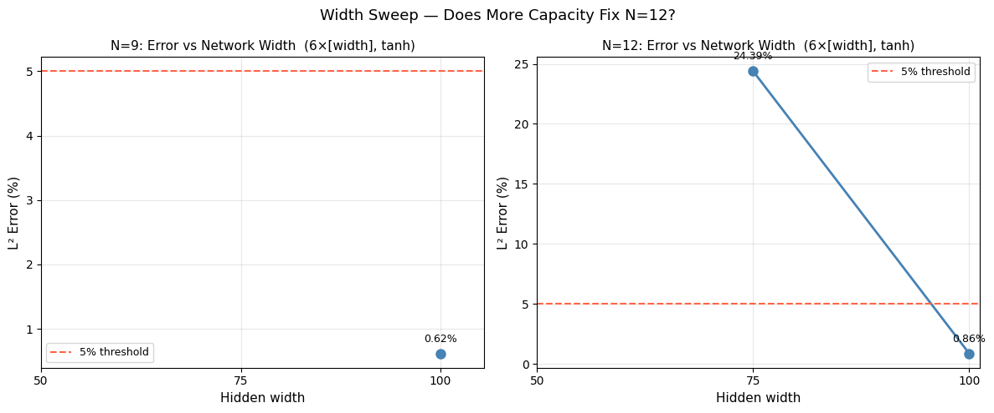

collcn_density results
=================================================================
N=9 | n_pde=5,000 | 6x50 architecture
domain=[-50.0, 82.5]
=================================================================
PDE: 5,000 | Data: 883 | IC: 1,104 | BC: 200
/usr/local/lib/python3.12/dist-packages/torch/autograd/graph.py:824: UserWarning: Attempting to run cuBLAS, but there was no current CUDA context! Attempting to set the primary context... (Triggered internally at /pytorch/aten/src/ATen/cuda/CublasHandlePool.cpp:181.)
return Variable._execution_engine.run_backward( # Calls into the C++ engine to run the backward pass
Adam 0 | Total=0.877435 PDE=0.001193 IC=0.385888 Data=0.413460
Adam 1000 | Total=0.275179 PDE=0.014794 IC=0.129073 Data=0.131044
Adam 2000 | Total=0.167765 PDE=0.007936 IC=0.081958 Data=0.077660
Adam 3000 | Total=0.117339 PDE=0.018353 IC=0.052466 Data=0.046482
Adam 4000 | Total=0.052603 PDE=0.012980 IC=0.017689 Data=0.021570
Adam 5000 | Total=0.028844 PDE=0.010158 IC=0.007913 Data=0.010655
Adam 6000 | Total=0.035623 PDE=0.004799 IC=0.013008 Data=0.017577
Adam 7000 | Total=0.003039 PDE=0.001498 IC=0.000456 Data=0.001071
Adam 8000 | Total=0.019024 PDE=0.004588 IC=0.007201 Data=0.007215
Adam 9000 | Total=0.025189 PDE=0.001481 IC=0.010488 Data=0.013214
Adam 10000 | Total=0.014618 PDE=0.001462 IC=0.006077 Data=0.007055
Adam 11000 | Total=0.004266 PDE=0.001020 IC=0.001080 Data=0.002165
Adam 12000 | Total=0.005354 PDE=0.002421 IC=0.001083 Data=0.001848
Adam 13000 | Total=0.004442 PDE=0.001463 IC=0.001427 Data=0.001534
Adam 14000 | Total=0.000919 PDE=0.000492 IC=0.000202 Data=0.000223
>> Adam done 330.6s | L2=12.2978% | loss=0.009236
LBFGS 0 | Total=1.21656775
LBFGS 200 | Total=nan
LBFGS 400 | Total=nan
LBFGS 600 | Total=nan
LBFGS 800 | Total=nan
LBFGS 1000 | Total=nan
LBFGS 1200 | Total=nan
LBFGS 1400 | Total=nan
LBFGS 1600 | Total=nan
LBFGS 1800 | Total=nan
>> LBFGS done 1069.3s | L2=nan% | loss=nan
saved: checkpoint_N9_pde5000.pt

=================================================================
N=9 | n_pde=10,000 | 6x50 architecture
domain=[-50.0, 82.5]
=================================================================
PDE: 10,000 | Data: 883 | IC: 1,104 | BC: 200
Adam 0 | Total=0.630025 PDE=0.001019 IC=0.323080 Data=0.277814
Adam 1000 | Total=0.392135 PDE=0.002624 IC=0.197476 Data=0.191723
Adam 2000 | Total=0.289474 PDE=0.008877 IC=0.141351 Data=0.138725
Adam 3000 | Total=0.063400 PDE=0.014781 IC=0.021080 Data=0.027475
Adam 4000 | Total=0.031268 PDE=0.004131 IC=0.014117 Data=0.012927
Adam 5000 | Total=0.007926 PDE=0.002308 IC=0.002317 Data=0.003273
Adam 6000 | Total=0.011284 PDE=0.002162 IC=0.004046 Data=0.004992
Adam 7000 | Total=0.012952 PDE=0.001428 IC=0.005324 Data=0.006188
Adam 8000 | Total=0.013119 PDE=0.001609 IC=0.005391 Data=0.006117
Adam 9000 | Total=0.001553 PDE=0.000557 IC=0.000257 Data=0.000735
Adam 10000 | Total=0.003699 PDE=0.000815 IC=0.001258 Data=0.001616
Adam 11000 | Total=0.010415 PDE=0.001998 IC=0.004126 Data=0.004282
Adam 12000 | Total=0.008813 PDE=0.000597 IC=0.003878 Data=0.004337
Adam 13000 | Total=0.002379 PDE=0.000941 IC=0.000930 Data=0.000453
Adam 14000 | Total=0.010230 PDE=0.001076 IC=0.004453 Data=0.004657
>> Adam done 352.5s | L2=4.2007% | loss=0.000948
LBFGS 0 | Total=0.00148101
LBFGS 200 | Total=0.00010670
LBFGS 400 | Total=0.00005540
LBFGS 600 | Total=0.00005540
LBFGS 800 | Total=0.00005540
LBFGS 1000 | Total=0.00005540
LBFGS 1200 | Total=0.00005540
LBFGS 1400 | Total=0.00005540
LBFGS 1600 | Total=0.00005540
LBFGS 1800 | Total=0.00005540
>> LBFGS done 268.2s | L2=0.5043% | loss=0.00005540
saved: checkpoint_N9_pde10000.pt

=================================================================
N=9 | n_pde=20,000 | 6x50 architecture
domain=[-50.0, 82.5]
=================================================================
PDE: 20,000 | Data: 883 | IC: 1,104 | BC: 200
Adam 0 | Total=2.877031 PDE=0.024116 IC=1.082156 Data=1.113690
Adam 1000 | Total=0.330999 PDE=0.010433 IC=0.160909 Data=0.159509
Adam 2000 | Total=0.125810 PDE=0.024405 IC=0.046900 Data=0.054474
Adam 3000 | Total=0.028096 PDE=0.012033 IC=0.004887 Data=0.010946
Adam 4000 | Total=0.011377 PDE=0.004732 IC=0.002248 Data=0.004368
Adam 5000 | Total=0.009466 PDE=0.002885 IC=0.002616 Data=0.003961
Adam 6000 | Total=0.008107 PDE=0.003919 IC=0.001383 Data=0.002763
Adam 7000 | Total=0.013657 PDE=0.002064 IC=0.005779 Data=0.005777
Adam 8000 | Total=0.019058 PDE=0.009658 IC=0.004007 Data=0.004827
Adam 9000 | Total=0.010140 PDE=0.002230 IC=0.003105 Data=0.004797
Adam 10000 | Total=0.002280 PDE=0.000729 IC=0.000612 Data=0.000929
Adam 11000 | Total=0.002259 PDE=0.000704 IC=0.000772 Data=0.000780
Adam 12000 | Total=0.011990 PDE=0.009930 IC=0.000615 Data=0.000824
Adam 13000 | Total=0.011084 PDE=0.001758 IC=0.003821 Data=0.005468
Adam 14000 | Total=0.000598 PDE=0.000445 IC=0.000033 Data=0.000114
>> Adam done 473.9s | L2=4.5146% | loss=0.001697
LBFGS 0 | Total=0.27359083
LBFGS 200 | Total=0.00013935
LBFGS 400 | Total=0.00009467
LBFGS 600 | Total=0.00009467
LBFGS 800 | Total=0.00009467
LBFGS 1000 | Total=0.00009467
LBFGS 1200 | Total=0.00009467
LBFGS 1400 | Total=0.00009467
LBFGS 1600 | Total=0.00009467
LBFGS 1800 | Total=0.00009467
>> LBFGS done 289.3s | L2=0.7087% | loss=0.00009467
saved: checkpoint_N9_pde20000.pt

=================================================================
N=9 | n_pde=40,000 | 6x50 architecture
domain=[-50.0, 82.5]
=================================================================
PDE: 40,000 | Data: 883 | IC: 1,104 | BC: 200
Adam 0 | Total=0.637863 PDE=0.000832 IC=0.322955 Data=0.310079
Adam 1000 | Total=0.271629 PDE=0.013619 IC=0.115901 Data=0.142078
Adam 2000 | Total=0.112789 PDE=0.023452 IC=0.038399 Data=0.050845
Adam 3000 | Total=0.077057 PDE=0.009004 IC=0.029483 Data=0.038547
Adam 4000 | Total=0.076861 PDE=0.009105 IC=0.030597 Data=0.037154
Adam 5000 | Total=0.070712 PDE=0.008652 IC=0.027002 Data=0.035053
Adam 6000 | Total=0.071068 PDE=0.011238 IC=0.024653 Data=0.035169
Adam 7000 | Total=0.090323 PDE=0.016306 IC=0.031776 Data=0.042059
Adam 8000 | Total=0.103099 PDE=0.010689 IC=0.037841 Data=0.053766
Adam 9000 | Total=0.092951 PDE=0.012817 IC=0.033418 Data=0.046679
Adam 10000 | Total=0.084086 PDE=0.012853 IC=0.025647 Data=0.045513
Adam 11000 | Total=0.083538 PDE=0.018594 IC=0.025126 Data=0.039672
Adam 12000 | Total=0.186456 PDE=0.066027 IC=0.058116 Data=0.062176
Adam 13000 | Total=0.026619 PDE=0.009214 IC=0.005871 Data=0.011489
Adam 14000 | Total=0.007397 PDE=0.003367 IC=0.001079 Data=0.002930
>> Adam done 743.9s | L2=10.3132% | loss=0.010845
LBFGS 0 | Total=0.47267675
LBFGS 200 | Total=0.00034739
LBFGS 400 | Total=0.00013225
LBFGS 600 | Total=0.00010496
LBFGS 800 | Total=0.00010496
LBFGS 1000 | Total=0.00010496
LBFGS 1200 | Total=0.00010496
LBFGS 1400 | Total=0.00010496
LBFGS 1600 | Total=0.00010496
LBFGS 1800 | Total=0.00010496
>> LBFGS done 598.2s | L2=0.9358% | loss=0.00010496
saved: checkpoint_N9_pde40000.pt

=================================================================
N=9 | n_pde=80,000 | 6x50 architecture
domain=[-50.0, 82.5]
=================================================================
PDE: 80,000 | Data: 883 | IC: 1,104 | BC: 200
Adam 0 | Total=0.812217 PDE=0.001500 IC=0.354646 Data=0.374801
Adam 1000 | Total=0.288488 PDE=0.013332 IC=0.133847 Data=0.141133
Adam 2000 | Total=0.130435 PDE=0.021299 IC=0.049496 Data=0.059565
Adam 3000 | Total=0.062257 PDE=0.012514 IC=0.022228 Data=0.027462
Adam 4000 | Total=0.075919 PDE=0.008166 IC=0.031250 Data=0.036408
Adam 5000 | Total=0.052161 PDE=0.009726 IC=0.020885 Data=0.021497
Adam 6000 | Total=0.046375 PDE=0.006559 IC=0.017236 Data=0.022478
Adam 7000 | Total=0.037136 PDE=0.008778 IC=0.012177 Data=0.016039
Adam 8000 | Total=0.030276 PDE=0.006947 IC=0.008895 Data=0.014407
Adam 9000 | Total=0.034182 PDE=0.007843 IC=0.009311 Data=0.017017
Adam 10000 | Total=0.029032 PDE=0.008294 IC=0.007494 Data=0.013133
Adam 11000 | Total=0.015563 PDE=0.006126 IC=0.001696 Data=0.007732
Adam 12000 | Total=0.001972 PDE=0.001231 IC=0.000092 Data=0.000647
Adam 13000 | Total=0.001259 PDE=0.000762 IC=0.000181 Data=0.000306
Adam 14000 | Total=0.002193 PDE=0.001475 IC=0.000201 Data=0.000507
>> Adam done 1462.3s | L2=10.5228% | loss=0.008930
LBFGS 0 | Total=0.18713602
LBFGS 200 | Total=0.00016578
LBFGS 400 | Total=0.00005548
LBFGS 600 | Total=0.00005548
LBFGS 800 | Total=0.00005548
LBFGS 1000 | Total=0.00005548
LBFGS 1200 | Total=0.00005548
LBFGS 1400 | Total=0.00005548
LBFGS 1600 | Total=0.00005548
LBFGS 1800 | Total=0.00005548
>> LBFGS done 977.3s | L2=0.5185% | loss=0.00005548
saved: checkpoint_N9_pde80000.pt

=================================================================
N=12 | n_pde=20,000 | 6x50 architecture
domain=[-65.0, 105.0]
=================================================================
PDE: 20,000 | Data: 1,133 | IC: 1,416 | BC: 200
Adam 0 | Total=2.309628 PDE=0.005211 IC=0.909626 Data=0.944642
Adam 1000 | Total=0.631326 PDE=0.005488 IC=0.297128 Data=0.328251
Adam 2000 | Total=0.510364 PDE=0.013522 IC=0.244188 Data=0.252439
Adam 3000 | Total=0.457990 PDE=0.018052 IC=0.221185 Data=0.218662
Adam 4000 | Total=0.425168 PDE=0.030082 IC=0.190647 Data=0.204206
Adam 5000 | Total=0.265793 PDE=0.019089 IC=0.117187 Data=0.129364
Adam 6000 | Total=0.269401 PDE=0.022641 IC=0.120691 Data=0.125764
Adam 7000 | Total=0.173089 PDE=0.017799 IC=0.071589 Data=0.083465
Adam 8000 | Total=0.106435 PDE=0.014265 IC=0.042141 Data=0.049970
Adam 9000 | Total=0.059966 PDE=0.013203 IC=0.017740 Data=0.028827
Adam 10000 | Total=0.062823 PDE=0.014885 IC=0.019205 Data=0.028476
Adam 11000 | Total=0.026281 PDE=0.010310 IC=0.005817 Data=0.010064
Adam 12000 | Total=0.020141 PDE=0.008848 IC=0.003515 Data=0.007658
Adam 13000 | Total=0.063285 PDE=0.010208 IC=0.022895 Data=0.030118
Adam 14000 | Total=0.030254 PDE=0.009899 IC=0.007587 Data=0.012376
>> Adam done 494.2s | L2=18.4606% | loss=0.054049
LBFGS 0 | Total=1.87521672
LBFGS 200 | Total=0.12466706
LBFGS 400 | Total=0.07786572
LBFGS 600 | Total=0.02571311
LBFGS 800 | Total=0.01964139
LBFGS 1000 | Total=0.01661174
LBFGS 1200 | Total=0.01469592
LBFGS 1400 | Total=0.01384275
LBFGS 1600 | Total=0.01326099
LBFGS 1800 | Total=0.01276003
>> LBFGS done 1518.3s | L2=30.6183% | loss=0.01236389
saved: checkpoint_N12_pde20000.pt

=================================================================
N=12 | n_pde=40,000 | 6x50 architecture
domain=[-65.0, 105.0]
=================================================================
PDE: 40,000 | Data: 1,133 | IC: 1,416 | BC: 200
Adam 0 | Total=1.642936 PDE=0.024185 IC=0.713261 Data=0.621652
Adam 1000 | Total=0.645981 PDE=0.002983 IC=0.305973 Data=0.336584
Adam 2000 | Total=0.551322 PDE=0.025697 IC=0.254029 Data=0.271328
Adam 3000 | Total=0.449463 PDE=0.013160 IC=0.218711 Data=0.217365
Adam 4000 | Total=0.419264 PDE=0.013970 IC=0.204385 Data=0.200865
Adam 5000 | Total=0.376275 PDE=0.025632 IC=0.168965 Data=0.181505
Adam 6000 | Total=0.256342 PDE=0.013686 IC=0.120765 Data=0.121828
Adam 7000 | Total=0.254393 PDE=0.014577 IC=0.115989 Data=0.123806
Adam 8000 | Total=0.247099 PDE=0.010767 IC=0.112793 Data=0.123502
Adam 9000 | Total=0.244862 PDE=0.012538 IC=0.109374 Data=0.122897
Adam 10000 | Total=0.231618 PDE=0.013287 IC=0.103918 Data=0.114249
Adam 11000 | Total=0.227799 PDE=0.010367 IC=0.102790 Data=0.114635
Adam 12000 | Total=0.197782 PDE=0.016797 IC=0.085526 Data=0.095275
Adam 13000 | Total=0.128050 PDE=0.018496 IC=0.049572 Data=0.059840
Adam 14000 | Total=0.138141 PDE=0.034528 IC=0.042740 Data=0.059926
>> Adam done 751.3s | L2=35.2199% | loss=0.138770
LBFGS 0 | Total=1.31595898
LBFGS 200 | Total=0.22794974
LBFGS 400 | Total=0.14171995
LBFGS 600 | Total=0.11066453
LBFGS 800 | Total=0.06257948
LBFGS 1000 | Total=0.04173192
LBFGS 1200 | Total=0.03633238
LBFGS 1400 | Total=0.03360543
LBFGS 1600 | Total=0.03175982
LBFGS 1800 | Total=0.03073383
>> LBFGS done 2223.1s | L2=42.8802% | loss=0.02926385
saved: checkpoint_N12_pde40000.pt

=================================================================
N=12 | n_pde=80,000 | 6x50 architecture
domain=[-65.0, 105.0]
=================================================================
PDE: 80,000 | Data: 1,133 | IC: 1,416 | BC: 200
Adam 0 | Total=1.972080 PDE=0.000991 IC=0.778167 Data=0.744960
Adam 1000 | Total=0.561953 PDE=0.010285 IC=0.251767 Data=0.299555
Adam 2000 | Total=0.440390 PDE=0.014924 IC=0.174737 Data=0.250369
Adam 3000 | Total=0.367928 PDE=0.022319 IC=0.126827 Data=0.218578
Adam 4000 | Total=0.252464 PDE=0.030921 IC=0.058353 Data=0.162870
Adam 5000 | Total=0.218477 PDE=0.029893 IC=0.046230 Data=0.142286
Adam 6000 | Total=0.234922 PDE=0.032822 IC=0.062044 Data=0.139751
Adam 7000 | Total=0.186476 PDE=0.041352 IC=0.034839 Data=0.110028
Adam 8000 | Total=0.159200 PDE=0.039064 IC=0.027236 Data=0.092397
Adam 9000 | Total=0.129928 PDE=0.036105 IC=0.016692 Data=0.077114
Adam 10000 | Total=0.118486 PDE=0.036755 IC=0.013435 Data=0.068108
Adam 11000 | Total=0.131740 PDE=0.047348 IC=0.016162 Data=0.067953
Adam 12000 | Total=0.089289 PDE=0.030560 IC=0.005551 Data=0.052946
Adam 13000 | Total=0.074849 PDE=0.027464 IC=0.003855 Data=0.043447
Adam 14000 | Total=0.079445 PDE=0.026823 IC=0.012310 Data=0.040227
>> Adam done 1465.4s | L2=36.9364% | loss=0.068862
LBFGS 0 | Total=0.36523151
LBFGS 200 | Total=0.04236817
LBFGS 400 | Total=0.03819746
LBFGS 600 | Total=0.03533630
LBFGS 800 | Total=0.03376694
LBFGS 1000 | Total=0.03195645
LBFGS 1200 | Total=0.03019146
LBFGS 1400 | Total=0.02826660
LBFGS 1600 | Total=0.02616496
LBFGS 1800 | Total=0.02401442
>> LBFGS done 4156.1s | L2=24.1723% | loss=0.02246667
saved: checkpoint_N12_pde80000.pt

=================================================================
N=12 | n_pde=160,000 | 6x50 architecture
domain=[-65.0, 105.0]
=================================================================
PDE: 160,000 | Data: 1,133 | IC: 1,416 | BC: 200
Adam 0 | Total=1.273704 PDE=0.028388 IC=0.600793 Data=0.563869
Adam 1000 | Total=0.557037 PDE=0.017228 IC=0.239443 Data=0.300273
Adam 2000 | Total=0.387872 PDE=0.035219 IC=0.127817 Data=0.224748
Adam 3000 | Total=0.334282 PDE=0.054023 IC=0.098109 Data=0.178590
Adam 4000 | Total=0.246533 PDE=0.024599 IC=0.089561 Data=0.132032
Adam 5000 | Total=0.249721 PDE=0.019220 IC=0.100298 Data=0.130091
Adam 6000 | Total=0.228310 PDE=0.017947 IC=0.090413 Data=0.119895
Adam 7000 | Total=0.223946 PDE=0.022061 IC=0.089754 Data=0.112095
Adam 8000 | Total=0.208597 PDE=0.023805 IC=0.080532 Data=0.103823
Adam 9000 | Total=0.211870 PDE=0.027218 IC=0.079939 Data=0.104677
Adam 10000 | Total=0.182950 PDE=0.033442 IC=0.052480 Data=0.096930
Adam 11000 | Total=0.145073 PDE=0.036592 IC=0.031644 Data=0.076795
Adam 12000 | Total=0.127232 PDE=0.035577 IC=0.025774 Data=0.065659
Adam 13000 | Total=0.085517 PDE=0.033351 IC=0.004479 Data=0.047042
Adam 14000 | Total=0.091286 PDE=0.030273 IC=0.012641 Data=0.048353
>> Adam done 2848.5s | L2=34.4891% | loss=0.072212
LBFGS 0 | Total=1.81475747
LBFGS 200 | Total=0.10898949
LBFGS 400 | Total=0.08411065
LBFGS 600 | Total=0.06338199
LBFGS 800 | Total=0.01561315
LBFGS 1000 | Total=0.00601372
LBFGS 1200 | Total=0.00355409
LBFGS 1400 | Total=0.00221206
LBFGS 1600 | Total=0.00171767
LBFGS 1800 | Total=0.00109310
>> LBFGS done 7859.7s | L2=2.4788% | loss=0.00086873
saved: checkpoint_N12_pde160000.pt

========================================================================
Key | N | n_pde | density/unit² | L2 Adam | L2 Final
------------------------------------------------------------------------
N9_pde5000 | 9 | 5,000 | 7.5 | 12.2978% | nan%
N9_pde10000 | 9 | 10,000 | 15.1 | 4.2007% | 0.5043%
N9_pde20000 | 9 | 20,000 | 30.2 | 4.5146% | 0.7087%
N9_pde40000 | 9 | 40,000 | 60.4 | 10.3132% | 0.9358%
N9_pde80000 | 9 | 80,000 | 120.8 | 10.5228% | 0.5185%
N12_pde20000 | 12 | 20,000 | 23.5 | 18.4606% | 30.6183%
N12_pde40000 | 12 | 40,000 | 47.1 | 35.2199% | 42.8802%
N12_pde80000 | 12 | 80,000 | 94.1 | 36.9364% | 24.1723%
N12_pde160000 | 12 | 160,000 | 188.2 | 34.4891% | 2.4788%
========================================================================

Single-soliton saturation reference: ~5000 pts in 30x5 domain = density ~33/unit²

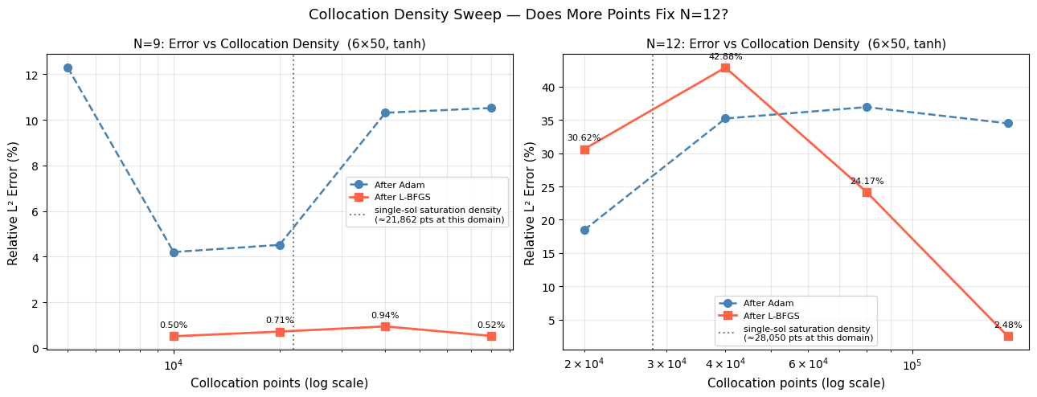

--- INTERPRETATION ---

N=9:
n_pde= 5,000 -> L2=nan%
n_pde= 10,000 -> L2=0.5043%
n_pde= 20,000 -> L2=0.7087%
n_pde= 40,000 -> L2=0.9358%
n_pde= 80,000 -> L2=0.5185%
=> still improving (44.6% change at top end) — more points may help

N=12:
n_pde= 20,000 -> L2=30.6183%
n_pde= 40,000 -> L2=42.8802%
n_pde= 80,000 -> L2=24.1723%
n_pde=160,000 -> L2=2.4788%
=> still improving (89.7% change at top end) — more points may help

datapoints@n=12 results
params: 12,951
N=12 domain: (-65.0, 105.0), width=170.0

============================================================
N=12 | n_data=0 | 6x50 | N=12 baseline settings
============================================================
PDE: 56,666 | Data: 0 | IC: 1,416 | BC: 200
/usr/local/lib/python3.12/dist-packages/torch/autograd/graph.py:824: UserWarning: Attempting to run cuBLAS, but there was no current CUDA context! Attempting to set the primary context... (Triggered internally at /pytorch/aten/src/ATen/cuda/CublasHandlePool.cpp:181.)
return Variable._execution_engine.run_backward( # Calls into the C++ engine to run the backward pass
Adam 0 | Total=0.577886 PDE=0.000537 IC=0.512954 Data=0.000000
Adam 1000 | Total=0.236440 PDE=0.005126 IC=0.231177 Data=0.000000
Adam 2000 | Total=0.184105 PDE=0.005327 IC=0.178469 Data=0.000000
Adam 3000 | Total=0.119476 PDE=0.013093 IC=0.106330 Data=0.000000
Adam 4000 | Total=0.098797 PDE=0.007439 IC=0.091211 Data=0.000000
Adam 5000 | Total=0.096072 PDE=0.006629 IC=0.089379 Data=0.000000
Adam 6000 | Total=0.086599 PDE=0.005803 IC=0.080773 Data=0.000000
Adam 7000 | Total=0.062522 PDE=0.007018 IC=0.055485 Data=0.000000
Adam 8000 | Total=0.051357 PDE=0.010998 IC=0.040204 Data=0.000000
Adam 9000 | Total=0.043610 PDE=0.012494 IC=0.031088 Data=0.000000
Adam 10000 | Total=0.036369 PDE=0.009800 IC=0.026418 Data=0.000000
Adam 11000 | Total=0.012573 PDE=0.006839 IC=0.005625 Data=0.000000
Adam 12000 | Total=0.033193 PDE=0.012557 IC=0.020114 Data=0.000000
Adam 13000 | Total=0.014484 PDE=0.005505 IC=0.008953 Data=0.000000
Adam 14000 | Total=0.007552 PDE=0.004203 IC=0.003226 Data=0.000000
>> Adam done 1092.0s | L2=91.2143% | loss=0.013999
LBFGS 0 | Total=8.89426708
LBFGS 200 | Total=0.15938301
LBFGS 400 | Total=0.12029300
LBFGS 600 | Total=0.11511000
LBFGS 800 | Total=0.11128865
LBFGS 1000 | Total=0.10873019
LBFGS 1200 | Total=0.07436505
LBFGS 1400 | Total=0.01917699
LBFGS 1600 | Total=0.01244464
LBFGS 1800 | Total=0.01088768
>> LBFGS done 3156.4s | L2=72.8992% | loss=0.01045172
saved: checkpoint_N12_ndata0.pt

============================================================
N=12 | n_data=100 | 6x50 | N=12 baseline settings
============================================================
PDE: 56,666 | Data: 100 | IC: 1,416 | BC: 200
Adam 0 | Total=0.941794 PDE=0.000442 IC=0.461455 Data=0.470062
Adam 1000 | Total=0.506245 PDE=0.040551 IC=0.261296 Data=0.202929
Adam 2000 | Total=0.364773 PDE=0.049274 IC=0.201538 Data=0.113759
Adam 3000 | Total=0.238453 PDE=0.055806 IC=0.113744 Data=0.068817
Adam 4000 | Total=0.139118 PDE=0.051876 IC=0.059743 Data=0.027438
Adam 5000 | Total=0.117090 PDE=0.049514 IC=0.050702 Data=0.016751
Adam 6000 | Total=0.097890 PDE=0.044656 IC=0.039254 Data=0.013686
Adam 7000 | Total=0.074849 PDE=0.038898 IC=0.027471 Data=0.008377
Adam 8000 | Total=0.074855 PDE=0.041511 IC=0.023332 Data=0.009673
Adam 9000 | Total=0.084885 PDE=0.034411 IC=0.036018 Data=0.014381
Adam 10000 | Total=0.062132 PDE=0.041855 IC=0.013095 Data=0.006710
Adam 11000 | Total=0.063698 PDE=0.031190 IC=0.021753 Data=0.010745
Adam 12000 | Total=0.068405 PDE=0.030901 IC=0.024732 Data=0.012678
Adam 13000 | Total=0.044797 PDE=0.030328 IC=0.009009 Data=0.005268
Adam 14000 | Total=0.056609 PDE=0.032629 IC=0.014730 Data=0.009241
>> Adam done 1038.5s | L2=76.2526% | loss=0.052491
LBFGS 0 | Total=0.41076866
LBFGS 200 | Total=0.02716558
LBFGS 400 | Total=0.02414814
LBFGS 600 | Total=0.02223053
LBFGS 800 | Total=0.02125314
LBFGS 1000 | Total=0.02037130
LBFGS 1200 | Total=0.01964909
LBFGS 1400 | Total=0.01900111
LBFGS 1600 | Total=0.01851151
LBFGS 1800 | Total=0.01812830
>> LBFGS done 3022.1s | L2=81.2255% | loss=0.01764369
saved: checkpoint_N12_ndata100.pt

============================================================
N=12 | n_data=200 | 6x50 | N=12 baseline settings
============================================================
PDE: 56,666 | Data: 200 | IC: 1,416 | BC: 200
Adam 0 | Total=0.878232 PDE=0.004130 IC=0.435732 Data=0.430316
Adam 1000 | Total=0.446629 PDE=0.008868 IC=0.272066 Data=0.165619
Adam 2000 | Total=0.418423 PDE=0.020017 IC=0.248117 Data=0.150113
Adam 3000 | Total=0.289779 PDE=0.030401 IC=0.158914 Data=0.100382
Adam 4000 | Total=0.202127 PDE=0.033556 IC=0.102985 Data=0.065250
Adam 5000 | Total=0.119905 PDE=0.032300 IC=0.056129 Data=0.031376
Adam 6000 | Total=0.074994 PDE=0.026132 IC=0.031580 Data=0.017262
Adam 7000 | Total=0.072263 PDE=0.032300 IC=0.022416 Data=0.017384
Adam 8000 | Total=0.052725 PDE=0.025274 IC=0.013991 Data=0.013424
Adam 9000 | Total=0.066914 PDE=0.040805 IC=0.012564 Data=0.013247
Adam 10000 | Total=0.039400 PDE=0.021200 IC=0.006213 Data=0.011955
Adam 11000 | Total=0.045914 PDE=0.020733 IC=0.011013 Data=0.014137
Adam 12000 | Total=0.040011 PDE=0.023154 IC=0.004665 Data=0.012033
Adam 13000 | Total=0.056019 PDE=0.020729 IC=0.019724 Data=0.015540
Adam 14000 | Total=0.034604 PDE=0.019392 IC=0.004175 Data=0.011029
>> Adam done 1036.3s | L2=74.8869% | loss=0.035864
LBFGS 0 | Total=0.29147381
LBFGS 200 | Total=0.06825297
LBFGS 400 | Total=0.03798520
LBFGS 600 | Total=0.03068139
LBFGS 800 | Total=0.02915936
LBFGS 1000 | Total=0.02791040
LBFGS 1200 | Total=0.02701246
LBFGS 1400 | Total=0.02629802
LBFGS 1600 | Total=0.02574322
LBFGS 1800 | Total=0.02521175
>> LBFGS done 3020.9s | L2=74.9669% | loss=0.02480596
saved: checkpoint_N12_ndata200.pt

============================================================
N=12 | n_data=500 | 6x50 | N=12 baseline settings
============================================================
PDE: 56,666 | Data: 500 | IC: 1,416 | BC: 200
Adam 0 | Total=1.153513 PDE=0.005539 IC=0.524242 Data=0.536118
Adam 1000 | Total=0.640258 PDE=0.004265 IC=0.300967 Data=0.334667
Adam 2000 | Total=0.540578 PDE=0.009440 IC=0.250365 Data=0.279987
Adam 3000 | Total=0.406778 PDE=0.027420 IC=0.170615 Data=0.208395
Adam 4000 | Total=0.292010 PDE=0.030537 IC=0.116678 Data=0.144770
Adam 5000 | Total=0.200489 PDE=0.033991 IC=0.061466 Data=0.104913
Adam 6000 | Total=0.132347 PDE=0.027936 IC=0.032905 Data=0.071438
Adam 7000 | Total=0.110604 PDE=0.026497 IC=0.019692 Data=0.064329
Adam 8000 | Total=0.143155 PDE=0.027668 IC=0.038439 Data=0.076906
Adam 9000 | Total=0.099132 PDE=0.023708 IC=0.021922 Data=0.053452
Adam 10000 | Total=0.078198 PDE=0.021892 IC=0.013146 Data=0.043126
Adam 11000 | Total=0.075010 PDE=0.020134 IC=0.011055 Data=0.043799
Adam 12000 | Total=0.077899 PDE=0.020018 IC=0.015089 Data=0.042690
Adam 13000 | Total=0.065501 PDE=0.019394 IC=0.010342 Data=0.035640
Adam 14000 | Total=0.083027 PDE=0.019009 IC=0.019024 Data=0.044989
>> Adam done 1034.7s | L2=34.5926% | loss=0.040103
LBFGS 0 | Total=1.25888050
LBFGS 200 | Total=0.04899622
LBFGS 400 | Total=0.02251206
LBFGS 600 | Total=0.01338054
LBFGS 800 | Total=0.00891942
LBFGS 1000 | Total=0.00648974
LBFGS 1200 | Total=0.00372252
LBFGS 1400 | Total=0.00196409
LBFGS 1600 | Total=0.00120470
LBFGS 1800 | Total=0.00070987
>> LBFGS done 2994.5s | L2=1.9530% | loss=0.00052273
saved: checkpoint_N12_ndata500.pt

============================================================
N=12 | n_data=1000 | 6x50 | N=12 baseline settings
============================================================
PDE: 56,666 | Data: 1000 | IC: 1,416 | BC: 200
Adam 0 | Total=0.957973 PDE=0.002813 IC=0.467919 Data=0.399411
Adam 1000 | Total=0.599141 PDE=0.019513 IC=0.274193 Data=0.305340
Adam 2000 | Total=0.442170 PDE=0.017119 IC=0.220463 Data=0.204422
Adam 3000 | Total=0.360853 PDE=0.016550 IC=0.170136 Data=0.174070
Adam 4000 | Total=0.276154 PDE=0.027322 IC=0.107424 Data=0.141079
Adam 5000 | Total=0.244333 PDE=0.024991 IC=0.096404 Data=0.122928
Adam 6000 | Total=0.224193 PDE=0.022560 IC=0.092150 Data=0.109453
Adam 7000 | Total=0.201308 PDE=0.021602 IC=0.085063 Data=0.094420
Adam 8000 | Total=0.172248 PDE=0.018189 IC=0.076604 Data=0.077397
Adam 9000 | Total=0.156281 PDE=0.021069 IC=0.068272 Data=0.066886
Adam 10000 | Total=0.118485 PDE=0.027031 IC=0.041158 Data=0.050256
Adam 11000 | Total=0.106088 PDE=0.029103 IC=0.031622 Data=0.045186
Adam 12000 | Total=0.089755 PDE=0.023878 IC=0.028213 Data=0.037652
Adam 13000 | Total=0.078782 PDE=0.024314 IC=0.023638 Data=0.030799
Adam 14000 | Total=0.071935 PDE=0.027611 IC=0.018568 Data=0.025481
>> Adam done 1035.7s | L2=33.9163% | loss=0.079226
LBFGS 0 | Total=1.00266004
LBFGS 200 | Total=0.16581953
LBFGS 400 | Total=0.12751310
LBFGS 600 | Total=0.05664670
LBFGS 800 | Total=0.02207859
LBFGS 1000 | Total=0.01284249
LBFGS 1200 | Total=0.00886260
LBFGS 1400 | Total=0.00693653
LBFGS 1600 | Total=0.00502727
LBFGS 1800 | Total=0.00316798
>> LBFGS done 3024.2s | L2=3.8584% | loss=0.00214669
saved: checkpoint_N12_ndata1000.pt

============================================================
N=12 | n_data=2000 | 6x50 | N=12 baseline settings
============================================================
PDE: 56,666 | Data: 2000 | IC: 1,416 | BC: 200
Adam 0 | Total=0.946703 PDE=0.001697 IC=0.443178 Data=0.497097
Adam 1000 | Total=0.567904 PDE=0.016149 IC=0.260668 Data=0.290657
Adam 2000 | Total=0.436905 PDE=0.021372 IC=0.188009 Data=0.227343
Adam 3000 | Total=0.338921 PDE=0.022566 IC=0.143084 Data=0.173021
Adam 4000 | Total=0.300471 PDE=0.014694 IC=0.132114 Data=0.153603
Adam 5000 | Total=0.248828 PDE=0.018988 IC=0.109341 Data=0.120407
Adam 6000 | Total=0.200229 PDE=0.024704 IC=0.081637 Data=0.093797
Adam 7000 | Total=0.163820 PDE=0.026199 IC=0.057979 Data=0.079554
Adam 8000 | Total=0.099807 PDE=0.011297 IC=0.039498 Data=0.048945
Adam 9000 | Total=0.082124 PDE=0.008685 IC=0.033127 Data=0.040279
Adam 10000 | Total=0.091886 PDE=0.007501 IC=0.034462 Data=0.049870
Adam 11000 | Total=0.089447 PDE=0.009608 IC=0.034113 Data=0.045653
Adam 12000 | Total=0.109400 PDE=0.053504 IC=0.024298 Data=0.030581
Adam 13000 | Total=0.065924 PDE=0.010594 IC=0.021110 Data=0.034117
Adam 14000 | Total=0.041784 PDE=0.009317 IC=0.013685 Data=0.018660
>> Adam done 1041.5s | L2=24.6099% | loss=0.096752
LBFGS 0 | Total=1.03500104
LBFGS 200 | Total=0.01457933
LBFGS 400 | Total=0.00509169
LBFGS 600 | Total=0.00249516
LBFGS 800 | Total=0.00125469
LBFGS 1000 | Total=0.00081054
LBFGS 1200 | Total=0.00052459
LBFGS 1400 | Total=0.00035620
LBFGS 1600 | Total=0.00029776
LBFGS 1800 | Total=0.00029011
>> LBFGS done 2488.1s | L2=1.2219% | loss=0.00029011
saved: checkpoint_N12_ndata2000.pt

=================================================================
n_data | L2 Adam | L2 Final | Adam loss | LBFGS loss
-----------------------------------------------------------------
0 | 91.2143% | 72.8992% | 0.013999 | 0.01045172
100 | 76.2526% | 81.2255% | 0.052491 | 0.01764369
200 | 74.8869% | 74.9669% | 0.035864 | 0.02480596
500 | 34.5926% | 1.9530% | 0.040103 | 0.00052273
1000 | 33.9163% | 3.8584% | 0.079226 | 0.00214669
2000 | 24.6099% | 1.2219% | 0.096752 | 0.00029011
=================================================================

n_data=0 -> 72.90%, n_data=2000 -> 1.22%
relative drop: 98.3%
=> data RESCUED N=12 — optimization problem, network has capacity

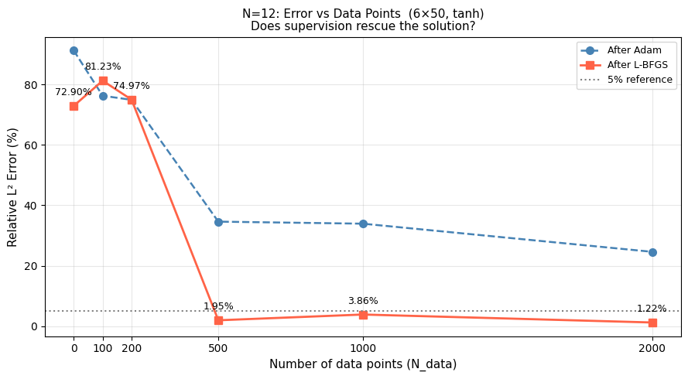

wave_speed results
=================================================================
baseline (2.5,2.0,1.5) | speeds=[2.5, 2.0, 1.5] | 6x50
domain=[-20.0, 40.0]
=================================================================
PDE: 20,000 | Data: 400 | IC: 500 | BC: 200

/usr/local/lib/python3.12/dist-packages/torch/autograd/graph.py:869: UserWarning: Attempting to run cuBLAS, but there was no current CUDA context! Attempting to set the primary context... (Triggered internally at /pytorch/aten/src/ATen/cuda/CublasHandlePool.cpp:335.)
return Variable._execution_engine.run_backward( # Calls into the C++ engine to run the backward pass

Adam 0 | Total=1.499755 PDE=0.012409 IC=0.493752 Data=0.445093
Adam 1000 | Total=0.001229 PDE=0.000701 IC=0.000071 Data=0.000447
Adam 2000 | Total=0.000790 PDE=0.000369 IC=0.000163 Data=0.000180
Adam 3000 | Total=0.000048 PDE=0.000037 IC=0.000002 Data=0.000008
Adam 4000 | Total=0.000031 PDE=0.000022 IC=0.000003 Data=0.000005
Adam 5000 | Total=0.000031 PDE=0.000021 IC=0.000003 Data=0.000004
Adam 6000 | Total=0.000349 PDE=0.000189 IC=0.000071 Data=0.000089
Adam 7000 | Total=0.000010 PDE=0.000007 IC=0.000001 Data=0.000002
Adam 8000 | Total=0.000048 PDE=0.000010 IC=0.000011 Data=0.000012
Adam 9000 | Total=0.000158 PDE=0.000041 IC=0.000054 Data=0.000040
Adam 10000 | Total=0.000036 PDE=0.000009 IC=0.000013 Data=0.000012
Adam 11000 | Total=0.000022 PDE=0.000012 IC=0.000004 Data=0.000005
Adam 12000 | Total=0.000142 PDE=0.000020 IC=0.000052 Data=0.000055
Adam 13000 | Total=0.000053 PDE=0.000018 IC=0.000017 Data=0.000014
Adam 14000 | Total=0.000037 PDE=0.000018 IC=0.000007 Data=0.000011
>> Adam done 666.6s | L2=0.4004% | loss=0.000006
LBFGS 0 | Total=0.00002152
LBFGS 200 | Total=0.00000199
LBFGS 400 | Total=0.00000199
LBFGS 600 | Total=0.00000199
LBFGS 800 | Total=0.00000199
LBFGS 1000 | Total=0.00000199
LBFGS 1200 | Total=0.00000199
LBFGS 1400 | Total=0.00000199
LBFGS 1600 | Total=0.00000199
LBFGS 1800 | Total=0.00000199
>> LBFGS done 104.4s | L2=0.1844% | loss=0.00000199

=================================================================
high-speed (4.0,2.0,1.0) | speeds=[4.0, 2.0, 1.0] | 6x50
domain=[-22.0, 47.0]
=================================================================
PDE: 23,000 | Data: 459 | IC: 575 | BC: 200
Adam 0 | Total=0.233053 PDE=0.002289 IC=0.118530 Data=0.110621
Adam 1000 | Total=0.003602 PDE=0.002881 IC=0.000218 Data=0.000478
Adam 2000 | Total=0.000180 PDE=0.000105 IC=0.000023 Data=0.000051
Adam 3000 | Total=0.000116 PDE=0.000085 IC=0.000010 Data=0.000021
Adam 4000 | Total=0.000048 PDE=0.000037 IC=0.000003 Data=0.000007
Adam 5000 | Total=0.000148 PDE=0.000135 IC=0.000005 Data=0.000008
Adam 6000 | Total=0.000124 PDE=0.000040 IC=0.000029 Data=0.000052
Adam 7000 | Total=0.000264 PDE=0.000205 IC=0.000022 Data=0.000034
Adam 8000 | Total=0.000309 PDE=0.000026 IC=0.000099 Data=0.000174
Adam 9000 | Total=0.000144 PDE=0.000053 IC=0.000032 Data=0.000057
Adam 10000 | Total=0.000150 PDE=0.000058 IC=0.000032 Data=0.000048
Adam 11000 | Total=0.000113 PDE=0.000057 IC=0.000020 Data=0.000036
Adam 12000 | Total=0.000036 PDE=0.000007 IC=0.000010 Data=0.000018
Adam 13000 | Total=0.000349 PDE=0.000042 IC=0.000104 Data=0.000188
Adam 14000 | Total=0.000584 PDE=0.000186 IC=0.000119 Data=0.000276
>> Adam done 744.3s | L2=2.3783% | loss=0.000278
LBFGS 0 | Total=0.00067503
LBFGS 200 | Total=0.00000386
LBFGS 400 | Total=0.00000386
LBFGS 600 | Total=0.00000386
LBFGS 800 | Total=0.00000386
LBFGS 1000 | Total=0.00000386
LBFGS 1200 | Total=0.00000386
LBFGS 1400 | Total=0.00000386
LBFGS 1600 | Total=0.00000386
LBFGS 1800 | Total=0.00000386
>> LBFGS done 129.3s | L2=0.1864% | loss=0.00000386

per-soliton L2 errors (high-speed run):
c=4.0 -> 0.1720%
c=2.0 -> 0.0938%
c=1.0 -> 0.2869%

=================================================================
Config | L2 Adam | L2 Final | Time (s)
-----------------------------------------------------------------
baseline (2.5,2.0,1.5) | 0.4004% | 0.1844% | 771.0
high-speed (4.0,2.0,1.0) | 2.3783% | 0.1864% | 873.6
=================================================================

reference (from single-soliton paper):
c=1.0 single -> ~0.07%
c=4.0 single -> ~29.5% (failed)

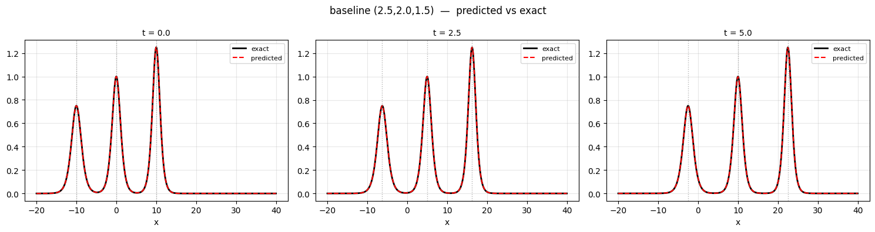
saved: baseline_2.52.01.5_snapshots.png

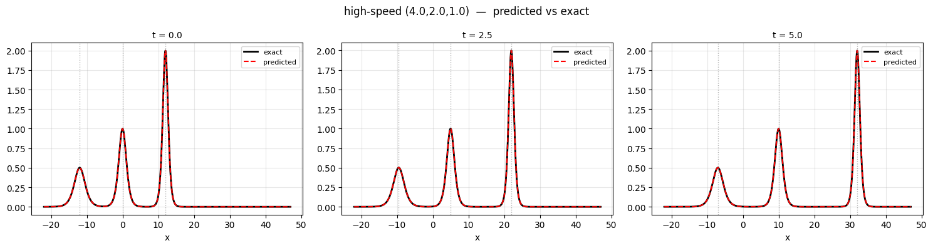
saved: high-speed_4.02.01.0_snapshots.png

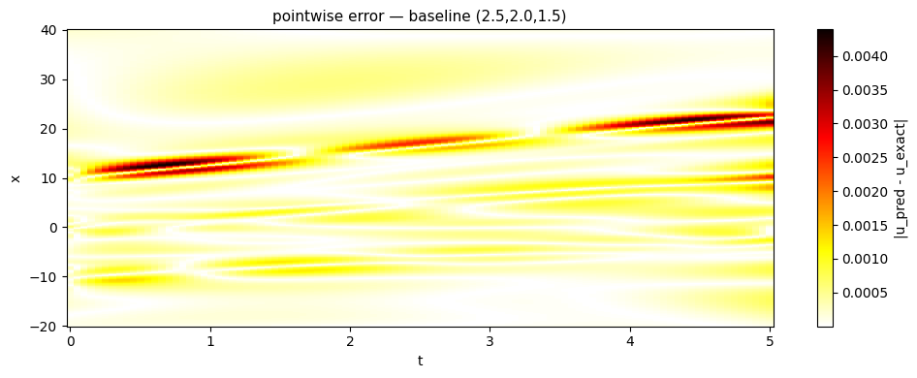
saved: heatmap_baseline.png

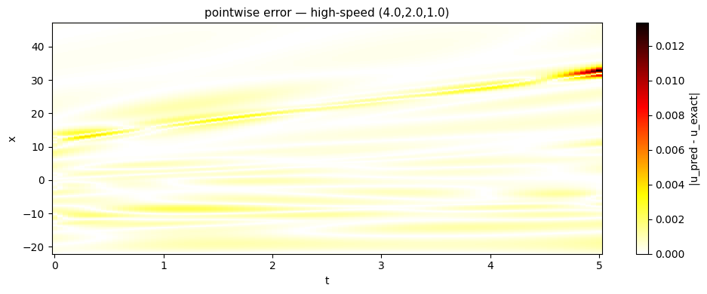
saved: heatmap_high-speed.png

Nirek

per-soliton error
N=12 speeds=[3. 2.81818182 2.63636364 2.45454545 2.27272727 2.09090909
1.90909091 1.72727273 1.54545455 1.36363636 1.18181818 1. ]
domain=(-50.0, 17.5)
no checkpoint found — training N=12 from scratch (~40 min on T4)
n_pde=22500 n_data=450

/usr/local/lib/python3.12/dist-packages/torch/autograd/graph.py:865: UserWarning: Attempting to run cuBLAS, but there was no current CUDA context! Attempting to set the primary context... (Triggered internally at /pytorch/aten/src/ATen/cuda/CublasHandlePool.cpp:330.)
return Variable._execution_engine.run_backward( # Calls into the C++ engine to run the backward pass

adam 0 loss=3.574e+00 pde=1.36e-02 ic=1.58e+00 bc=5.08e-01 data=1.47e+00
adam 1500 loss=1.186e-01 pde=4.80e-02 ic=1.46e-02 bc=4.67e-05 data=5.59e-02
adam 3000 loss=1.118e-01 pde=4.83e-02 ic=9.85e-03 bc=3.08e-05 data=5.36e-02
adam 4500 loss=1.108e-01 pde=4.84e-02 ic=9.53e-03 bc=3.56e-05 data=5.29e-02
adam 6000 loss=1.096e-01 pde=4.84e-02 ic=9.68e-03 bc=5.33e-05 data=5.14e-02
adam 7500 loss=1.093e-01 pde=4.76e-02 ic=8.73e-03 bc=9.41e-05 data=5.28e-02
adam 9000 loss=1.073e-01 pde=4.68e-02 ic=8.21e-03 bc=8.76e-05 data=5.21e-02
adam 10500 loss=1.076e-01 pde=4.70e-02 ic=7.83e-03 bc=1.29e-04 data=5.26e-02
adam 12000 loss=1.121e-01 pde=5.39e-02 ic=1.00e-02 bc=2.02e-04 data=4.79e-02
adam 13500 loss=1.082e-01 pde=4.89e-02 ic=9.15e-03 bc=2.32e-04 data=4.99e-02
adam 14999 loss=1.033e-01 pde=4.77e-02 ic=9.08e-03 bc=7.91e-05 data=4.65e-02
lbfgs 200 loss=9.808e-02
lbfgs 400 loss=9.740e-02
lbfgs 600 loss=9.695e-02
lbfgs 800 loss=9.654e-02
lbfgs 1000 loss=9.619e-02
lbfgs 1200 loss=9.589e-02
lbfgs 1400 loss=9.552e-02
lbfgs 1600 loss=9.519e-02
lbfgs 1800 loss=9.487e-02
lbfgs 2000 loss=9.460e-02
lbfgs 2200 loss=9.434e-02
done. adam_loss=1.033e-01 lbfgs_loss=9.429e-02 time=891.9s
saved n12_model.pt

global L2 error: 34.33%

soliton 1 c=3.00 x0=-40.0 local L2 = 47.28%
soliton 2 c=2.82 x0=-37.3 local L2 = 37.40%
soliton 3 c=2.64 x0=-34.5 local L2 = 30.96%
soliton 4 c=2.45 x0=-31.8 local L2 = 25.65%
soliton 5 c=2.27 x0=-29.1 local L2 = 22.00%
soliton 6 c=2.09 x0=-26.4 local L2 = 19.93%
soliton 7 c=1.91 x0=-23.6 local L2 = 19.48%
soliton 8 c=1.73 x0=-20.9 local L2 = 20.26%
soliton 9 c=1.55 x0=-18.2 local L2 = 21.53%
soliton 10 c=1.36 x0=-15.5 local L2 = 22.64%
soliton 11 c=1.18 x0=-12.7 local L2 = 22.90%
soliton 12 c=1.00 x0=-10.0 local L2 = 26.55%
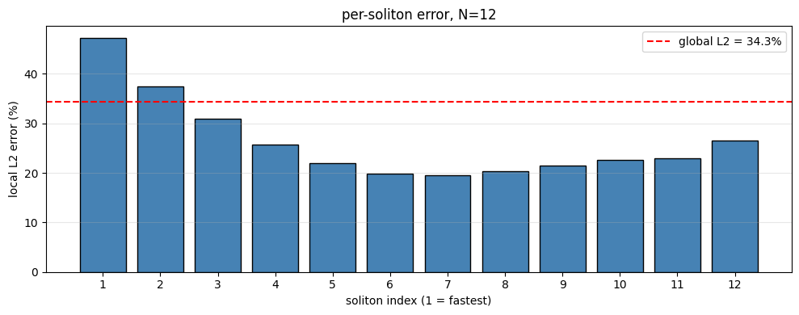
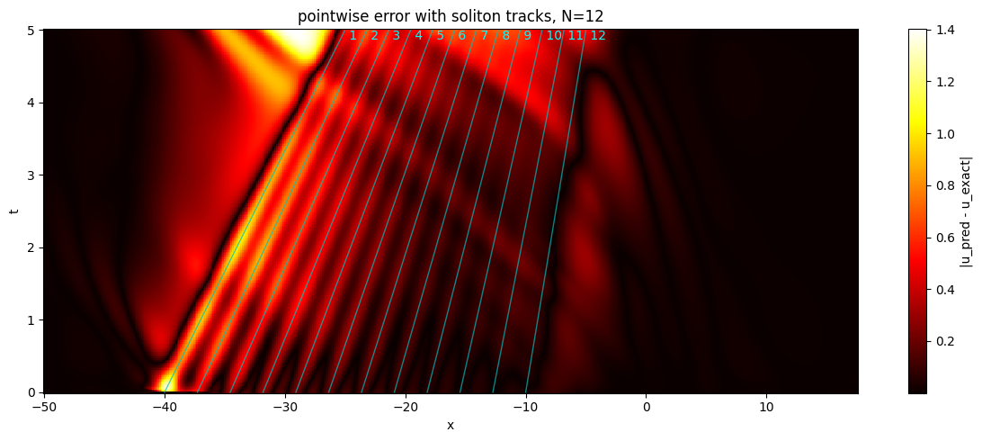

saved per_soliton_results.csv

mean local L2 = 26.38% std = 8.04%
--> errors highly non-uniform. some solitons captured, others missed. likely optimization stuck in partial basin
worst: soliton 1 (c=3.00) at 47.3%
best: soliton 7 (c=1.91) at 19.5%

noiserob@n=9
N=9 speeds=[3. 2.75 2.5 2.25 2. 1.75 1.5 1.25 1. ]
domain=(-50.0, 17.5)

=================================================================
noise sigma = 0%
=================================================================
n_pde=22500 n_data=450

/usr/local/lib/python3.12/dist-packages/torch/autograd/graph.py:865: UserWarning: Attempting to run cuBLAS, but there was no current CUDA context! Attempting to set the primary context... (Triggered internally at /pytorch/aten/src/ATen/cuda/CublasHandlePool.cpp:330.)
return Variable._execution_engine.run_backward( # Calls into the C++ engine to run the backward pass

adam 0 loss=2.813e+00
adam 1500 loss=9.050e-02
adam 3000 loss=8.304e-02
adam 4500 loss=8.013e-02
adam 6000 loss=7.451e-02
adam 7500 loss=7.082e-02
adam 9000 loss=7.022e-02
adam 10500 loss=7.237e-02
adam 12000 loss=6.759e-02
adam 13500 loss=6.393e-02
adam 14999 loss=8.096e-02
after adam: L2 = 35.975%
lbfgs 200 loss=6.481e-02
lbfgs 400 loss=6.424e-02
lbfgs 600 loss=6.374e-02
lbfgs 800 loss=6.319e-02
lbfgs 1000 loss=6.267e-02
lbfgs 1200 loss=6.236e-02
lbfgs 1400 loss=6.208e-02
lbfgs 1600 loss=6.182e-02
lbfgs 1800 loss=6.162e-02
lbfgs 2000 loss=6.141e-02
lbfgs 2200 loss=6.126e-02
after lbfgs: L2 = 36.410%

=================================================================
noise sigma = 1%
=================================================================
n_pde=22500 n_data=450
adam 0 loss=2.815e+00
adam 1500 loss=9.094e-02
adam 3000 loss=8.219e-02
adam 4500 loss=8.015e-02
adam 6000 loss=7.444e-02
adam 7500 loss=7.272e-02
adam 9000 loss=7.351e-02
adam 10500 loss=6.974e-02
adam 12000 loss=6.714e-02
adam 13500 loss=6.685e-02
adam 14999 loss=5.845e-02
after adam: L2 = 36.861%
lbfgs 200 loss=5.733e-02
lbfgs 400 loss=5.707e-02
lbfgs 600 loss=5.682e-02
lbfgs 800 loss=5.652e-02
lbfgs 1000 loss=5.627e-02
lbfgs 1200 loss=5.603e-02
lbfgs 1400 loss=5.572e-02
lbfgs 1600 loss=5.541e-02
lbfgs 1800 loss=5.519e-02
lbfgs 2000 loss=5.491e-02
lbfgs 2200 loss=5.467e-02
after lbfgs: L2 = 36.998%
=================================================================
noise sigma = 5%
=================================================================
n_pde=22500 n_data=450
adam 0 loss=2.828e+00
adam 1500 loss=9.577e-02
adam 3000 loss=8.735e-02
adam 4500 loss=8.400e-02
adam 6000 loss=7.803e-02
adam 7500 loss=7.494e-02
adam 9000 loss=7.456e-02
adam 10500 loss=6.787e-02
adam 12000 loss=6.996e-02
adam 13500 loss=6.742e-02
adam 14999 loss=7.006e-02
after adam: L2 = 38.103%
lbfgs 200 loss=6.304e-02
lbfgs 400 loss=6.253e-02
lbfgs 600 loss=6.221e-02
lbfgs 800 loss=6.193e-02
lbfgs 1000 loss=6.161e-02
lbfgs 1200 loss=6.123e-02
lbfgs 1400 loss=6.091e-02
lbfgs 1600 loss=6.068e-02
lbfgs 1800 loss=6.087e-02
lbfgs 2000 loss=6.013e-02
lbfgs 2200 loss=5.987e-02
after lbfgs: L2 = 37.477%
=================================================================
noise sigma = 10%
=================================================================
n_pde=22500 n_data=450
adam 0 loss=2.853e+00
adam 1500 loss=1.111e-01
adam 3000 loss=1.004e-01
adam 4500 loss=9.809e-02
adam 6000 loss=9.151e-02
adam 7500 loss=8.728e-02
adam 9000 loss=8.913e-02
adam 10500 loss=8.345e-02
adam 12000 loss=8.891e-02
adam 13500 loss=9.674e-02
adam 14999 loss=9.068e-02
after adam: L2 = 37.258%
lbfgs 200 loss=8.845e-02
lbfgs 400 loss=8.763e-02
lbfgs 600 loss=8.706e-02
lbfgs 800 loss=8.648e-02
lbfgs 1000 loss=8.583e-02
lbfgs 1200 loss=8.523e-02
lbfgs 1400 loss=8.443e-02
lbfgs 1600 loss=8.344e-02
lbfgs 1800 loss=8.231e-02
lbfgs 2000 loss=8.136e-02
lbfgs 2200 loss=8.008e-02
after lbfgs: L2 = 37.618%

done
saved noise_results.csv

sigma | L2 after adam | L2 after lbfgs | lbfgs help?
------------------------------------------------------------
0% | 35.975% | 36.410% | NO (hurt)
1% | 36.861% | 36.998% | NO (hurt)
5% | 38.103% | 37.477% | yes
10% | 37.258% | 37.618% | NO (hurt)
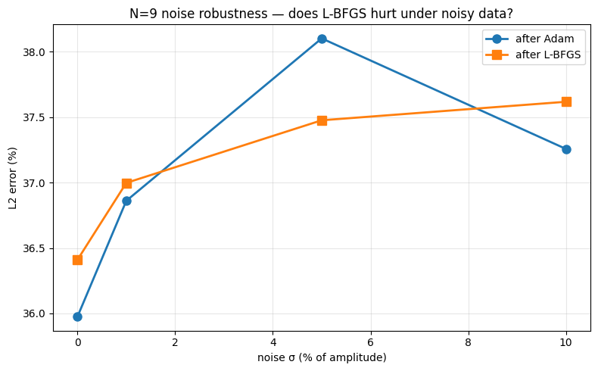
interpretation:
L-BFGS hurts at multiple noise levels — confirms single-soliton finding in multi-soliton regime
10% noise degrades L2 by factor 1.0x vs clean

ICsub@multi
=================================================================
N=3 (no IC, PDE+BC+data only, 400 data pts)
=================================================================
speeds=[3. 2. 1.]
domain=(-50.0, 17.5)
n_pde=22500 n_data=400

/usr/local/lib/python3.12/dist-packages/torch/autograd/graph.py:865: UserWarning: Attempting to run cuBLAS, but there was no current CUDA context! Attempting to set the primary context... (Triggered internally at /pytorch/aten/src/ATen/cuda/CublasHandlePool.cpp:330.)
return Variable._execution_engine.run_backward( # Calls into the C++ engine to run the backward pass

adam 0 loss=1.118e+00 pde=1.36e-02 ic=0.00e+00 bc=5.08e-01 data=5.96e-01
adam 1500 loss=6.648e-02 pde=1.76e-03 ic=0.00e+00 bc=8.01e-05 data=6.46e-02
adam 3000 loss=5.564e-02 pde=7.49e-03 ic=0.00e+00 bc=5.47e-05 data=4.81e-02
adam 4500 loss=5.272e-02 pde=8.08e-03 ic=0.00e+00 bc=6.22e-06 data=4.46e-02
adam 6000 loss=5.077e-02 pde=8.64e-03 ic=0.00e+00 bc=2.35e-06 data=4.21e-02
adam 7500 loss=4.949e-02 pde=9.22e-03 ic=0.00e+00 bc=3.68e-06 data=4.03e-02
adam 9000 loss=4.855e-02 pde=9.34e-03 ic=0.00e+00 bc=3.10e-06 data=3.92e-02
adam 10500 loss=4.779e-02 pde=9.53e-03 ic=0.00e+00 bc=8.02e-06 data=3.83e-02
adam 12000 loss=4.703e-02 pde=9.72e-03 ic=0.00e+00 bc=1.68e-05 data=3.73e-02
adam 13500 loss=4.650e-02 pde=9.86e-03 ic=0.00e+00 bc=6.51e-06 data=3.66e-02
adam 14999 loss=4.594e-02 pde=9.90e-03 ic=0.00e+00 bc=3.16e-06 data=3.60e-02
lbfgs 200 loss=4.574e-02
lbfgs 400 loss=4.548e-02
lbfgs 600 loss=4.524e-02
lbfgs 800 loss=4.506e-02
lbfgs 1000 loss=4.489e-02
lbfgs 1200 loss=4.475e-02
lbfgs 1400 loss=4.459e-02
lbfgs 1600 loss=4.443e-02
lbfgs 1800 loss=4.426e-02
lbfgs 2000 loss=4.410e-02
lbfgs 2200 loss=4.393e-02
final L2 (no IC) = 77.362%
baseline (with IC) = 0.300%
=================================================================
N=6 (no IC, PDE+BC+data only, 400 data pts)
=================================================================
speeds=[3. 2.6 2.2 1.8 1.4 1. ]
domain=(-50.0, 17.5)
n_pde=22500 n_data=400
adam 0 loss=1.363e+00 pde=1.36e-02 ic=0.00e+00 bc=5.08e-01 data=8.41e-01
adam 1500 loss=6.370e-02 pde=5.79e-03 ic=0.00e+00 bc=1.07e-05 data=5.79e-02
adam 3000 loss=6.310e-02 pde=6.03e-03 ic=0.00e+00 bc=5.17e-06 data=5.71e-02
adam 4500 loss=5.731e-02 pde=7.40e-03 ic=0.00e+00 bc=3.65e-06 data=4.99e-02
adam 6000 loss=5.577e-02 pde=7.95e-03 ic=0.00e+00 bc=5.48e-06 data=4.78e-02
adam 7500 loss=5.530e-02 pde=8.12e-03 ic=0.00e+00 bc=4.65e-05 data=4.71e-02
adam 9000 loss=5.375e-02 pde=8.51e-03 ic=0.00e+00 bc=2.42e-06 data=4.52e-02
adam 10500 loss=5.295e-02 pde=8.56e-03 ic=0.00e+00 bc=1.06e-05 data=4.44e-02
adam 12000 loss=5.210e-02 pde=9.00e-03 ic=0.00e+00 bc=1.16e-05 data=4.31e-02
adam 13500 loss=5.128e-02 pde=9.12e-03 ic=0.00e+00 bc=1.47e-05 data=4.21e-02
adam 14999 loss=5.075e-02 pde=9.99e-03 ic=0.00e+00 bc=2.32e-05 data=4.07e-02
lbfgs 200 loss=5.007e-02
lbfgs 400 loss=4.980e-02
lbfgs 600 loss=4.958e-02
lbfgs 800 loss=4.936e-02
lbfgs 1000 loss=4.912e-02
lbfgs 1200 loss=4.890e-02
lbfgs 1400 loss=4.867e-02
lbfgs 1600 loss=4.849e-02
lbfgs 1800 loss=4.830e-02
lbfgs 2000 loss=4.815e-02
lbfgs 2200 loss=4.800e-02
final L2 (no IC) = 60.416%
baseline (with IC) = 0.500%

=================================================================
N=9 (no IC, PDE+BC+data only, 400 data pts)
=================================================================
speeds=[3. 2.75 2.5 2.25 2. 1.75 1.5 1.25 1. ]
domain=(-50.0, 17.5)
n_pde=22500 n_data=400
adam 0 loss=1.670e+00 pde=1.36e-02 ic=0.00e+00 bc=5.08e-01 data=1.15e+00
adam 1500 loss=5.979e-02 pde=1.76e-02 ic=0.00e+00 bc=5.29e-06 data=4.22e-02
adam 3000 loss=5.868e-02 pde=1.77e-02 ic=0.00e+00 bc=3.19e-06 data=4.10e-02
adam 4500 loss=5.747e-02 pde=1.79e-02 ic=0.00e+00 bc=1.82e-06 data=3.95e-02
adam 6000 loss=5.608e-02 pde=1.79e-02 ic=0.00e+00 bc=1.18e-05 data=3.81e-02
adam 7500 loss=5.457e-02 pde=1.88e-02 ic=0.00e+00 bc=1.03e-04 data=3.56e-02
adam 9000 loss=5.348e-02 pde=1.82e-02 ic=0.00e+00 bc=1.53e-06 data=3.52e-02
adam 10500 loss=5.297e-02 pde=1.86e-02 ic=0.00e+00 bc=4.03e-06 data=3.43e-02
adam 12000 loss=5.247e-02 pde=1.86e-02 ic=0.00e+00 bc=5.93e-07 data=3.39e-02
adam 13500 loss=5.183e-02 pde=1.90e-02 ic=0.00e+00 bc=1.23e-05 data=3.28e-02
adam 14999 loss=5.104e-02 pde=1.86e-02 ic=0.00e+00 bc=2.66e-05 data=3.24e-02
lbfgs 200 loss=5.069e-02
lbfgs 400 loss=5.048e-02
lbfgs 600 loss=5.014e-02
lbfgs 800 loss=4.981e-02
lbfgs 1000 loss=4.952e-02
lbfgs 1200 loss=4.913e-02
lbfgs 1400 loss=4.882e-02
lbfgs 1600 loss=4.858e-02
lbfgs 1800 loss=4.832e-02
lbfgs 2000 loss=4.812e-02
final L2 (no IC) = 37.477%
baseline (with IC) = 0.500%

done
saved ic_substitution_results.csv

N | no IC | with IC | ratio | verdict
-----------------------------------------------------------------
3 | 77.362% | 0.300% | 257.87x | IC NOT substitutable — data insufficient
6 | 60.416% | 0.500% | 120.83x | IC NOT substitutable — data insufficient
9 | 37.477% | 0.500% | 74.95x | IC NOT substitutable — data insufficient
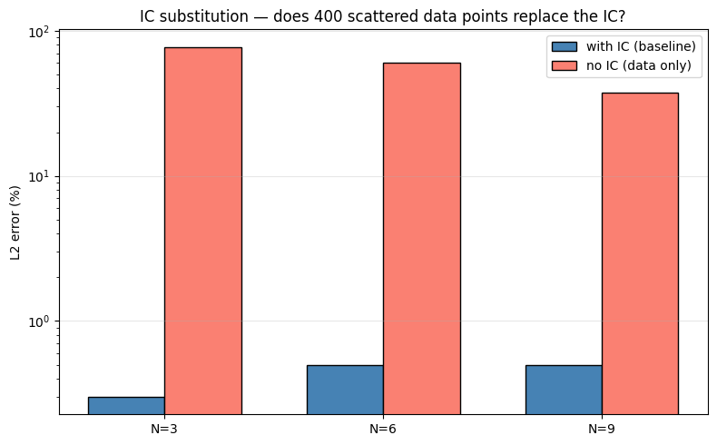interpretation:
removing IC severely degrades multi-soliton — confirms IC encodes discrete info (number of peaks, amplitudes, positions) that sparse data does not constrain

Reruns

per-soliton
============================================================
PIPELINE SANITY CHECK (N=3, short Adam, no L-BFGS)
============================================================
device = cuda
domain = (-20.0, 37.5) | n_pde=19166 | n_data=383
params = 12,951
Adam 0 | Total=3.982009e-01 PDE=1.980e-03 IC=1.918e-01 BC=7.812e-02 Data=1.263e-01
Adam 100 | Total=1.092705e-01 PDE=1.383e-03 IC=5.837e-02 BC=1.032e-03 Data=4.848e-02
Adam 200 | Total=7.957551e-02 PDE=3.694e-03 IC=3.079e-02 BC=9.330e-04 Data=4.416e-02
Adam 300 | Total=1.782456e-02 PDE=4.707e-03 IC=3.421e-03 BC=1.365e-04 Data=9.560e-03
Adam 400 | Total=3.167343e-03 PDE=1.486e-03 IC=2.782e-04 BC=1.535e-05 Data=1.388e-03
Adam 499 | Total=1.084195e-03 PDE=6.693e-04 IC=8.519e-05 BC=5.504e-06 Data=3.242e-04
>> Adam done 21.6s | L2=5.5763%
LBFGS 0 | Total=1.09952257e-03
>> LBFGS done 0.1s | L2=5.5763%
L2 after 500 Adam iters: 5.576%
>> sanity OK

N=12 domain=(-65.0, 105.0) width=170.0
speeds=[7.0, 6.5, 6.0, 5.5, 5.0, 4.5, 4.0, 3.5, 3.0, 2.5, 2.0, 1.5]
x0s =[55.0, 45.0, 35.0, 25.0, 15.0, 5.0, -5.0, -15.0, -25.0, -35.0, -45.0, -55.0]
points: PDE=56,666 Data=1,133 IC=1,416 BC=200
=================================================================
TRAIN N=12 width=50 15k Adam + 2k LBFGS
=================================================================
params = 12,951
Adam 0 | Total=1.121710e+00 PDE=1.032e-03 IC=5.102e-01 BC=1.174e-01 Data=4.931e-01
Adam 1000 | Total=6.560636e-01 PDE=3.646e-03 IC=3.001e-01 BC=7.773e-04 Data=3.516e-01
Adam 2000 | Total=5.242666e-01 PDE=2.543e-02 IC=2.270e-01 BC=3.421e-04 Data=2.715e-01
Adam 3000 | Total=3.380961e-01 PDE=2.727e-02 IC=1.438e-01 BC=8.895e-04 Data=1.661e-01
Adam 4000 | Total=2.293550e-01 PDE=2.470e-02 IC=9.325e-02 BC=1.573e-04 Data=1.113e-01
Adam 5000 | Total=1.839529e-01 PDE=2.638e-02 IC=6.712e-02 BC=1.403e-04 Data=9.031e-02
Adam 6000 | Total=1.416011e-01 PDE=2.630e-02 IC=5.072e-02 BC=5.926e-05 Data=6.452e-02
Adam 7000 | Total=1.593048e-01 PDE=3.157e-02 IC=5.969e-02 BC=3.440e-05 Data=6.801e-02
Adam 8000 | Total=1.059559e-01 PDE=2.748e-02 IC=3.094e-02 BC=1.172e-05 Data=4.752e-02
Adam 9000 | Total=8.506860e-02 PDE=2.849e-02 IC=1.841e-02 BC=1.927e-05 Data=3.815e-02
Adam 10000 | Total=7.681061e-02 PDE=2.761e-02 IC=1.618e-02 BC=1.588e-05 Data=3.300e-02
Adam 11000 | Total=5.582088e-02 PDE=2.559e-02 IC=6.003e-03 BC=7.139e-05 Data=2.416e-02
Adam 12000 | Total=6.128031e-02 PDE=2.233e-02 IC=1.084e-02 BC=2.942e-06 Data=2.811e-02
Adam 13000 | Total=6.779438e-02 PDE=2.286e-02 IC=1.324e-02 BC=2.842e-05 Data=3.167e-02
Adam 14000 | Total=5.275507e-02 PDE=2.114e-02 IC=6.712e-03 BC=7.372e-06 Data=2.490e-02
Adam 14999 | Total=8.088590e-02 PDE=2.535e-02 IC=1.916e-02 BC=6.607e-05 Data=3.631e-02
>> Adam done 1744.6s | L2=43.0907%
LBFGS 0 | Total=8.34995806e-02
LBFGS 200 | Total=3.79998758e-02
LBFGS 400 | Total=3.70220169e-02
LBFGS 600 | Total=3.63601670e-02
LBFGS 800 | Total=3.56978439e-02
LBFGS 1000 | Total=3.50422822e-02
LBFGS 1200 | Total=3.44515368e-02
LBFGS 1400 | Total=3.36880945e-02
LBFGS 1600 | Total=3.29018049e-02
LBFGS 1800 | Total=3.22572924e-02
LBFGS 2000 | Total=3.17107774e-02
>> LBFGS done 253.3s | L2=38.9951%
saved /kaggle/working/checkpoint_N12_w50_persoliton.pt

w=50 Adam L2=43.0907% Final L2=38.9951%
Reference: ~42.15% final (expected to fail)
=================================================================
TRAIN N=12 width=100 25k Adam + 2k LBFGS
=================================================================
params = 50,901
Adam 0 | Total=1.925906e+00 PDE=1.868e-03 IC=7.683e-01 BC=4.273e-01 Data=7.285e-01
Adam 1000 | Total=6.116962e-01 PDE=1.704e-02 IC=2.742e-01 BC=3.421e-04 Data=3.201e-01
Adam 2000 | Total=4.395250e-01 PDE=2.282e-02 IC=1.895e-01 BC=1.248e-04 Data=2.271e-01
Adam 3000 | Total=2.944023e-01 PDE=2.405e-02 IC=1.156e-01 BC=5.189e-04 Data=1.542e-01
Adam 4000 | Total=1.877229e-01 PDE=2.852e-02 IC=6.252e-02 BC=7.710e-06 Data=9.668e-02
Adam 5000 | Total=1.188865e-01 PDE=3.214e-02 IC=2.617e-02 BC=9.390e-06 Data=6.056e-02
Adam 6000 | Total=6.376161e-02 PDE=2.579e-02 IC=5.380e-03 BC=6.750e-06 Data=3.258e-02
Adam 7000 | Total=9.475298e-02 PDE=2.700e-02 IC=2.154e-02 BC=6.866e-05 Data=4.614e-02
Adam 8000 | Total=4.005629e-02 PDE=1.887e-02 IC=1.452e-03 BC=4.533e-06 Data=1.973e-02
Adam 9000 | Total=3.391465e-02 PDE=1.655e-02 IC=7.712e-04 BC=4.516e-06 Data=1.659e-02
Adam 10000 | Total=9.419499e-02 PDE=2.788e-02 IC=2.554e-02 BC=2.685e-04 Data=4.050e-02
Adam 11000 | Total=3.117225e-02 PDE=1.517e-02 IC=5.434e-04 BC=9.169e-06 Data=1.545e-02
Adam 12000 | Total=3.429942e-02 PDE=1.673e-02 IC=1.869e-03 BC=6.553e-05 Data=1.563e-02
Adam 13000 | Total=1.700295e-01 PDE=2.511e-02 IC=6.797e-02 BC=4.183e-05 Data=7.691e-02
Adam 14000 | Total=3.536479e-02 PDE=1.574e-02 IC=2.325e-03 BC=3.284e-06 Data=1.730e-02
Adam 15000 | Total=3.345230e-02 PDE=1.529e-02 IC=2.093e-03 BC=6.961e-06 Data=1.606e-02
Adam 16000 | Total=2.961904e-02 PDE=1.535e-02 IC=4.546e-04 BC=2.031e-05 Data=1.379e-02
Adam 17000 | Total=3.104243e-02 PDE=1.688e-02 IC=3.689e-04 BC=7.219e-05 Data=1.372e-02
Adam 18000 | Total=8.818194e-02 PDE=2.204e-02 IC=2.693e-02 BC=1.174e-05 Data=3.920e-02
Adam 19000 | Total=3.169722e-02 PDE=1.500e-02 IC=2.301e-03 BC=2.331e-05 Data=1.437e-02
Adam 20000 | Total=2.741081e-02 PDE=1.417e-02 IC=3.764e-04 BC=1.574e-06 Data=1.287e-02
Adam 21000 | Total=2.715442e-02 PDE=1.388e-02 IC=4.431e-04 BC=6.434e-06 Data=1.283e-02
Adam 22000 | Total=3.003201e-02 PDE=1.621e-02 IC=6.139e-04 BC=4.927e-05 Data=1.316e-02
Adam 23000 | Total=2.730992e-02 PDE=1.493e-02 IC=3.394e-04 BC=3.646e-05 Data=1.201e-02
Adam 24000 | Total=7.163016e-02 PDE=1.933e-02 IC=2.269e-02 BC=5.722e-06 Data=2.961e-02
Adam 24999 | Total=2.756390e-02 PDE=1.422e-02 IC=8.395e-04 BC=6.805e-06 Data=1.249e-02
>> Adam done 6045.4s | L2=38.6993%
LBFGS 0 | Total=2.80302446e-02
LBFGS 200 | Total=2.52229534e-02
LBFGS 400 | Total=2.50949748e-02
LBFGS 600 | Total=2.50155143e-02
LBFGS 800 | Total=2.49384884e-02
LBFGS 1000 | Total=2.48651858e-02
LBFGS 1200 | Total=2.47977152e-02
LBFGS 1400 | Total=2.47369893e-02
LBFGS 1600 | Total=2.46786159e-02
LBFGS 1800 | Total=2.46184487e-02
LBFGS 2000 | Total=2.45593861e-02
>> LBFGS done 513.7s | L2=38.5079%
saved /kaggle/working/checkpoint_N12_w100_persoliton.pt

w=100 Adam L2=38.6993% Final L2=38.5079%
Reference: ~0.86% final (should rescue)

[WARN] w=100 did not rescue. LBFGS may not have found a good basin.
The per-soliton comparison will show two failing models.
Consider increasing adam_iter further or re-running with a different seed.
=======================================================
config Adam L2 Final L2
-------------------------------------------------------
w=50 43.0907% 38.9951%
w=100 38.6993% 38.5079%
=======================================================
Reference: w=50 -> ~42.15%, w=100 -> ~0.86%
Computing per-soliton errors for w=50 ...
Done.
Computing per-soliton errors for w=100 ...
Done.

--- w=50 ---
soliton c x0 local_L2_pct
1 7.0000 55.0000 2.3154
2 6.5000 45.0000 86.6778
3 6.0000 35.0000 50.6370
4 5.5000 25.0000 6.9926
5 5.0000 15.0000 4.2280
6 4.5000 5.0000 1.3315
7 4.0000 -5.0000 1.3030
8 3.5000 -15.0000 1.9216
9 3.0000 -25.0000 14.1817
10 2.5000 -35.0000 6.9430
11 2.0000 -45.0000 4.5152
12 1.5000 -55.0000 5.8984

--- w=100 ---
soliton c x0 local_L2_pct
1 7.0000 55.0000 3.5381
2 6.5000 45.0000 85.0132
3 6.0000 35.0000 51.3738
4 5.5000 25.0000 2.4777
5 5.0000 15.0000 0.4043
6 4.5000 5.0000 0.2928
7 4.0000 -5.0000 0.4672
8 3.5000 -15.0000 0.3313
9 3.0000 -25.0000 0.8180
10 2.5000 -35.0000 1.4020
11 2.0000 -45.0000 1.0844
12 1.5000 -55.0000 1.2469
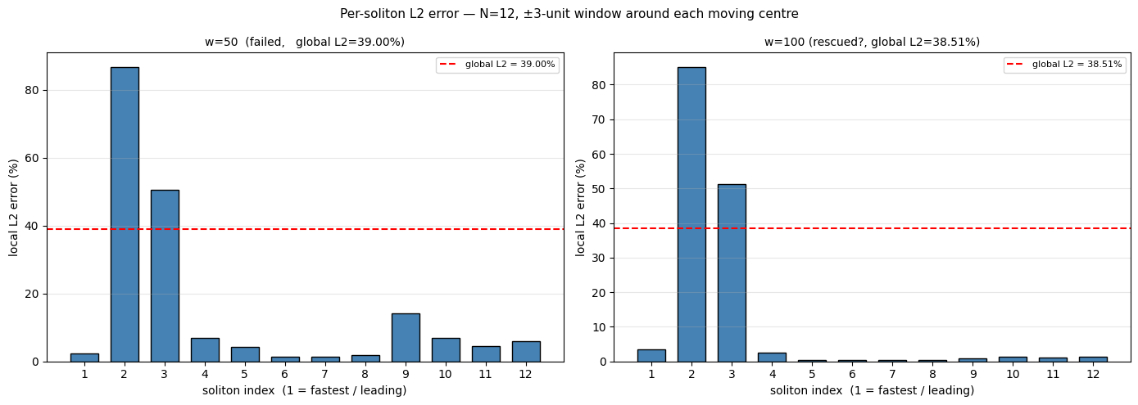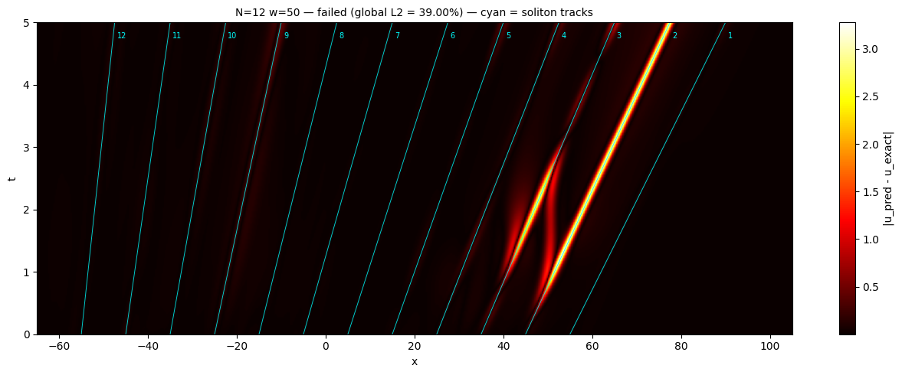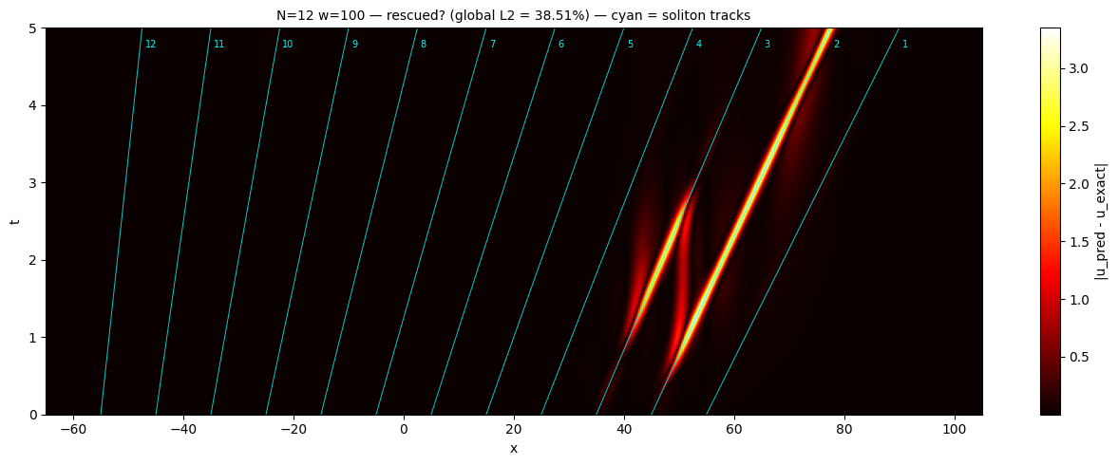w=50 (failed)
mean = 15.579% std = 25.081% CV = 1.610
worst: soliton 2 (c=6.50) 86.678%
best: soliton 7 (c=4.00) 1.303%
-> highly non-uniform -> partial basin (optimisation failure)

w=100 (rescued?)
mean = 12.371% std = 25.908% CV = 2.094
worst: soliton 2 (c=6.50) 85.013%
best: soliton 6 (c=4.50) 0.293%
-> highly non-uniform -> partial basin (optimisation failure)

saved per_soliton_summary.json

Done. All outputs in /kaggle/working

noise_rob
============================================================
PIPELINE SANITY CHECK (N=3, short Adam, no L-BFGS)
============================================================
device = cuda
domain = (-20.0, 37.5) | n_pde=19166 | n_data=383
params = 12,951
Adam 0 | Total=3.982009e-01 PDE=1.980e-03 IC=1.918e-01 BC=7.812e-02 Data=1.263e-01
Adam 100 | Total=1.092705e-01 PDE=1.383e-03 IC=5.837e-02 BC=1.032e-03 Data=4.848e-02
Adam 200 | Total=7.957551e-02 PDE=3.694e-03 IC=3.079e-02 BC=9.330e-04 Data=4.416e-02
Adam 300 | Total=1.782456e-02 PDE=4.707e-03 IC=3.421e-03 BC=1.365e-04 Data=9.560e-03
Adam 400 | Total=3.167343e-03 PDE=1.486e-03 IC=2.782e-04 BC=1.535e-05 Data=1.388e-03
Adam 499 | Total=1.084195e-03 PDE=6.693e-04 IC=8.519e-05 BC=5.504e-06 Data=3.242e-04
>> Adam done 22.4s | L2=5.5763%
LBFGS 0 | Total=1.09952257e-03
>> LBFGS done 0.1s | L2=5.5763%
L2 after 500 Adam iters: 5.576%
>> sanity OK

N=9 domain=(-50.0, 82.5) width=132.5
speeds=[5.5, 5.0, 4.5, 4.0, 3.5, 3.0, 2.5, 2.0, 1.5]
x0s =[40.0, 30.0, 20.0, 10.0, 0.0, -10.0, -20.0, -30.0, -40.0]
points: PDE=44,166 Data=883 IC=1,104 BC=200

============================================================
NOISE sigma=0% (N9_noise_sig00)
============================================================
Adam 0 | Total=8.229927e-01 PDE=1.294e-03 IC=3.686e-01 BC=1.145e-01 Data=3.386e-01
Adam 1000 | Total=3.630542e-01 PDE=4.564e-03 IC=1.727e-01 BC=1.237e-04 Data=1.857e-01
Adam 2000 | Total=2.419089e-01 PDE=1.355e-02 IC=1.125e-01 BC=5.191e-04 Data=1.153e-01
Adam 3000 | Total=1.149563e-01 PDE=2.930e-02 IC=3.610e-02 BC=4.547e-04 Data=4.911e-02
Adam 4000 | Total=4.989022e-02 PDE=1.440e-02 IC=1.303e-02 BC=4.437e-05 Data=2.242e-02
Adam 5000 | Total=3.530810e-02 PDE=1.098e-02 IC=9.230e-03 BC=7.978e-06 Data=1.509e-02
Adam 6000 | Total=1.978586e-02 PDE=6.924e-03 IC=4.424e-03 BC=7.340e-05 Data=8.365e-03
Adam 7000 | Total=1.487445e-02 PDE=5.419e-03 IC=3.165e-03 BC=1.187e-05 Data=6.279e-03
Adam 8000 | Total=1.470739e-02 PDE=5.551e-03 IC=3.145e-03 BC=4.420e-05 Data=5.967e-03
Adam 9000 | Total=1.811306e-02 PDE=6.404e-03 IC=4.084e-03 BC=1.100e-04 Data=7.515e-03
Adam 10000 | Total=1.005404e-02 PDE=3.424e-03 IC=2.060e-03 BC=8.334e-06 Data=4.561e-03
Adam 11000 | Total=4.743203e-03 PDE=2.125e-03 IC=5.739e-04 BC=4.559e-06 Data=2.040e-03
Adam 12000 | Total=4.897519e-03 PDE=2.112e-03 IC=8.457e-04 BC=2.020e-05 Data=1.920e-03
Adam 13000 | Total=4.366644e-03 PDE=2.400e-03 IC=4.553e-04 BC=2.455e-05 Data=1.487e-03
Adam 14000 | Total=4.082208e-03 PDE=2.176e-03 IC=4.793e-04 BC=6.494e-05 Data=1.362e-03
Adam 14999 | Total=8.031975e-03 PDE=1.524e-03 IC=2.519e-03 BC=1.957e-06 Data=3.987e-03
>> Adam done 1416.8s | L2=13.1085%
LBFGS 0 | Total=1.06696133e-02
LBFGS 200 | Total=9.65162937e-04
LBFGS 400 | Total=8.49500531e-04
LBFGS 600 | Total=7.22866156e-04
LBFGS 800 | Total=5.87176124e-04
LBFGS 1000 | Total=4.72744665e-04
LBFGS 1200 | Total=3.99306125e-04
LBFGS 1400 | Total=3.51490133e-04
LBFGS 1600 | Total=3.17678379e-04
LBFGS 1800 | Total=2.73426820e-04
LBFGS 2000 | Total=2.42493101e-04
>> LBFGS done 207.5s | L2=1.1574%
saved /kaggle/working/checkpoint_N9_noise_sig00.pt

============================================================
NOISE sigma=1% (N9_noise_sig01)
============================================================
Adam 0 | Total=8.574768e-01 PDE=1.294e-03 IC=4.017e-01 BC=1.139e-01 Data=3.406e-01
Adam 1000 | Total=3.898656e-01 PDE=3.891e-03 IC=1.957e-01 BC=2.245e-04 Data=1.900e-01
Adam 2000 | Total=2.175492e-01 PDE=1.379e-02 IC=9.569e-02 BC=2.241e-04 Data=1.079e-01
Adam 3000 | Total=1.144223e-01 PDE=1.009e-02 IC=4.910e-02 BC=1.692e-04 Data=5.507e-02
Adam 4000 | Total=3.524127e-02 PDE=6.302e-03 IC=1.008e-02 BC=8.230e-05 Data=1.878e-02
Adam 5000 | Total=1.051225e-02 PDE=4.109e-03 IC=1.787e-03 BC=1.122e-04 Data=4.504e-03
Adam 6000 | Total=4.383930e-03 PDE=1.585e-03 IC=4.692e-04 BC=5.962e-06 Data=2.324e-03
Adam 7000 | Total=5.383227e-03 PDE=2.240e-03 IC=6.386e-04 BC=4.432e-05 Data=2.460e-03
Adam 8000 | Total=2.445726e-02 PDE=9.301e-03 IC=5.901e-03 BC=2.090e-04 Data=9.046e-03
Adam 9000 | Total=5.578013e-03 PDE=2.170e-03 IC=8.282e-04 BC=5.530e-05 Data=2.524e-03
Adam 10000 | Total=1.894533e-03 PDE=6.976e-04 IC=7.146e-05 BC=8.384e-06 Data=1.117e-03
Adam 11000 | Total=2.216604e-03 PDE=1.062e-03 IC=1.023e-04 BC=9.310e-06 Data=1.043e-03
Adam 12000 | Total=2.135666e-02 PDE=4.288e-03 IC=5.881e-03 BC=9.485e-05 Data=1.109e-02
Adam 13000 | Total=4.853619e-03 PDE=1.090e-03 IC=8.868e-04 BC=6.504e-05 Data=2.812e-03
Adam 14000 | Total=5.532056e-03 PDE=7.182e-04 IC=1.402e-03 BC=1.086e-05 Data=3.401e-03
Adam 14999 | Total=2.969821e-03 PDE=3.305e-04 IC=8.276e-04 BC=6.112e-06 Data=1.806e-03
>> Adam done 1419.8s | L2=6.0932%
LBFGS 0 | Total=2.90083792e-03
LBFGS 200 | Total=1.04413123e-03
LBFGS 400 | Total=1.01041328e-03
LBFGS 600 | Total=9.88655840e-04
LBFGS 800 | Total=9.57668817e-04
LBFGS 1000 | Total=9.24165826e-04
LBFGS 1200 | Total=8.88456940e-04
LBFGS 1400 | Total=8.65204143e-04
LBFGS 1600 | Total=8.49512930e-04
LBFGS 1800 | Total=8.35903280e-04
LBFGS 2000 | Total=8.22026632e-04
>> LBFGS done 207.2s | L2=1.2942%
saved /kaggle/working/checkpoint_N9_noise_sig01.pt

============================================================
NOISE sigma=5% (N9_noise_sig05)
============================================================
Adam 0 | Total=8.803676e-01 PDE=1.294e-03 IC=4.017e-01 BC=1.139e-01 Data=3.635e-01
Adam 1000 | Total=4.102899e-01 PDE=4.273e-03 IC=1.955e-01 BC=6.405e-05 Data=2.105e-01
Adam 2000 | Total=2.476735e-01 PDE=1.971e-02 IC=9.364e-02 BC=1.643e-03 Data=1.327e-01
Adam 3000 | Total=5.279260e-02 PDE=1.277e-02 IC=6.408e-03 BC=5.398e-04 Data=3.308e-02
Adam 4000 | Total=3.022293e-02 PDE=4.268e-03 IC=2.080e-03 BC=6.283e-05 Data=2.381e-02
Adam 5000 | Total=3.718627e-02 PDE=4.841e-03 IC=6.204e-03 BC=1.101e-04 Data=2.603e-02
Adam 6000 | Total=4.071433e-02 PDE=7.191e-03 IC=5.536e-03 BC=1.949e-04 Data=2.779e-02
Adam 7000 | Total=3.189108e-02 PDE=2.521e-03 IC=4.031e-03 BC=1.804e-05 Data=2.532e-02
Adam 8000 | Total=3.036512e-02 PDE=3.123e-03 IC=3.260e-03 BC=3.936e-05 Data=2.394e-02
Adam 9000 | Total=2.065131e-02 PDE=2.369e-03 IC=2.996e-04 BC=1.696e-04 Data=1.781e-02
Adam 10000 | Total=1.856522e-02 PDE=7.877e-04 IC=1.294e-04 BC=5.122e-06 Data=1.764e-02
Adam 11000 | Total=2.303051e-02 PDE=1.156e-03 IC=1.873e-03 BC=6.875e-06 Data=1.999e-02
Adam 12000 | Total=3.451559e-02 PDE=3.212e-03 IC=5.732e-03 BC=5.968e-05 Data=2.551e-02
Adam 13000 | Total=2.917529e-02 PDE=1.301e-03 IC=3.639e-03 BC=7.371e-05 Data=2.416e-02
Adam 14000 | Total=2.885233e-02 PDE=3.283e-03 IC=2.966e-03 BC=1.351e-04 Data=2.247e-02
Adam 14999 | Total=2.793784e-02 PDE=3.300e-03 IC=3.221e-03 BC=1.950e-04 Data=2.122e-02
>> Adam done 1417.9s | L2=10.8777%
LBFGS 0 | Total=2.37705670e-02
LBFGS 200 | Total=1.77742094e-02
LBFGS 400 | Total=1.77518949e-02
LBFGS 600 | Total=1.77266598e-02
LBFGS 800 | Total=1.76949054e-02
LBFGS 1000 | Total=1.76693276e-02
LBFGS 1200 | Total=1.76345240e-02
LBFGS 1400 | Total=1.76072344e-02
LBFGS 1600 | Total=1.75830182e-02
LBFGS 1800 | Total=1.75635759e-02
LBFGS 2000 | Total=1.75463073e-02
>> LBFGS done 206.8s | L2=5.0710%
saved /kaggle/working/checkpoint_N9_noise_sig05.pt

============================================================
NOISE sigma=10% (N9_noise_sig10)
============================================================
Adam 0 | Total=9.424068e-01 PDE=1.294e-03 IC=4.017e-01 BC=1.139e-01 Data=4.255e-01
Adam 1000 | Total=4.689074e-01 PDE=4.493e-03 IC=1.953e-01 BC=9.559e-05 Data=2.690e-01
Adam 2000 | Total=3.347018e-01 PDE=1.182e-02 IC=1.242e-01 BC=2.343e-04 Data=1.984e-01
Adam 3000 | Total=1.543093e-01 PDE=1.567e-02 IC=2.898e-02 BC=1.897e-04 Data=1.095e-01
Adam 4000 | Total=8.881434e-02 PDE=8.620e-03 IC=3.206e-03 BC=4.224e-05 Data=7.695e-02
Adam 5000 | Total=8.236169e-02 PDE=4.956e-03 IC=2.788e-03 BC=1.757e-05 Data=7.460e-02
Adam 6000 | Total=9.020804e-02 PDE=6.853e-03 IC=5.000e-03 BC=1.437e-04 Data=7.821e-02
Adam 7000 | Total=8.024257e-02 PDE=8.499e-03 IC=1.004e-03 BC=5.252e-04 Data=7.022e-02
Adam 8000 | Total=8.158573e-02 PDE=3.117e-03 IC=4.311e-03 BC=5.750e-05 Data=7.410e-02
Adam 9000 | Total=7.480530e-02 PDE=4.268e-03 IC=7.571e-04 BC=1.798e-04 Data=6.960e-02
Adam 10000 | Total=8.785928e-02 PDE=3.695e-03 IC=6.534e-03 BC=6.139e-05 Data=7.757e-02
Adam 11000 | Total=7.279669e-02 PDE=2.270e-03 IC=1.226e-03 BC=5.518e-05 Data=6.925e-02
Adam 12000 | Total=7.119800e-02 PDE=1.848e-03 IC=5.336e-04 BC=5.601e-05 Data=6.876e-02
Adam 13000 | Total=8.143649e-02 PDE=2.211e-03 IC=4.337e-03 BC=3.600e-05 Data=7.485e-02
Adam 14000 | Total=7.540888e-02 PDE=5.601e-03 IC=7.963e-04 BC=3.654e-04 Data=6.865e-02
Adam 14999 | Total=7.078061e-02 PDE=1.774e-03 IC=4.377e-04 BC=2.165e-05 Data=6.855e-02
>> Adam done 1419.1s | L2=10.5725%
LBFGS 0 | Total=6.97723627e-02
LBFGS 200 | Total=6.95160702e-02
>> LBFGS done 33.5s | L2=10.2354%
saved /kaggle/working/checkpoint_N9_noise_sig10.pt

--- Results ---
sigma_pct L2_adam L2_final adam_time lbfgs_time lbfgs_helped
0 13.1085 1.1574 1416.7593 207.5235 True
1 6.0932 1.2942 1419.7909 207.1525 True
5 10.8777 5.0710 1417.8613 206.8251 True
10 10.5725 10.2354 1419.0854 33.5070 True
sigma=0% Final L2 = 1.1574%
Reference: ~0.9754%
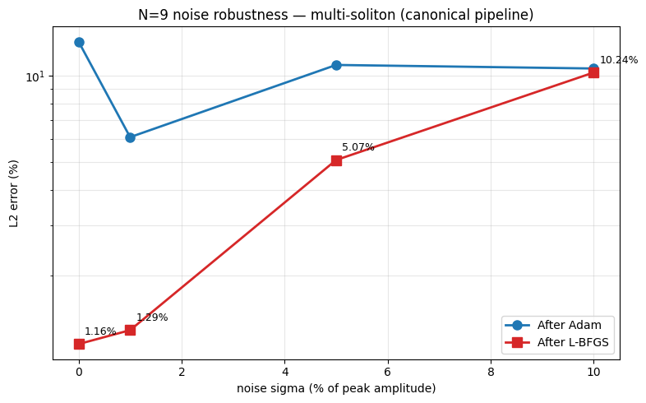
[OK] Reproduces baseline -> pipeline healthy, noise results trustworthy.
sigma_pct L2_final single_sol_PINN_pct degradation_factor
0 1.1574 0.0700 1.0000
1 1.2942 0.8300 1.1182
5 5.0710 5.5100 4.3815
10 10.2354 12.2000 8.8436

ic_sub
============================================================
PIPELINE SANITY CHECK (N=3, short Adam, no L-BFGS)
============================================================
device = cuda
domain = (-20.0, 37.5) | n_pde=19166 | n_data=383
params = 12,951
Adam 0 | Total=3.982009e-01 PDE=1.980e-03 IC=1.918e-01 BC=7.812e-02 Data=1.263e-01
Adam 100 | Total=1.092705e-01 PDE=1.383e-03 IC=5.837e-02 BC=1.032e-03 Data=4.848e-02
Adam 200 | Total=7.957551e-02 PDE=3.694e-03 IC=3.079e-02 BC=9.330e-04 Data=4.416e-02
Adam 300 | Total=1.782456e-02 PDE=4.707e-03 IC=3.421e-03 BC=1.365e-04 Data=9.560e-03
Adam 400 | Total=3.167343e-03 PDE=1.486e-03 IC=2.782e-04 BC=1.535e-05 Data=1.388e-03
Adam 499 | Total=1.084195e-03 PDE=6.693e-04 IC=8.519e-05 BC=5.504e-06 Data=3.242e-04
>> Adam done 21.4s | L2=5.5763%
LBFGS 0 | Total=1.09952257e-03
>> LBFGS done 0.1s | L2=5.5763%
L2 after 500 Adam iters: 5.576%
>> sanity OK

label N n_data use_ic
N3_noIC_n400 3 400 False
N6_noIC_n400 6 400 False
N9_noIC_n400 9 400 False
N3_noIC_n1000 3 1,000 False
N3_noIC_n2000 3 2,000 False

With-IC baselines (from scaling notebook): {3: 0.158, 6: 0.4935, 9: 0.9754}
============================================================
N3_noIC_n400 | N=3 n_data=400 use_ic=False
============================================================
Adam 0 | Total=2.063874e-01 PDE=1.980e-03 IC=0.000e+00 BC=7.648e-02 Data=1.279e-01
Adam 1000 | Total=7.465074e-04 PDE=5.620e-04 IC=0.000e+00 BC=9.789e-06 Data=1.747e-04
Adam 2000 | Total=3.272775e-05 PDE=2.035e-05 IC=0.000e+00 BC=2.382e-06 Data=9.994e-06
Adam 3000 | Total=3.964804e-05 PDE=3.233e-05 IC=0.000e+00 BC=2.050e-06 Data=5.267e-06
Adam 4000 | Total=6.452367e-05 PDE=5.029e-05 IC=0.000e+00 BC=6.435e-07 Data=1.359e-05
Adam 5000 | Total=6.504351e-05 PDE=5.553e-05 IC=0.000e+00 BC=2.180e-06 Data=7.333e-06
Adam 6000 | Total=5.489546e-05 PDE=1.598e-05 IC=0.000e+00 BC=3.854e-06 Data=3.506e-05
Adam 7000 | Total=1.985710e-05 PDE=4.415e-06 IC=0.000e+00 BC=2.424e-06 Data=1.302e-05
Adam 8000 | Total=7.868920e-06 PDE=6.283e-06 IC=0.000e+00 BC=2.775e-07 Data=1.308e-06
Adam 9000 | Total=1.317078e-05 PDE=5.207e-06 IC=0.000e+00 BC=1.093e-06 Data=6.870e-06
Adam 10000 | Total=2.260896e-04 PDE=3.031e-05 IC=0.000e+00 BC=2.883e-05 Data=1.670e-04
Adam 11000 | Total=1.984147e-04 PDE=1.747e-04 IC=0.000e+00 BC=2.889e-06 Data=2.087e-05
Adam 12000 | Total=1.921818e-05 PDE=1.720e-05 IC=0.000e+00 BC=1.131e-07 Data=1.904e-06
Adam 13000 | Total=5.242286e-05 PDE=9.532e-06 IC=0.000e+00 BC=1.133e-06 Data=4.176e-05
Adam 14000 | Total=9.776608e-06 PDE=2.323e-06 IC=0.000e+00 BC=9.635e-07 Data=6.491e-06
Adam 14999 | Total=1.742772e-05 PDE=3.971e-06 IC=0.000e+00 BC=3.574e-06 Data=9.883e-06
>> Adam done 619.9s | L2=1.1809%
LBFGS 0 | Total=2.61913628e-05
LBFGS 200 | Total=1.07541484e-06
LBFGS 400 | Total=7.92060803e-07
LBFGS 600 | Total=5.82307621e-07
LBFGS 800 | Total=4.48681277e-07
LBFGS 1000 | Total=3.50411000e-07
>> LBFGS done 49.5s | L2=0.0634%
============================================================
N6_noIC_n400 | N=6 n_data=400 use_ic=False
============================================================
Adam 0 | Total=3.465163e-01 PDE=1.676e-03 IC=0.000e+00 BC=9.948e-02 Data=2.454e-01
Adam 1000 | Total=1.257638e-01 PDE=1.185e-02 IC=0.000e+00 BC=1.197e-02 Data=1.019e-01
Adam 2000 | Total=1.965570e-02 PDE=5.182e-03 IC=0.000e+00 BC=8.937e-06 Data=1.446e-02
Adam 3000 | Total=3.096531e-04 PDE=2.535e-04 IC=0.000e+00 BC=1.241e-06 Data=5.493e-05
Adam 4000 | Total=1.538698e-04 PDE=1.290e-04 IC=0.000e+00 BC=4.173e-07 Data=2.446e-05
Adam 5000 | Total=9.568166e-05 PDE=8.075e-05 IC=0.000e+00 BC=2.641e-07 Data=1.466e-05
Adam 6000 | Total=7.070331e-05 PDE=5.902e-05 IC=0.000e+00 BC=2.144e-07 Data=1.147e-05
Adam 7000 | Total=6.406683e-04 PDE=3.658e-04 IC=0.000e+00 BC=4.985e-07 Data=2.744e-04
Adam 8000 | Total=5.433226e-05 PDE=4.234e-05 IC=0.000e+00 BC=4.620e-07 Data=1.153e-05
Adam 9000 | Total=1.994758e-03 PDE=5.986e-04 IC=0.000e+00 BC=1.152e-06 Data=1.395e-03
Adam 10000 | Total=6.298353e-05 PDE=4.034e-05 IC=0.000e+00 BC=1.483e-07 Data=2.249e-05
Adam 11000 | Total=4.161514e-05 PDE=3.472e-05 IC=0.000e+00 BC=1.159e-06 Data=5.735e-06
Adam 12000 | Total=1.001936e-03 PDE=8.861e-04 IC=0.000e+00 BC=3.508e-06 Data=1.123e-04
Adam 13000 | Total=4.179855e-04 PDE=3.573e-04 IC=0.000e+00 BC=1.464e-05 Data=4.604e-05
Adam 14000 | Total=2.492916e-05 PDE=2.070e-05 IC=0.000e+00 BC=7.081e-08 Data=4.155e-06
Adam 14999 | Total=1.776489e-05 PDE=1.566e-05 IC=0.000e+00 BC=5.601e-08 Data=2.049e-06
>> Adam done 1001.9s | L2=0.4379%
LBFGS 0 | Total=1.79261624e-05
LBFGS 200 | Total=1.51404729e-05
LBFGS 400 | Total=1.31724055e-05
LBFGS 600 | Total=1.12435891e-05
LBFGS 800 | Total=9.64382889e-06
LBFGS 1000 | Total=8.15910153e-06
LBFGS 1200 | Total=6.96707230e-06
LBFGS 1400 | Total=5.75652939e-06
LBFGS 1600 | Total=4.96438224e-06
LBFGS 1800 | Total=4.34626327e-06
LBFGS 2000 | Total=3.83174893e-06
>> LBFGS done 149.6s | L2=0.2094%
saved /kaggle/working/checkpoint_N6_noIC_n400.pt

============================================================
N9_noIC_n400 | N=9 n_data=400 use_ic=False
============================================================
Adam 0 | Total=4.207025e-01 PDE=1.294e-03 IC=0.000e+00 BC=1.152e-01 Data=3.042e-01
Adam 1000 | Total=1.387610e-01 PDE=9.200e-03 IC=0.000e+00 BC=2.138e-04 Data=1.293e-01
Adam 2000 | Total=9.193729e-02 PDE=5.398e-03 IC=0.000e+00 BC=7.988e-05 Data=8.646e-02
Adam 3000 | Total=7.477286e-02 PDE=5.110e-03 IC=0.000e+00 BC=2.336e-04 Data=6.943e-02
Adam 4000 | Total=6.679761e-02 PDE=5.028e-03 IC=0.000e+00 BC=1.087e-04 Data=6.166e-02
Adam 5000 | Total=6.426661e-02 PDE=6.853e-03 IC=0.000e+00 BC=8.841e-05 Data=5.733e-02
Adam 6000 | Total=5.939436e-02 PDE=7.375e-03 IC=0.000e+00 BC=3.563e-05 Data=5.198e-02
Adam 7000 | Total=5.894727e-02 PDE=8.842e-03 IC=0.000e+00 BC=7.267e-05 Data=5.003e-02
Adam 8000 | Total=5.291451e-02 PDE=7.454e-03 IC=0.000e+00 BC=7.714e-05 Data=4.538e-02
Adam 9000 | Total=4.693499e-02 PDE=8.581e-03 IC=0.000e+00 BC=2.451e-04 Data=3.811e-02
Adam 10000 | Total=4.175335e-02 PDE=9.853e-03 IC=0.000e+00 BC=4.155e-05 Data=3.186e-02
Adam 11000 | Total=4.257547e-02 PDE=1.238e-02 IC=0.000e+00 BC=2.074e-05 Data=3.017e-02
Adam 12000 | Total=3.260627e-02 PDE=1.054e-02 IC=0.000e+00 BC=4.017e-05 Data=2.203e-02
Adam 13000 | Total=2.875458e-02 PDE=1.087e-02 IC=0.000e+00 BC=4.944e-05 Data=1.783e-02
Adam 14000 | Total=1.865233e-02 PDE=7.954e-03 IC=0.000e+00 BC=1.382e-05 Data=1.068e-02
Adam 14999 | Total=1.692903e-02 PDE=7.297e-03 IC=0.000e+00 BC=1.323e-05 Data=9.618e-03
>> Adam done 1357.4s | L2=46.8651%
LBFGS 0 | Total=2.03510579e-02
LBFGS 200 | Total=1.00962576e-02
LBFGS 400 | Total=9.36957821e-03
LBFGS 600 | Total=8.87601450e-03
LBFGS 800 | Total=8.52269400e-03
LBFGS 1000 | Total=8.17891583e-03
LBFGS 1200 | Total=7.88249727e-03
LBFGS 1400 | Total=7.62430206e-03
LBFGS 1600 | Total=7.45831896e-03
LBFGS 1800 | Total=7.32912123e-03
LBFGS 2000 | Total=7.21933879e-03
>> LBFGS done 199.5s | L2=46.0091%
saved /kaggle/working/checkpoint_N9_noIC_n400.pt

============================================================
N3_noIC_n1000 | N=3 n_data=1000 use_ic=False
============================================================
Adam 0 | Total=2.138819e-01 PDE=1.980e-03 IC=0.000e+00 BC=7.791e-02 Data=1.340e-01
Adam 1000 | Total=4.653874e-04 PDE=2.824e-04 IC=0.000e+00 BC=6.309e-05 Data=1.199e-04
Adam 2000 | Total=9.699396e-05 PDE=7.917e-05 IC=0.000e+00 BC=1.800e-06 Data=1.602e-05
Adam 3000 | Total=1.268411e-05 PDE=1.108e-05 IC=0.000e+00 BC=7.726e-08 Data=1.526e-06
Adam 4000 | Total=8.366299e-04 PDE=6.883e-04 IC=0.000e+00 BC=3.777e-05 Data=1.106e-04
Adam 5000 | Total=2.721359e-05 PDE=1.070e-05 IC=0.000e+00 BC=1.638e-06 Data=1.488e-05
Adam 6000 | Total=3.375899e-05 PDE=5.977e-06 IC=0.000e+00 BC=3.386e-06 Data=2.440e-05
Adam 7000 | Total=7.997421e-05 PDE=2.551e-05 IC=0.000e+00 BC=5.987e-06 Data=4.848e-05
Adam 8000 | Total=2.415925e-05 PDE=1.642e-05 IC=0.000e+00 BC=2.426e-07 Data=7.495e-06
Adam 9000 | Total=8.315189e-06 PDE=5.734e-06 IC=0.000e+00 BC=5.830e-07 Data=1.998e-06
Adam 10000 | Total=3.340389e-05 PDE=4.656e-06 IC=0.000e+00 BC=2.987e-06 Data=2.576e-05
Adam 11000 | Total=3.568763e-04 PDE=3.749e-05 IC=0.000e+00 BC=3.199e-05 Data=2.874e-04
Adam 12000 | Total=8.005471e-06 PDE=2.668e-06 IC=0.000e+00 BC=7.660e-07 Data=4.572e-06
Adam 13000 | Total=9.437099e-05 PDE=1.084e-05 IC=0.000e+00 BC=6.849e-06 Data=7.668e-05
Adam 14000 | Total=7.150772e-05 PDE=2.440e-05 IC=0.000e+00 BC=9.887e-06 Data=3.722e-05
Adam 14999 | Total=5.932607e-06 PDE=2.716e-06 IC=0.000e+00 BC=1.643e-07 Data=3.052e-06
>> Adam done 621.2s | L2=0.6564%
LBFGS 0 | Total=6.98112035e-06
LBFGS 200 | Total=9.95899882e-07
LBFGS 400 | Total=7.30409965e-07
LBFGS 600 | Total=5.53594475e-07
LBFGS 800 | Total=4.26204821e-07
LBFGS 1000 | Total=3.64850280e-07
LBFGS 1200 | Total=3.43785473e-07
>> LBFGS done 56.9s | L2=0.0615%
saved /kaggle/working/checkpoint_N3_noIC_n1000.pt

============================================================
N3_noIC_n2000 | N=3 n_data=2000 use_ic=False
============================================================
Adam 0 | Total=2.161638e-01 PDE=1.980e-03 IC=0.000e+00 BC=7.941e-02 Data=1.348e-01
Adam 1000 | Total=1.459464e-04 PDE=8.760e-05 IC=0.000e+00 BC=1.531e-05 Data=4.304e-05
Adam 2000 | Total=8.025525e-05 PDE=6.501e-05 IC=0.000e+00 BC=3.168e-06 Data=1.208e-05
Adam 3000 | Total=9.077801e-05 PDE=4.405e-05 IC=0.000e+00 BC=3.603e-06 Data=4.313e-05
Adam 4000 | Total=3.559513e-05 PDE=2.502e-05 IC=0.000e+00 BC=3.430e-07 Data=1.024e-05
Adam 5000 | Total=3.792008e-04 PDE=1.059e-04 IC=0.000e+00 BC=5.202e-05 Data=2.212e-04
Adam 6000 | Total=1.101509e-04 PDE=9.156e-05 IC=0.000e+00 BC=1.696e-06 Data=1.689e-05
Adam 7000 | Total=1.031914e-04 PDE=1.850e-05 IC=0.000e+00 BC=2.566e-05 Data=5.903e-05
Adam 8000 | Total=1.048196e-04 PDE=7.228e-05 IC=0.000e+00 BC=1.571e-06 Data=3.096e-05
Adam 9000 | Total=3.510652e-05 PDE=2.460e-05 IC=0.000e+00 BC=9.891e-07 Data=9.519e-06
Adam 10000 | Total=3.680749e-05 PDE=2.709e-05 IC=0.000e+00 BC=2.179e-06 Data=7.537e-06
Adam 11000 | Total=2.351330e-06 PDE=1.928e-06 IC=0.000e+00 BC=3.389e-08 Data=3.892e-07
Adam 12000 | Total=6.331463e-06 PDE=4.276e-06 IC=0.000e+00 BC=5.043e-07 Data=1.551e-06
Adam 13000 | Total=4.436696e-05 PDE=4.963e-06 IC=0.000e+00 BC=2.901e-07 Data=3.911e-05
Adam 14000 | Total=3.287230e-05 PDE=1.712e-05 IC=0.000e+00 BC=9.047e-07 Data=1.485e-05
Adam 14999 | Total=6.258490e-06 PDE=2.390e-06 IC=0.000e+00 BC=5.288e-07 Data=3.340e-06
>> Adam done 622.1s | L2=0.5381%
LBFGS 0 | Total=4.92281197e-06
LBFGS 200 | Total=9.47982642e-07
LBFGS 400 | Total=7.01644240e-07
LBFGS 600 | Total=5.39463826e-07
LBFGS 800 | Total=4.00881248e-07
LBFGS 1000 | Total=3.32656100e-07
>> LBFGS done 50.4s | L2=0.0590%
saved /kaggle/working/checkpoint_N3_noIC_n2000.pt

--- Results ---
label N n_data use_ic L2_adam L2_final time_min baseline_with_IC ratio
N3_noIC_n400 3 400 False 1.1809 0.0634 11.1561 0.1580 0.4010
N6_noIC_n400 6 400 False 0.4379 0.2094 19.1917 0.4935 0.4243
N9_noIC_n400 9 400 False 46.8651 46.0091 25.9493 0.9754 47.1695
N3_noIC_n1000 3 1000 False 0.6564 0.0615 11.3014 0.1580 0.3892
N3_noIC_n2000 3 2000 False 0.5381 0.0590 11.2076 0.1580 0.3734
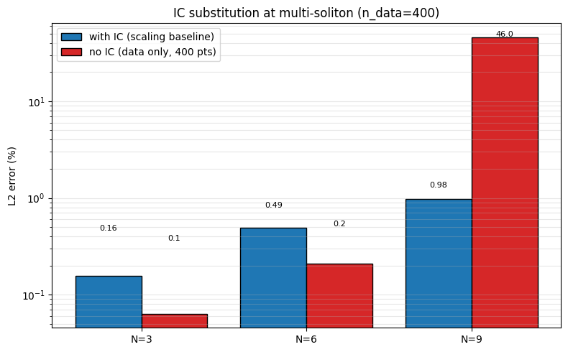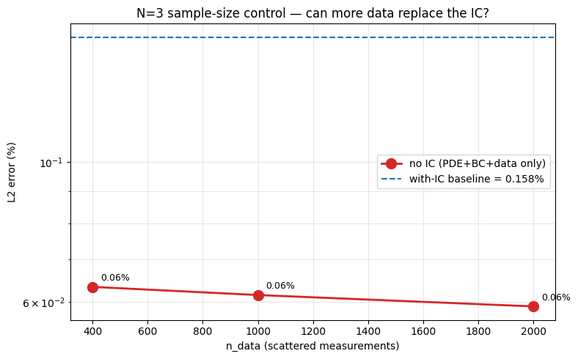============================================================
VERDICT
============================================================
N=3 n_data= 400 no-IC L2 = 0.06%
N=3 n_data=1,000 no-IC L2 = 0.06%
N=3 n_data=2,000 no-IC L2 = 0.06%

-> n_data=2000 RESCUES N=3 no-IC.
Conclusion: data-limited, not truly IC-limited.

Done. Outputs in /kaggle/working

width threshold
============================================================
PIPELINE SANITY CHECK (N=3, short Adam, no L-BFGS)
============================================================
device = cuda
domain = (-20.0, 37.5) | n_pde=19166 | n_data=383
params = 12,951
Adam 0 | Total=3.982009e-01 PDE=1.980e-03 IC=1.918e-01 BC=7.812e-02 Data=1.263e-01
Adam 100 | Total=1.092705e-01 PDE=1.383e-03 IC=5.837e-02 BC=1.032e-03 Data=4.848e-02
Adam 200 | Total=7.957551e-02 PDE=3.694e-03 IC=3.079e-02 BC=9.330e-04 Data=4.416e-02
Adam 300 | Total=1.782456e-02 PDE=4.707e-03 IC=3.421e-03 BC=1.365e-04 Data=9.560e-03
Adam 400 | Total=3.167343e-03 PDE=1.486e-03 IC=2.782e-04 BC=1.535e-05 Data=1.388e-03
Adam 499 | Total=1.084195e-03 PDE=6.693e-04 IC=8.519e-05 BC=5.504e-06 Data=3.242e-04
>> Adam done 21.6s | L2=5.5763%
LBFGS 0 | Total=1.09952257e-03
>> LBFGS done 0.1s | L2=5.5763%
L2 after 500 Adam iters: 5.576%
>> sanity OK
N=12 domain=(-65.0, 105.0) width=170.0
speeds=[7.0, 6.5, 6.0, 5.5, 5.0, 4.5, 4.0, 3.5, 3.0, 2.5, 2.0, 1.5]
x0s =[55.0, 45.0, 35.0, 25.0, 15.0, 5.0, -5.0, -15.0, -25.0, -35.0, -45.0, -55.0]
points: PDE=56,666 Data=1,133 IC=1,416 BC=200

============================================================
N=12, WIDTH=80
============================================================
params = 32,721
Adam 0 | Total=1.663048e+00 PDE=1.185e-03 IC=6.563e-01 BC=3.424e-01 Data=6.631e-01
Adam 1000 | Total=5.334454e-01 PDE=3.232e-02 IC=2.249e-01 BC=2.450e-04 Data=2.760e-01
Adam 2000 | Total=3.099090e-01 PDE=2.762e-02 IC=1.287e-01 BC=4.139e-05 Data=1.536e-01
Adam 3000 | Total=2.285627e-01 PDE=3.381e-02 IC=8.380e-02 BC=2.732e-04 Data=1.107e-01
Adam 4000 | Total=1.490843e-01 PDE=3.017e-02 IC=4.902e-02 BC=3.047e-05 Data=6.986e-02
Adam 5000 | Total=1.151668e-01 PDE=3.256e-02 IC=3.218e-02 BC=4.830e-05 Data=5.038e-02
Adam 6000 | Total=7.746610e-02 PDE=3.051e-02 IC=1.249e-02 BC=8.609e-06 Data=3.446e-02
Adam 7000 | Total=4.840183e-02 PDE=2.313e-02 IC=2.981e-03 BC=2.557e-05 Data=2.227e-02
Adam 8000 | Total=4.527324e-02 PDE=2.389e-02 IC=1.741e-03 BC=2.913e-05 Data=1.962e-02
Adam 9000 | Total=6.196141e-02 PDE=4.157e-02 IC=1.815e-03 BC=2.478e-04 Data=1.833e-02
Adam 10000 | Total=3.272651e-02 PDE=1.601e-02 IC=4.633e-04 BC=2.073e-06 Data=1.625e-02
Adam 11000 | Total=4.252649e-02 PDE=2.110e-02 IC=2.132e-03 BC=8.366e-05 Data=1.921e-02
Adam 12000 | Total=3.058428e-02 PDE=1.493e-02 IC=3.556e-04 BC=2.082e-06 Data=1.529e-02
Adam 13000 | Total=5.183858e-02 PDE=3.035e-02 IC=2.916e-03 BC=3.047e-04 Data=1.827e-02
Adam 14000 | Total=3.301460e-02 PDE=1.442e-02 IC=2.309e-03 BC=5.390e-06 Data=1.628e-02
Adam 14999 | Total=2.936067e-02 PDE=1.429e-02 IC=2.741e-04 BC=1.983e-06 Data=1.479e-02
>> Adam done 2874.6s | L2=39.1794%
LBFGS 0 | Total=2.96541676e-02
LBFGS 200 | Total=2.85012163e-02
LBFGS 400 | Total=2.83681415e-02
LBFGS 600 | Total=2.82222666e-02
LBFGS 800 | Total=2.80839074e-02
LBFGS 1000 | Total=2.79424675e-02
LBFGS 1200 | Total=2.78367456e-02
LBFGS 1400 | Total=2.77319215e-02
LBFGS 1600 | Total=2.76446939e-02
LBFGS 1800 | Total=2.75822543e-02
LBFGS 2000 | Total=2.75132209e-02
>> LBFGS done 410.1s | L2=39.1150%
saved /kaggle/working/checkpoint_N12_w80.pt

============================================================
N=12, WIDTH=85
============================================================
params = 36,891
Adam 0 | Total=1.331949e+00 PDE=2.793e-03 IC=6.054e-01 BC=8.031e-02 Data=6.434e-01
Adam 1000 | Total=6.147819e-01 PDE=1.928e-02 IC=2.762e-01 BC=6.613e-04 Data=3.186e-01
Adam 2000 | Total=3.768749e-01 PDE=2.555e-02 IC=1.564e-01 BC=2.223e-05 Data=1.949e-01
Adam 3000 | Total=2.364127e-01 PDE=3.115e-02 IC=9.152e-02 BC=7.317e-05 Data=1.137e-01
Adam 4000 | Total=1.744851e-01 PDE=2.731e-02 IC=6.570e-02 BC=4.316e-05 Data=8.143e-02
Adam 5000 | Total=1.885163e-01 PDE=4.028e-02 IC=6.184e-02 BC=4.662e-04 Data=8.593e-02
Adam 6000 | Total=1.947349e-01 PDE=7.895e-02 IC=3.394e-02 BC=3.545e-03 Data=7.830e-02
Adam 7000 | Total=6.815606e-02 PDE=2.725e-02 IC=8.300e-03 BC=3.611e-05 Data=3.257e-02
Adam 8000 | Total=5.076507e-02 PDE=2.291e-02 IC=3.108e-03 BC=8.399e-05 Data=2.466e-02
Adam 9000 | Total=4.310666e-02 PDE=1.967e-02 IC=2.071e-03 BC=7.625e-06 Data=2.136e-02
Adam 10000 | Total=9.892981e-02 PDE=4.002e-02 IC=1.024e-02 BC=6.805e-04 Data=4.799e-02
Adam 11000 | Total=3.367969e-02 PDE=1.643e-02 IC=7.824e-04 BC=2.039e-06 Data=1.646e-02
Adam 12000 | Total=3.185254e-02 PDE=1.578e-02 IC=2.990e-04 BC=4.930e-06 Data=1.577e-02
Adam 13000 | Total=3.453788e-02 PDE=1.718e-02 IC=8.069e-04 BC=2.087e-05 Data=1.653e-02
Adam 14000 | Total=1.305645e-01 PDE=2.730e-02 IC=3.494e-02 BC=3.816e-04 Data=6.794e-02
Adam 14999 | Total=3.125501e-02 PDE=1.496e-02 IC=6.130e-04 BC=2.667e-05 Data=1.566e-02
>> Adam done 3098.9s | L2=38.9873%
LBFGS 0 | Total=3.26607972e-02
LBFGS 200 | Total=2.90290080e-02
LBFGS 400 | Total=2.88068429e-02
LBFGS 600 | Total=2.86327377e-02
LBFGS 800 | Total=2.84734294e-02
LBFGS 1000 | Total=2.83003412e-02
LBFGS 1200 | Total=2.81304680e-02
LBFGS 1400 | Total=2.79608946e-02
LBFGS 1600 | Total=2.78171655e-02
LBFGS 1800 | Total=2.76744142e-02
LBFGS 2000 | Total=2.75456607e-02
>> LBFGS done 441.0s | L2=38.7430%
saved /kaggle/working/checkpoint_N12_w85.pt

============================================================
N=12, WIDTH=90
============================================================

params = 41,311
Adam 0 | Total=1.990384e+00 PDE=1.472e-03 IC=8.137e-01 BC=3.262e-01 Data=8.491e-01
Adam 1000 | Total=6.355984e-01 PDE=1.079e-02 IC=2.884e-01 BC=1.063e-03 Data=3.353e-01
Adam 2000 | Total=4.644855e-01 PDE=2.407e-02 IC=2.027e-01 BC=3.112e-04 Data=2.374e-01
Adam 3000 | Total=2.888511e-01 PDE=1.652e-02 IC=1.252e-01 BC=5.855e-05 Data=1.470e-01
Adam 4000 | Total=2.574334e-01 PDE=2.262e-02 IC=1.098e-01 BC=2.899e-04 Data=1.247e-01
Adam 5000 | Total=1.540370e-01 PDE=2.848e-02 IC=5.104e-02 BC=2.235e-05 Data=7.450e-02
Adam 6000 | Total=2.229925e-01 PDE=6.261e-02 IC=6.803e-02 BC=2.274e-03 Data=9.007e-02
Adam 7000 | Total=6.789623e-02 PDE=2.369e-02 IC=1.029e-02 BC=1.645e-05 Data=3.391e-02
Adam 8000 | Total=6.125198e-02 PDE=2.238e-02 IC=1.074e-02 BC=6.783e-05 Data=2.807e-02
Adam 9000 | Total=4.002617e-02 PDE=1.865e-02 IC=1.977e-03 BC=1.258e-05 Data=1.939e-02
Adam 10000 | Total=5.647463e-02 PDE=3.620e-02 IC=2.143e-03 BC=3.111e-04 Data=1.782e-02
Adam 11000 | Total=2.658147e-02 PDE=1.042e-02 IC=1.547e-03 BC=2.776e-06 Data=1.461e-02
Adam 12000 | Total=6.807519e-02 PDE=4.649e-02 IC=4.789e-03 BC=3.778e-04 Data=1.641e-02
Adam 13000 | Total=1.615521e-02 PDE=5.911e-03 IC=2.625e-04 BC=3.685e-06 Data=9.978e-03
Adam 14000 | Total=1.521942e-02 PDE=5.446e-03 IC=1.767e-04 BC=2.387e-06 Data=9.594e-03
Adam 14999 | Total=1.552179e-02 PDE=5.373e-03 IC=2.593e-04 BC=2.396e-06 Data=9.887e-03
>> Adam done 3283.0s | L2=32.7409%
LBFGS 0 | Total=1.56475864e-02
LBFGS 200 | Total=1.46952700e-02
LBFGS 400 | Total=1.45089850e-02
LBFGS 600 | Total=1.43938903e-02
LBFGS 800 | Total=1.43092852e-02
LBFGS 1000 | Total=1.42164165e-02
LBFGS 1200 | Total=1.41292214e-02
LBFGS 1400 | Total=1.40607981e-02
LBFGS 1600 | Total=1.39869358e-02
LBFGS 1800 | Total=1.39230229e-02
LBFGS 2000 | Total=1.38553726e-02
>> LBFGS done 467.2s | L2=32.6414%
saved /kaggle/working/checkpoint_N12_w90.pt
============================================================
N=12, WIDTH=95
============================================================
params = 45,981
Adam 0 | Total=1.157515e+00 PDE=1.233e-04 IC=5.244e-01 BC=6.936e-02 Data=5.636e-01
Adam 1000 | Total=5.509818e-01 PDE=2.077e-02 IC=2.476e-01 BC=3.382e-04 Data=2.823e-01
Adam 2000 | Total=4.167131e-01 PDE=3.379e-02 IC=1.838e-01 BC=2.355e-04 Data=1.989e-01
Adam 3000 | Total=2.629301e-01 PDE=3.286e-02 IC=1.010e-01 BC=5.304e-05 Data=1.290e-01
Adam 4000 | Total=1.410500e-01 PDE=2.672e-02 IC=5.425e-02 BC=1.694e-05 Data=6.006e-02
Adam 5000 | Total=2.950445e-01 PDE=6.235e-02 IC=1.116e-01 BC=5.607e-04 Data=1.206e-01
Adam 6000 | Total=7.599745e-02 PDE=2.754e-02 IC=1.357e-02 BC=2.012e-04 Data=3.469e-02
Adam 7000 | Total=4.559117e-02 PDE=1.894e-02 IC=4.031e-03 BC=5.606e-06 Data=2.262e-02
Adam 8000 | Total=4.597617e-02 PDE=1.783e-02 IC=6.754e-03 BC=7.410e-06 Data=2.138e-02
Adam 9000 | Total=3.516410e-02 PDE=1.524e-02 IC=2.496e-03 BC=9.742e-06 Data=1.742e-02
Adam 10000 | Total=4.165050e-02 PDE=1.631e-02 IC=5.234e-03 BC=5.632e-05 Data=2.005e-02
Adam 11000 | Total=4.049066e-02 PDE=2.344e-02 IC=1.410e-03 BC=1.907e-04 Data=1.545e-02
Adam 12000 | Total=2.389009e-01 PDE=6.289e-02 IC=6.445e-02 BC=1.313e-04 Data=1.114e-01
Adam 13000 | Total=2.311313e-01 PDE=4.612e-02 IC=8.512e-02 BC=2.352e-04 Data=9.965e-02
Adam 14000 | Total=4.238589e-02 PDE=1.682e-02 IC=4.639e-03 BC=2.627e-05 Data=2.090e-02
Adam 14999 | Total=5.567335e-02 PDE=3.495e-02 IC=3.257e-03 BC=4.111e-04 Data=1.706e-02
>> Adam done 3433.4s | L2=40.1368%
LBFGS 0 | Total=6.52092546e-02
LBFGS 200 | Total=2.69805230e-02
LBFGS 400 | Total=2.72807404e-02
LBFGS 600 | Total=2.67058816e-02
LBFGS 800 | Total=2.65836865e-02
LBFGS 1000 | Total=2.64864676e-02
LBFGS 1200 | Total=2.63926312e-02
LBFGS 1400 | Total=2.62905937e-02
LBFGS 1600 | Total=2.62012146e-02
LBFGS 1800 | Total=2.60895453e-02
LBFGS 2000 | Total=2.59732455e-02
>> LBFGS done 487.8s | L2=39.1089%
saved /kaggle/working/checkpoint_N12_w95.pt

--- Results ---
width params L2_adam L2_final adam_time lbfgs_time
80 32721 39.1794 39.1150 2874.6490 410.0841
85 36891 38.9873 38.7430 3098.8602 441.0432
90 41311 32.7409 32.6414 3283.0407 467.2116
95 45981 40.1368 39.1089 3433.3980 487.7646

width params L2_final source
50 12951 42.1502 scaling
75 28801 24.3948 width sweep
80 32721 39.1150 this notebook
85 36891 38.7430 this notebook
90 41311 32.6414 this notebook
95 45981 39.1089 this notebook
100 50901 0.8554 width sweep
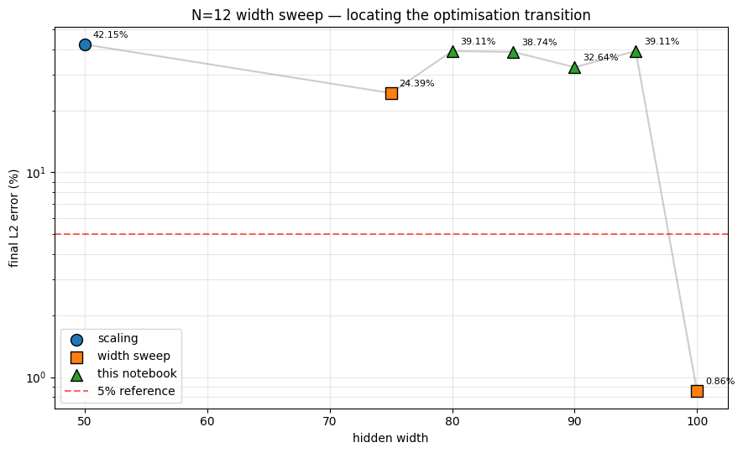Width step changes:
w= 50 -> w= 75: 42.15% -> 24.39% (drop=+17.76)
w= 75 -> w= 80: 24.39% -> 39.11% (drop=-14.72)
w= 80 -> w= 85: 39.11% -> 38.74% (drop=+0.37)
w= 85 -> w= 90: 38.74% -> 32.64% (drop=+6.10)
w= 90 -> w= 95: 32.64% -> 39.11% (drop=-6.47)
w= 95 -> w=100: 39.11% -> 0.86% (drop=+38.25)

Largest drop: w=95 -> w=100: 39.11% -> 0.86%

Done. Outputs in /kaggle/working

minm intervention
============================================================
PIPELINE SANITY CHECK (N=3, short Adam, no L-BFGS)
============================================================
device = cuda
domain = (-20.0, 37.5) | n_pde=19166 | n_data=383
params = 12,951
Adam 0 | Total=3.982009e-01 PDE=1.980e-03 IC=1.918e-01 BC=7.812e-02 Data=1.263e-01
Adam 100 | Total=1.092705e-01 PDE=1.383e-03 IC=5.837e-02 BC=1.032e-03 Data=4.848e-02
Adam 200 | Total=7.957551e-02 PDE=3.694e-03 IC=3.079e-02 BC=9.330e-04 Data=4.416e-02
Adam 300 | Total=1.782456e-02 PDE=4.707e-03 IC=3.421e-03 BC=1.365e-04 Data=9.560e-03
Adam 400 | Total=3.167343e-03 PDE=1.486e-03 IC=2.782e-04 BC=1.535e-05 Data=1.388e-03
Adam 499 | Total=1.084195e-03 PDE=6.693e-04 IC=8.519e-05 BC=5.504e-06 Data=3.242e-04
>> Adam done 21.9s | L2=5.5763%
LBFGS 0 | Total=1.09952257e-03
>> LBFGS done 0.1s | L2=5.5763%
L2 after 500 Adam iters: 5.576%
>> sanity OK
name n_pde n_data note
D_lowpde_lowdata 20,000 400 sanity - both low, expect FAIL
A_lowpde_highdata 20,000 2,000 extreme data, minimal collocation
E_midpde_highdata 40,000 2,000 probe boundary
C_midpde_middata 80,000 500 mid + mid
F_midpde_highdata2 80,000 1,000 probe boundary
B_highpde_lowdata 160,000 400 extreme collocation, minimal data
N=12 domain=(-65.0, 105.0) width=170.0
speeds=[7.0, 6.5, 6.0, 5.5, 5.0, 4.5, 4.0, 3.5, 3.0, 2.5, 2.0, 1.5]
x0s =[55.0, 45.0, 35.0, 25.0, 15.0, 5.0, -5.0, -15.0, -25.0, -35.0, -45.0, -55.0]
points: PDE=56,666 Data=1,133 IC=1,416 BC=200

======================================================================
N12_w50_D_lowpde_lowdata | n_pde=20,000 n_data=400
note: sanity - both low, expect FAIL
======================================================================
params = 12,951
Adam 0 | Total=9.984869e-01 PDE=1.019e-03 IC=4.652e-01 BC=1.169e-01 Data=4.154e-01
Adam 1000 | Total=5.815958e-01 PDE=4.884e-03 IC=2.751e-01 BC=1.729e-04 Data=3.014e-01
Adam 2000 | Total=4.855500e-01 PDE=2.387e-02 IC=2.235e-01 BC=2.006e-04 Data=2.379e-01
Adam 3000 | Total=4.039010e-01 PDE=1.689e-02 IC=1.863e-01 BC=7.229e-05 Data=2.006e-01
Adam 4000 | Total=4.012892e-01 PDE=1.177e-02 IC=1.876e-01 BC=7.256e-05 Data=2.019e-01
Adam 5000 | Total=3.775555e-01 PDE=1.286e-02 IC=1.797e-01 BC=9.110e-05 Data=1.849e-01
Adam 6000 | Total=3.560708e-01 PDE=1.645e-02 IC=1.619e-01 BC=1.462e-04 Data=1.776e-01
Adam 7000 | Total=3.193261e-01 PDE=1.773e-02 IC=1.446e-01 BC=3.824e-05 Data=1.570e-01
Adam 8000 | Total=2.837934e-01 PDE=3.080e-02 IC=1.213e-01 BC=6.255e-05 Data=1.316e-01
Adam 9000 | Total=2.325405e-01 PDE=4.941e-02 IC=7.567e-02 BC=4.159e-04 Data=1.070e-01
Adam 10000 | Total=1.602477e-01 PDE=3.288e-02 IC=4.608e-02 BC=4.624e-05 Data=8.124e-02
Adam 11000 | Total=9.433991e-02 PDE=2.701e-02 IC=2.361e-02 BC=1.737e-05 Data=4.370e-02
Adam 12000 | Total=5.262931e-02 PDE=1.552e-02 IC=9.837e-03 BC=2.836e-05 Data=2.724e-02
Adam 13000 | Total=3.224291e-02 PDE=1.413e-02 IC=3.434e-03 BC=2.773e-05 Data=1.465e-02
Adam 14000 | Total=5.358689e-02 PDE=1.112e-02 IC=1.467e-02 BC=5.937e-05 Data=2.774e-02
Adam 14999 | Total=2.597059e-02 PDE=1.390e-02 IC=2.039e-03 BC=3.110e-04 Data=9.723e-03
>> Adam done 671.6s | L2=31.3446%
LBFGS 0 | Total=2.69554816e-02
LBFGS 200 | Total=1.50305405e-02
LBFGS 400 | Total=1.40570253e-02
LBFGS 600 | Total=1.34378951e-02
LBFGS 800 | Total=1.29393358e-02
LBFGS 1000 | Total=1.24027692e-02
LBFGS 1200 | Total=1.19917654e-02
LBFGS 1400 | Total=1.15682771e-02
LBFGS 1600 | Total=1.11470055e-02
LBFGS 1800 | Total=1.07657369e-02
LBFGS 2000 | Total=1.04769589e-02
>> LBFGS done 102.3s | L2=30.2198%
total 12.9 min
saved /kaggle/working/checkpoint_N12_w50_D_lowpde_lowdata.pt

======================================================================
N12_w50_A_lowpde_highdata | n_pde=20,000 n_data=2,000
note: extreme data, minimal collocation
======================================================================
params = 12,951
Adam 0 | Total=1.099959e+00 PDE=1.019e-03 IC=4.916e-01 BC=1.170e-01 Data=4.904e-01
Adam 1000 | Total=6.199987e-01 PDE=6.324e-03 IC=2.675e-01 BC=3.336e-03 Data=3.429e-01
Adam 2000 | Total=5.092769e-01 PDE=1.400e-02 IC=2.125e-01 BC=2.615e-04 Data=2.825e-01
Adam 3000 | Total=4.170455e-01 PDE=3.475e-02 IC=1.649e-01 BC=2.065e-04 Data=2.172e-01
Adam 4000 | Total=2.709707e-01 PDE=3.086e-02 IC=9.948e-02 BC=1.437e-03 Data=1.392e-01
Adam 5000 | Total=2.309609e-01 PDE=2.400e-02 IC=8.454e-02 BC=4.822e-05 Data=1.224e-01
Adam 6000 | Total=1.864367e-01 PDE=3.378e-02 IC=6.418e-02 BC=1.749e-04 Data=8.830e-02
Adam 7000 | Total=1.466529e-01 PDE=2.503e-02 IC=4.661e-02 BC=1.899e-04 Data=7.482e-02
Adam 8000 | Total=8.287441e-02 PDE=1.664e-02 IC=2.665e-02 BC=8.197e-05 Data=3.950e-02
Adam 9000 | Total=8.394401e-02 PDE=1.820e-02 IC=2.572e-02 BC=9.769e-05 Data=3.992e-02
Adam 10000 | Total=5.554354e-02 PDE=2.269e-02 IC=9.209e-03 BC=1.492e-04 Data=2.350e-02
Adam 11000 | Total=4.259041e-02 PDE=1.252e-02 IC=1.167e-02 BC=5.169e-05 Data=1.835e-02
Adam 12000 | Total=3.594692e-02 PDE=9.992e-03 IC=1.083e-02 BC=5.553e-05 Data=1.507e-02
Adam 13000 | Total=2.069969e-02 PDE=1.635e-02 IC=1.107e-03 BC=4.840e-04 Data=2.755e-03
Adam 14000 | Total=2.422155e-02 PDE=1.514e-02 IC=3.092e-03 BC=5.103e-04 Data=5.478e-03
Adam 14999 | Total=1.394206e-02 PDE=2.704e-03 IC=4.067e-03 BC=8.907e-06 Data=7.162e-03
>> Adam done 673.1s | L2=15.4735%
LBFGS 0 | Total=1.89234465e-02
LBFGS 200 | Total=3.37819778e-03
LBFGS 400 | Total=2.88624037e-03
LBFGS 600 | Total=2.70836730e-03
LBFGS 800 | Total=2.48476258e-03
LBFGS 1000 | Total=2.26236507e-03
LBFGS 1200 | Total=2.05503334e-03
LBFGS 1400 | Total=1.84441230e-03
LBFGS 1600 | Total=1.63229369e-03
LBFGS 1800 | Total=1.48568023e-03
LBFGS 2000 | Total=1.35179504e-03
>> LBFGS done 102.6s | L2=2.3781%
total 12.9 min
saved /kaggle/working/checkpoint_N12_w50_A_lowpde_highdata.pt

======================================================================
N12_w50_E_midpde_highdata | n_pde=40,000 n_data=2,000
note: probe boundary
======================================================================
params = 12,951
Adam 0 | Total=1.116394e+00 PDE=1.059e-03 IC=5.290e-01 BC=1.170e-01 Data=4.693e-01
Adam 1000 | Total=6.329083e-01 PDE=3.107e-03 IC=3.157e-01 BC=2.018e-04 Data=3.139e-01
Adam 2000 | Total=5.619071e-01 PDE=1.840e-02 IC=2.585e-01 BC=4.806e-05 Data=2.850e-01
Adam 3000 | Total=3.624560e-01 PDE=2.814e-02 IC=1.453e-01 BC=1.177e-04 Data=1.889e-01
Adam 4000 | Total=2.544948e-01 PDE=1.707e-02 IC=1.050e-01 BC=1.505e-04 Data=1.323e-01
Adam 5000 | Total=2.019776e-01 PDE=1.095e-02 IC=8.848e-02 BC=4.984e-05 Data=1.025e-01
Adam 6000 | Total=1.949893e-01 PDE=1.192e-02 IC=8.219e-02 BC=3.989e-05 Data=1.008e-01
Adam 7000 | Total=1.931182e-01 PDE=1.088e-02 IC=8.453e-02 BC=7.444e-05 Data=9.763e-02
Adam 8000 | Total=1.774796e-01 PDE=6.806e-03 IC=7.864e-02 BC=2.511e-05 Data=9.201e-02
Adam 9000 | Total=1.734740e-01 PDE=8.438e-03 IC=7.590e-02 BC=1.958e-05 Data=8.912e-02
Adam 10000 | Total=1.733498e-01 PDE=9.741e-03 IC=7.287e-02 BC=2.861e-05 Data=9.071e-02
Adam 11000 | Total=1.550977e-01 PDE=1.572e-02 IC=6.398e-02 BC=2.473e-04 Data=7.515e-02
Adam 12000 | Total=9.370477e-02 PDE=1.463e-02 IC=3.525e-02 BC=1.152e-04 Data=4.370e-02
Adam 13000 | Total=9.094121e-02 PDE=1.557e-02 IC=3.101e-02 BC=2.252e-04 Data=4.414e-02
Adam 14000 | Total=8.049018e-02 PDE=1.765e-02 IC=2.531e-02 BC=2.392e-05 Data=3.751e-02
Adam 14999 | Total=1.678672e-02 PDE=6.628e-03 IC=3.361e-03 BC=2.209e-05 Data=6.775e-03
>> Adam done 1253.1s | L2=14.3728%
LBFGS 0 | Total=1.94224995e-02
LBFGS 200 | Total=1.42856417e-02
LBFGS 400 | Total=1.22743752e-02
LBFGS 600 | Total=9.84432735e-03
LBFGS 800 | Total=8.27275775e-03
LBFGS 1000 | Total=6.67393394e-03
LBFGS 1200 | Total=5.08227618e-03
LBFGS 1400 | Total=4.11280384e-03
LBFGS 1600 | Total=3.58327548e-03
LBFGS 1800 | Total=3.18098627e-03
LBFGS 2000 | Total=2.81167729e-03
>> LBFGS done 183.8s | L2=3.9321%
total 23.9 min
saved /kaggle/working/checkpoint_N12_w50_E_midpde_highdata.pt

======================================================================
N12_w50_C_midpde_middata | n_pde=80,000 n_data=500
note: mid + mid
======================================================================
params = 12,951
Adam 0 | Total=1.010402e+00 PDE=1.017e-03 IC=4.992e-01 BC=1.176e-01 Data=3.926e-01
Adam 1000 | Total=5.620103e-01 PDE=6.001e-03 IC=3.039e-01 BC=2.157e-03 Data=2.499e-01
Adam 2000 | Total=5.040981e-01 PDE=1.563e-02 IC=2.687e-01 BC=7.169e-05 Data=2.197e-01
Adam 3000 | Total=3.649510e-01 PDE=2.444e-02 IC=1.830e-01 BC=1.061e-04 Data=1.574e-01
Adam 4000 | Total=2.491907e-01 PDE=3.388e-02 IC=1.024e-01 BC=1.604e-04 Data=1.127e-01
Adam 5000 | Total=1.972284e-01 PDE=3.339e-02 IC=7.027e-02 BC=2.486e-04 Data=9.332e-02
Adam 6000 | Total=1.563035e-01 PDE=2.667e-02 IC=5.162e-02 BC=1.627e-04 Data=7.785e-02
Adam 7000 | Total=1.427995e-01 PDE=3.573e-02 IC=4.167e-02 BC=1.038e-04 Data=6.530e-02
Adam 8000 | Total=1.040389e-01 PDE=2.696e-02 IC=2.511e-02 BC=1.100e-04 Data=5.186e-02
Adam 9000 | Total=9.610287e-02 PDE=2.588e-02 IC=2.146e-02 BC=8.106e-05 Data=4.869e-02
Adam 10000 | Total=8.788320e-02 PDE=2.448e-02 IC=1.694e-02 BC=1.013e-04 Data=4.637e-02
Adam 11000 | Total=7.488586e-02 PDE=2.191e-02 IC=1.060e-02 BC=8.981e-05 Data=4.229e-02
Adam 12000 | Total=6.589910e-02 PDE=2.051e-02 IC=6.912e-03 BC=3.599e-05 Data=3.844e-02
Adam 13000 | Total=6.357640e-02 PDE=2.004e-02 IC=6.398e-03 BC=2.227e-05 Data=3.712e-02
Adam 14000 | Total=5.803397e-02 PDE=1.950e-02 IC=3.999e-03 BC=2.096e-05 Data=3.452e-02
Adam 14999 | Total=7.467402e-02 PDE=2.232e-02 IC=1.262e-02 BC=2.383e-05 Data=3.971e-02
>> Adam done 2388.1s | L2=60.7968%
LBFGS 0 | Total=6.70025647e-02
LBFGS 200 | Total=5.39335199e-02
LBFGS 400 | Total=5.35678938e-02
LBFGS 600 | Total=5.31689823e-02
LBFGS 800 | Total=5.28233834e-02
LBFGS 1000 | Total=5.24753183e-02
LBFGS 1200 | Total=5.21478206e-02
LBFGS 1400 | Total=5.18577993e-02
LBFGS 1600 | Total=5.15237823e-02
LBFGS 1800 | Total=5.11754155e-02
LBFGS 2000 | Total=5.08544631e-02
>> LBFGS done 342.2s | L2=59.9989%
total 45.5 min
saved /kaggle/working/checkpoint_N12_w50_C_midpde_middata.pt

======================================================================
N12_w50_F_midpde_highdata2 | n_pde=80,000 n_data=1,000
note: probe boundary
======================================================================
params = 12,951
Adam 0 | Total=1.040124e+00 PDE=1.017e-03 IC=4.618e-01 BC=1.169e-01 Data=4.604e-01
Adam 1000 | Total=5.924129e-01 PDE=5.826e-03 IC=2.651e-01 BC=1.548e-04 Data=3.213e-01
Adam 2000 | Total=4.593247e-01 PDE=1.284e-02 IC=1.936e-01 BC=2.835e-04 Data=2.526e-01
Adam 3000 | Total=3.743135e-01 PDE=1.973e-02 IC=1.420e-01 BC=2.758e-04 Data=2.123e-01
Adam 4000 | Total=3.175425e-01 PDE=2.291e-02 IC=1.159e-01 BC=6.704e-05 Data=1.787e-01
Adam 5000 | Total=2.112126e-01 PDE=4.188e-02 IC=4.735e-02 BC=2.413e-04 Data=1.217e-01
Adam 6000 | Total=1.345459e-01 PDE=3.572e-02 IC=2.025e-02 BC=1.665e-04 Data=7.841e-02
Adam 7000 | Total=7.806710e-02 PDE=2.222e-02 IC=8.657e-03 BC=4.470e-05 Data=4.714e-02
Adam 8000 | Total=6.405313e-02 PDE=1.776e-02 IC=8.174e-03 BC=7.877e-05 Data=3.804e-02
Adam 9000 | Total=7.226223e-02 PDE=1.920e-02 IC=1.706e-02 BC=1.597e-04 Data=3.585e-02
Adam 10000 | Total=4.312407e-02 PDE=1.345e-02 IC=2.033e-03 BC=1.967e-05 Data=2.762e-02
Adam 11000 | Total=4.420369e-02 PDE=1.362e-02 IC=2.927e-03 BC=2.792e-04 Data=2.737e-02
Adam 12000 | Total=3.781415e-02 PDE=1.105e-02 IC=1.321e-03 BC=2.628e-05 Data=2.542e-02
Adam 13000 | Total=8.583048e-02 PDE=3.650e-02 IC=1.424e-02 BC=2.107e-03 Data=3.298e-02
Adam 14000 | Total=6.375781e-02 PDE=1.625e-02 IC=1.447e-02 BC=6.035e-04 Data=3.244e-02
Adam 14999 | Total=3.366499e-02 PDE=1.023e-02 IC=1.228e-03 BC=6.818e-05 Data=2.214e-02
>> Adam done 2384.7s | L2=36.6623%
LBFGS 0 | Total=3.59783247e-02
LBFGS 200 | Total=3.16473022e-02
LBFGS 400 | Total=3.11783962e-02
LBFGS 600 | Total=3.08226533e-02
LBFGS 800 | Total=3.05271782e-02
LBFGS 1000 | Total=3.01240906e-02
LBFGS 1200 | Total=2.98140608e-02
LBFGS 1400 | Total=2.95426678e-02
LBFGS 1600 | Total=2.92428210e-02
LBFGS 1800 | Total=2.89522633e-02
LBFGS 2000 | Total=2.86473818e-02
>> LBFGS done 342.1s | L2=35.2665%
total 45.4 min
saved /kaggle/working/checkpoint_N12_w50_F_midpde_highdata2.pt
======================================================================
N12_w50_B_highpde_lowdata | n_pde=160,000 n_data=400
note: extreme collocation, minimal data
======================================================================
params = 12,951
Adam 0 | Total=1.062640e+00 PDE=1.019e-03 IC=4.757e-01 BC=1.178e-01 Data=4.681e-01
Adam 1000 | Total=5.680857e-01 PDE=8.070e-03 IC=2.785e-01 BC=5.102e-04 Data=2.810e-01
Adam 2000 | Total=4.250368e-01 PDE=2.724e-02 IC=1.765e-01 BC=2.111e-04 Data=2.211e-01
Adam 3000 | Total=3.061155e-01 PDE=5.650e-02 IC=1.098e-01 BC=3.458e-03 Data=1.364e-01
Adam 4000 | Total=1.979301e-01 PDE=4.053e-02 IC=5.867e-02 BC=4.618e-05 Data=9.869e-02
Adam 5000 | Total=1.473633e-01 PDE=3.498e-02 IC=3.462e-02 BC=8.571e-05 Data=7.767e-02
Adam 6000 | Total=1.205162e-01 PDE=3.003e-02 IC=3.094e-02 BC=8.471e-05 Data=5.946e-02
Adam 7000 | Total=1.046705e-01 PDE=2.832e-02 IC=2.482e-02 BC=7.170e-06 Data=5.153e-02
Adam 8000 | Total=1.155754e-01 PDE=3.221e-02 IC=3.420e-02 BC=3.746e-04 Data=4.879e-02
Adam 9000 | Total=1.125363e-01 PDE=2.864e-02 IC=3.283e-02 BC=2.510e-05 Data=5.104e-02
Adam 10000 | Total=1.032541e-01 PDE=3.066e-02 IC=2.639e-02 BC=2.409e-04 Data=4.597e-02
Adam 11000 | Total=9.579021e-02 PDE=2.856e-02 IC=2.623e-02 BC=3.620e-05 Data=4.096e-02
Adam 12000 | Total=8.333839e-02 PDE=3.103e-02 IC=1.566e-02 BC=2.184e-04 Data=3.643e-02
Adam 13000 | Total=7.519431e-02 PDE=2.918e-02 IC=1.283e-02 BC=2.186e-05 Data=3.316e-02
Adam 14000 | Total=8.821981e-02 PDE=3.055e-02 IC=2.134e-02 BC=4.625e-05 Data=3.629e-02
Adam 14999 | Total=7.510088e-02 PDE=2.987e-02 IC=1.123e-02 BC=7.432e-05 Data=3.393e-02
>> Adam done 4645.8s | L2=57.7817%
LBFGS 0 | Total=7.88662881e-02
LBFGS 200 | Total=6.56885803e-02
LBFGS 400 | Total=6.47550523e-02
LBFGS 600 | Total=6.35511056e-02
LBFGS 800 | Total=6.19699284e-02
LBFGS 1000 | Total=6.03334978e-02
LBFGS 1200 | Total=5.89522496e-02
LBFGS 1400 | Total=5.72948232e-02
LBFGS 1600 | Total=5.49193174e-02
LBFGS 1800 | Total=5.26474863e-02
LBFGS 2000 | Total=5.10674119e-02
>> LBFGS done 659.6s | L2=53.8235%
total 88.4 min
saved /kaggle/working/checkpoint_N12_w50_B_highpde_lowdata.pt

--- Results ---
name n_pde n_data note L2_adam L2_final total_min rescued
D_lowpde_lowdata 20000 400 sanity - both low, expect FAIL 31.3446 30.2198 12.8994 False
A_lowpde_highdata 20000 2000 extreme data, minimal collocation 15.4735 2.3781 12.9285 True
E_midpde_highdata 40000 2000 probe boundary 14.3728 3.9321 23.9487 True
C_midpde_middata 80000 500 mid + mid 60.7968 59.9989 45.5045 False
F_midpde_highdata2 80000 1000 probe boundary 36.6623 35.2665 45.4472 False
B_highpde_lowdata 160000 400 extreme collocation, minimal data 57.7817 53.8235 88.4226 False
name n_pde n_data L2_final rescued source
baseline_FAIL 56666 1133 42.1502 False prior runs
rescue_pde160k_default 160000 1133 2.4788 True prior runs
rescue_ndata500_default 56666 500 1.9530 True prior runs
rescue_ndata2000_default 56666 2000 1.2219 True prior runs
fail_pde40k_default 40000 1133 42.8802 False prior runs
fail_pde80k_default 80000 1133 24.1723 False prior runs
D_lowpde_lowdata 20000 400 30.2198 False this notebook
A_lowpde_highdata 20000 2000 2.3781 True this notebook
E_midpde_highdata 40000 2000 3.9321 True this notebook
C_midpde_middata 80000 500 59.9989 False this notebook
F_midpde_highdata2 80000 1000 35.2665 False this notebook
B_highpde_lowdata 160000 400 53.8235 False this notebook
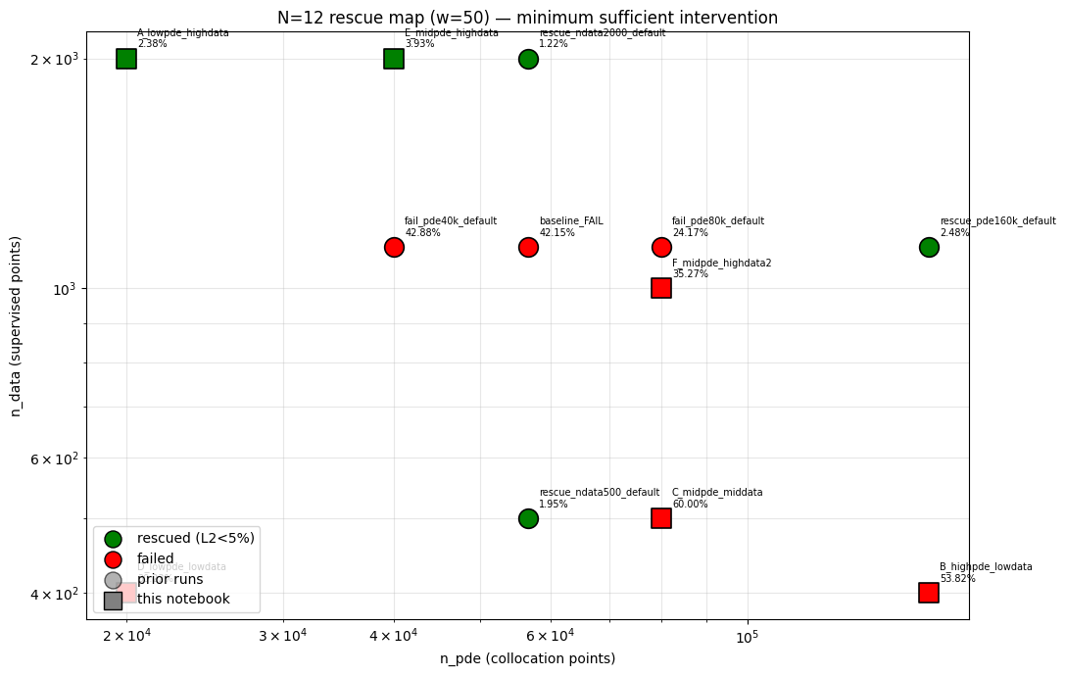=================================================================
RESCUE SUMMARY (sorted by L2)
=================================================================
RESCUED n_pde= 56,666 n_data= 2,000 L2= 1.22% (rescue_ndata2000_default)
RESCUED n_pde= 56,666 n_data= 500 L2= 1.95% (rescue_ndata500_default)
RESCUED n_pde= 20,000 n_data= 2,000 L2= 2.38% (A_lowpde_highdata)
RESCUED n_pde=160,000 n_data= 1,133 L2= 2.48% (rescue_pde160k_default)
RESCUED n_pde= 40,000 n_data= 2,000 L2= 3.93% (E_midpde_highdata)
failed n_pde= 80,000 n_data= 1,133 L2= 24.17% (fail_pde80k_default)
failed n_pde= 20,000 n_data= 400 L2= 30.22% (D_lowpde_lowdata)
failed n_pde= 80,000 n_data= 1,000 L2= 35.27% (F_midpde_highdata2)
failed n_pde= 56,666 n_data= 1,133 L2= 42.15% (baseline_FAIL)
failed n_pde= 40,000 n_data= 1,133 L2= 42.88% (fail_pde40k_default)
failed n_pde=160,000 n_data= 400 L2= 53.82% (B_highpde_lowdata)
failed n_pde= 80,000 n_data= 500 L2= 60.00% (C_midpde_middata)

Cheapest rescue (by total points): A_lowpde_highdata
n_pde=20,000 n_data=2,000 total=22,000 L2=2.38%

Done. Outputs in /kaggle/working

multiseed n=12
N=12 domain=(-65.0, 105.0) width=170.0
speeds=[np.float64(7.0), np.float64(6.5), np.float64(6.0), np.float64(5.5), np.float64(5.0), np.float64(4.5), np.float64(4.0), np.float64(3.5), np.float64(3.0), np.float64(2.5), np.float64(2.0), np.float64(1.5)]
x0s =[np.float64(55.0), np.float64(45.0), np.float64(35.0), np.float64(25.0), np.float64(15.0), np.float64(5.0), np.float64(-5.0), np.float64(-15.0), np.float64(-25.0), np.float64(-35.0), np.float64(-45.0), np.float64(-55.0)]
points: PDE=56,666 Data=1,133 IC=1,416 BC=200
seeds : [1, 7, 23, 42, 99, 137, 256, 999]
width=50 params=12,951
============================================================
PIPELINE SANITY CHECK (N=3, short Adam, no L-BFGS)
============================================================
device = cuda
domain = (-20.0, 37.5) | n_pde=19166 | n_data=383
params = 12,951

/usr/local/lib/python3.12/dist-packages/torch/autograd/graph.py:865: UserWarning: Attempting to run cuBLAS, but there was no current CUDA context! Attempting to set the primary context... (Triggered internally at /pytorch/aten/src/ATen/cuda/CublasHandlePool.cpp:330.)
return Variable._execution_engine.run_backward( # Calls into the C++ engine to run the backward pass

Adam 0 | Total=3.875886e-01 PDE=1.98e-03 IC=1.78e-01 BC=8.10e-02 Data=1.26e-01
Adam 100 | Total=1.073739e-01 PDE=1.25e-03 IC=5.65e-02 BC=9.43e-04 Data=4.87e-02
Adam 200 | Total=7.882582e-02 PDE=3.68e-03 IC=2.99e-02 BC=8.00e-04 Data=4.45e-02
Adam 300 | Total=1.786188e-02 PDE=4.54e-03 IC=3.95e-03 BC=8.94e-05 Data=9.29e-03
Adam 400 | Total=3.078925e-03 PDE=1.50e-03 IC=3.65e-04 BC=1.22e-05 Data=1.20e-03
>> Adam done 20.5s | L2=6.3671%
LBFGS 0 | Total=1.11213501e-03
>> LBFGS done 0.1s | L2=6.3671%
L2 after 500 Adam iters: 6.3671%
>> sanity OK
======================================================================
SEED=1 N=12 width=50 domain=(-65.0,105.0)
======================================================================
params=12,951 PDE=56,666 Data=1,133 IC=1,416 BC=200
Adam 0 | Total=1.169207e+00 PDE=3.81e-03 IC=4.67e-01 BC=2.07e-02 Data=6.78e-01
Adam 1000 | Total=6.034743e-01 PDE=2.66e-02 IC=2.55e-01 BC=4.98e-04 Data=3.22e-01
Adam 2000 | Total=4.818894e-01 PDE=2.22e-02 IC=2.13e-01 BC=5.91e-04 Data=2.46e-01
Adam 3000 | Total=4.071581e-01 PDE=1.80e-02 IC=1.78e-01 BC=1.99e-04 Data=2.11e-01
Adam 4000 | Total=3.956927e-01 PDE=1.75e-02 IC=1.72e-01 BC=3.13e-04 Data=2.06e-01
Adam 5000 | Total=3.461460e-01 PDE=2.85e-02 IC=1.38e-01 BC=8.55e-04 Data=1.79e-01
Adam 6000 | Total=2.829767e-01 PDE=2.99e-02 IC=1.00e-01 BC=5.73e-04 Data=1.52e-01
Adam 7000 | Total=1.939204e-01 PDE=2.78e-02 IC=6.50e-02 BC=9.48e-05 Data=1.01e-01
Adam 8000 | Total=1.494579e-01 PDE=3.24e-02 IC=3.83e-02 BC=1.50e-04 Data=7.86e-02
Adam 9000 | Total=1.235596e-01 PDE=2.89e-02 IC=2.57e-02 BC=2.54e-05 Data=6.90e-02
Adam 10000 | Total=8.642381e-02 PDE=1.94e-02 IC=1.23e-02 BC=9.75e-06 Data=5.47e-02
Adam 11000 | Total=6.906986e-02 PDE=1.76e-02 IC=9.95e-03 BC=2.20e-05 Data=4.15e-02
Adam 12000 | Total=8.348426e-02 PDE=2.04e-02 IC=1.26e-02 BC=2.08e-06 Data=5.05e-02
Adam 13000 | Total=4.835153e-02 PDE=1.47e-02 IC=3.16e-03 BC=1.89e-05 Data=3.04e-02
Adam 14000 | Total=6.075448e-02 PDE=1.04e-02 IC=1.98e-02 BC=6.60e-05 Data=3.04e-02
>> Adam done 1701.3s | L2=19.5239%
LBFGS 20 | Total=7.26539362e-03
LBFGS 220 | Total=6.07567001e-03
LBFGS 420 | Total=5.27491374e-03
LBFGS 620 | Total=4.44613770e-03
LBFGS 820 | Total=3.89650278e-03
LBFGS 1020 | Total=3.47381807e-03
LBFGS 1220 | Total=3.05602024e-03
LBFGS 1420 | Total=2.67802156e-03
LBFGS 1620 | Total=2.38276506e-03
LBFGS 1820 | Total=2.09994940e-03
>> LBFGS done 279.4s | L2=3.1104%
computing per-soliton L2...
soliton 1 c=7.00 x0= 55.0 local L2 = 1.48%
soliton 2 c=6.50 x0= 45.0 local L2 = 1.07%
soliton 3 c=6.00 x0= 35.0 local L2 = 1.29%
soliton 4 c=5.50 x0= 25.0 local L2 = 1.12%
soliton 5 c=5.00 x0= 15.0 local L2 = 1.08%
soliton 6 c=4.50 x0= 5.0 local L2 = 1.25%
soliton 7 c=4.00 x0= -5.0 local L2 = 2.64%
soliton 8 c=3.50 x0= -15.0 local L2 = 2.67%
soliton 9 c=3.00 x0= -25.0 local L2 = 4.46%
soliton 10 c=2.50 x0= -35.0 local L2 = 6.95%
soliton 11 c=2.00 x0= -45.0 local L2 = 5.26%
soliton 12 c=1.50 x0= -55.0 local L2 = 6.15%
worst: soliton 10 (c=2.50) at 6.95%
best: soliton 2 (c=6.50) at 1.07%
[running save — 1/8 seeds done]

======================================================================
SEED=7 N=12 width=50 domain=(-65.0,105.0)
======================================================================
params=12,951 PDE=56,666 Data=1,133 IC=1,416 BC=200
Adam 0 | Total=3.722903e+00 PDE=2.24e-02 IC=1.41e+00 BC=9.02e-01 Data=1.39e+00
Adam 1000 | Total=6.405684e-01 PDE=4.79e-03 IC=3.05e-01 BC=3.20e-03 Data=3.28e-01
Adam 2000 | Total=5.457181e-01 PDE=2.42e-02 IC=2.45e-01 BC=2.26e-04 Data=2.76e-01
Adam 3000 | Total=4.567469e-01 PDE=2.66e-02 IC=1.93e-01 BC=3.91e-05 Data=2.37e-01
Adam 4000 | Total=3.663251e-01 PDE=3.29e-02 IC=1.49e-01 BC=1.09e-03 Data=1.84e-01
Adam 5000 | Total=3.058773e-01 PDE=4.57e-02 IC=1.17e-01 BC=2.41e-04 Data=1.43e-01
Adam 6000 | Total=2.368068e-01 PDE=3.59e-02 IC=8.23e-02 BC=3.90e-04 Data=1.18e-01
Adam 7000 | Total=2.054365e-01 PDE=2.95e-02 IC=7.25e-02 BC=6.13e-05 Data=1.03e-01
Adam 8000 | Total=1.695356e-01 PDE=1.31e-02 IC=7.73e-02 BC=1.02e-04 Data=7.90e-02
Adam 9000 | Total=1.527106e-01 PDE=9.50e-03 IC=7.47e-02 BC=2.41e-04 Data=6.83e-02
Adam 10000 | Total=1.541414e-01 PDE=1.19e-02 IC=7.49e-02 BC=9.39e-05 Data=6.73e-02
Adam 11000 | Total=1.411410e-01 PDE=6.75e-03 IC=7.17e-02 BC=7.36e-05 Data=6.26e-02
Adam 12000 | Total=1.457778e-01 PDE=8.66e-03 IC=7.23e-02 BC=1.24e-04 Data=6.47e-02
Adam 13000 | Total=1.270809e-01 PDE=1.09e-02 IC=6.23e-02 BC=3.88e-05 Data=5.38e-02
Adam 14000 | Total=1.395918e-01 PDE=3.10e-02 IC=5.20e-02 BC=1.35e-03 Data=5.52e-02
>> Adam done 1701.6s | L2=31.1970%
LBFGS 20 | Total=6.50247931e-02
LBFGS 220 | Total=6.23837560e-02
LBFGS 420 | Total=5.92216179e-02
LBFGS 620 | Total=5.43852895e-02
LBFGS 820 | Total=4.97706942e-02
LBFGS 1020 | Total=4.39919308e-02
LBFGS 1220 | Total=3.58479694e-02
LBFGS 1420 | Total=2.41255313e-02
LBFGS 1620 | Total=1.64781325e-02
LBFGS 1820 | Total=1.18016470e-02
>> LBFGS done 281.5s | L2=8.7508%
saved /kaggle/working/checkpoint_N12_w50_seed7.pt
computing per-soliton L2...
soliton 1 c=7.00 x0= 55.0 local L2 = 3.68%
soliton 2 c=6.50 x0= 45.0 local L2 = 3.69%
soliton 3 c=6.00 x0= 35.0 local L2 = 3.01%
soliton 4 c=5.50 x0= 25.0 local L2 = 12.77%
soliton 5 c=5.00 x0= 15.0 local L2 = 3.65%
soliton 6 c=4.50 x0= 5.0 local L2 = 3.90%
soliton 7 c=4.00 x0= -5.0 local L2 = 6.43%
soliton 8 c=3.50 x0= -15.0 local L2 = 5.40%
soliton 9 c=3.00 x0= -25.0 local L2 = 6.52%
soliton 10 c=2.50 x0= -35.0 local L2 = 5.60%
soliton 11 c=2.00 x0= -45.0 local L2 = 9.45%
soliton 12 c=1.50 x0= -55.0 local L2 = 29.93%
worst: soliton 12 (c=1.50) at 29.93%
best: soliton 3 (c=6.00) at 3.01%
[running save — 2/8 seeds done]

======================================================================
SEED=23 N=12 width=50 domain=(-65.0,105.0)
======================================================================
params=12,951 PDE=56,666 Data=1,133 IC=1,416 BC=200
Adam 0 | Total=8.696007e-01 PDE=1.82e-03 IC=4.40e-01 BC=1.29e-02 Data=4.15e-01
Adam 1000 | Total=5.309487e-01 PDE=9.83e-03 IC=2.53e-01 BC=1.57e-04 Data=2.68e-01
Adam 2000 | Total=4.566599e-01 PDE=1.98e-02 IC=2.12e-01 BC=1.89e-04 Data=2.25e-01
Adam 3000 | Total=3.600454e-01 PDE=3.10e-02 IC=1.55e-01 BC=8.02e-05 Data=1.74e-01
Adam 4000 | Total=3.086237e-01 PDE=2.08e-02 IC=1.35e-01 BC=5.31e-05 Data=1.53e-01
Adam 5000 | Total=2.667006e-01 PDE=1.78e-02 IC=1.13e-01 BC=1.93e-05 Data=1.36e-01
Adam 6000 | Total=2.380382e-01 PDE=2.05e-02 IC=9.49e-02 BC=5.41e-05 Data=1.23e-01
Adam 7000 | Total=2.255817e-01 PDE=2.02e-02 IC=9.06e-02 BC=5.16e-06 Data=1.15e-01
Adam 8000 | Total=1.930314e-01 PDE=2.76e-02 IC=6.76e-02 BC=2.96e-05 Data=9.78e-02
Adam 9000 | Total=1.793964e-01 PDE=3.57e-02 IC=5.48e-02 BC=1.26e-03 Data=8.77e-02
Adam 10000 | Total=1.357557e-01 PDE=3.79e-02 IC=3.39e-02 BC=4.17e-04 Data=6.34e-02
Adam 11000 | Total=9.947945e-02 PDE=2.24e-02 IC=2.31e-02 BC=6.89e-06 Data=5.40e-02
Adam 12000 | Total=1.034519e-01 PDE=2.61e-02 IC=2.31e-02 BC=1.87e-05 Data=5.42e-02
Adam 13000 | Total=9.780878e-02 PDE=2.43e-02 IC=2.14e-02 BC=2.00e-05 Data=5.21e-02
Adam 14000 | Total=8.255277e-02 PDE=2.36e-02 IC=1.50e-02 BC=3.68e-05 Data=4.39e-02
>> Adam done 1701.4s | L2=33.7149%
LBFGS 20 | Total=4.53449935e-02
LBFGS 220 | Total=4.24153544e-02
LBFGS 420 | Total=3.93871590e-02
LBFGS 620 | Total=3.73178348e-02
LBFGS 820 | Total=3.56951356e-02
LBFGS 1020 | Total=3.44315805e-02
LBFGS 1220 | Total=3.36316191e-02
LBFGS 1420 | Total=3.29731740e-02
LBFGS 1620 | Total=3.25320177e-02
LBFGS 1820 | Total=3.21667306e-02
>> LBFGS done 279.2s | L2=29.8706%
saved /kaggle/working/checkpoint_N12_w50_seed23.pt
computing per-soliton L2...
soliton 1 c=7.00 x0= 55.0 local L2 = 60.64%
soliton 2 c=6.50 x0= 45.0 local L2 = 4.61%
soliton 3 c=6.00 x0= 35.0 local L2 = 2.15%
soliton 4 c=5.50 x0= 25.0 local L2 = 6.19%
soliton 5 c=5.00 x0= 15.0 local L2 = 1.86%
soliton 6 c=4.50 x0= 5.0 local L2 = 1.15%
soliton 7 c=4.00 x0= -5.0 local L2 = 2.22%
soliton 8 c=3.50 x0= -15.0 local L2 = 3.66%
soliton 9 c=3.00 x0= -25.0 local L2 = 5.13%
soliton 10 c=2.50 x0= -35.0 local L2 = 3.39%
soliton 11 c=2.00 x0= -45.0 local L2 = 6.43%
soliton 12 c=1.50 x0= -55.0 local L2 = 5.66%
worst: soliton 1 (c=7.00) at 60.64%
best: soliton 6 (c=4.50) at 1.15%
[running save — 3/8 seeds done]

======================================================================
SEED=42 N=12 width=50 domain=(-65.0,105.0)
======================================================================
params=12,951 PDE=56,666 Data=1,133 IC=1,416 BC=200
Adam 0 | Total=9.529213e-01 PDE=3.40e-03 IC=5.16e-01 BC=2.79e-02 Data=4.05e-01
Adam 1000 | Total=5.310193e-01 PDE=6.21e-03 IC=2.75e-01 BC=1.18e-04 Data=2.50e-01
Adam 2000 | Total=4.929935e-01 PDE=1.32e-02 IC=2.47e-01 BC=1.99e-04 Data=2.33e-01
Adam 3000 | Total=4.257901e-01 PDE=2.03e-02 IC=1.96e-01 BC=4.25e-04 Data=2.09e-01
Adam 4000 | Total=3.105712e-01 PDE=2.94e-02 IC=1.19e-01 BC=2.66e-04 Data=1.62e-01
Adam 5000 | Total=2.656483e-01 PDE=2.85e-02 IC=9.36e-02 BC=4.76e-04 Data=1.43e-01
Adam 6000 | Total=2.380438e-01 PDE=2.42e-02 IC=7.97e-02 BC=1.38e-04 Data=1.34e-01
Adam 7000 | Total=2.512825e-01 PDE=2.39e-02 IC=9.28e-02 BC=4.89e-05 Data=1.34e-01
Adam 8000 | Total=1.980332e-01 PDE=2.06e-02 IC=6.11e-02 BC=1.19e-05 Data=1.16e-01
Adam 9000 | Total=2.013055e-01 PDE=3.13e-02 IC=5.60e-02 BC=3.91e-04 Data=1.14e-01
Adam 10000 | Total=1.684896e-01 PDE=2.79e-02 IC=4.12e-02 BC=1.71e-05 Data=9.94e-02
Adam 11000 | Total=1.384823e-01 PDE=3.05e-02 IC=2.27e-02 BC=7.63e-05 Data=8.53e-02
Adam 12000 | Total=1.123762e-01 PDE=3.19e-02 IC=1.00e-02 BC=6.69e-05 Data=7.04e-02
Adam 13000 | Total=8.362142e-02 PDE=2.24e-02 IC=4.99e-03 BC=1.17e-05 Data=5.62e-02
Adam 14000 | Total=8.395629e-02 PDE=2.31e-02 IC=8.53e-03 BC=5.95e-05 Data=5.23e-02
>> Adam done 1700.8s | L2=42.3521%
LBFGS 20 | Total=6.25494719e-02
LBFGS 220 | Total=6.09374568e-02
LBFGS 420 | Total=5.94263971e-02
LBFGS 620 | Total=5.78010827e-02
LBFGS 820 | Total=5.64978719e-02
LBFGS 1020 | Total=5.54014295e-02
LBFGS 1220 | Total=5.43596260e-02
LBFGS 1420 | Total=5.36808074e-02
LBFGS 1620 | Total=5.30659817e-02
LBFGS 1820 | Total=5.25729693e-02
>> LBFGS done 279.3s | L2=40.5915%
saved /kaggle/working/checkpoint_N12_w50_seed42.pt
computing per-soliton L2...
soliton 1 c=7.00 x0= 55.0 local L2 = 43.63%
soliton 2 c=6.50 x0= 45.0 local L2 = 79.36%
soliton 3 c=6.00 x0= 35.0 local L2 = 7.09%
soliton 4 c=5.50 x0= 25.0 local L2 = 3.03%
soliton 5 c=5.00 x0= 15.0 local L2 = 3.83%
soliton 6 c=4.50 x0= 5.0 local L2 = 1.74%
soliton 7 c=4.00 x0= -5.0 local L2 = 1.78%
soliton 8 c=3.50 x0= -15.0 local L2 = 3.52%
soliton 9 c=3.00 x0= -25.0 local L2 = 2.48%
soliton 10 c=2.50 x0= -35.0 local L2 = 3.88%
soliton 11 c=2.00 x0= -45.0 local L2 = 4.39%
soliton 12 c=1.50 x0= -55.0 local L2 = 5.79%
worst: soliton 2 (c=6.50) at 79.36%
best: soliton 6 (c=4.50) at 1.74%
[running save — 4/8 seeds done]

======================================================================
SEED=99 N=12 width=50 domain=(-65.0,105.0)
======================================================================
params=12,951 PDE=56,666 Data=1,133 IC=1,416 BC=200
Adam 0 | Total=1.118990e+00 PDE=1.03e-03 IC=5.08e-01 BC=1.17e-01 Data=4.93e-01
Adam 1000 | Total=6.542276e-01 PDE=3.86e-03 IC=2.97e-01 BC=6.22e-04 Data=3.52e-01
Adam 2000 | Total=5.638873e-01 PDE=2.94e-02 IC=2.44e-01 BC=1.14e-03 Data=2.89e-01
Adam 3000 | Total=3.945532e-01 PDE=1.65e-02 IC=1.72e-01 BC=1.33e-04 Data=2.06e-01
Adam 4000 | Total=2.825180e-01 PDE=1.92e-02 IC=1.20e-01 BC=3.19e-05 Data=1.43e-01
Adam 5000 | Total=3.460920e-01 PDE=5.03e-02 IC=1.12e-01 BC=1.14e-04 Data=1.83e-01
Adam 6000 | Total=2.368084e-01 PDE=6.67e-02 IC=6.91e-02 BC=2.04e-04 Data=1.01e-01
Adam 7000 | Total=1.222393e-01 PDE=3.29e-02 IC=2.99e-02 BC=6.90e-05 Data=5.94e-02
Adam 8000 | Total=1.068363e-01 PDE=3.06e-02 IC=2.49e-02 BC=5.34e-05 Data=5.13e-02
Adam 9000 | Total=8.926786e-02 PDE=3.24e-02 IC=1.65e-02 BC=1.08e-04 Data=4.02e-02
Adam 10000 | Total=9.229000e-02 PDE=3.05e-02 IC=1.98e-02 BC=1.47e-04 Data=4.18e-02
Adam 11000 | Total=6.990202e-02 PDE=2.84e-02 IC=1.20e-02 BC=1.48e-04 Data=2.93e-02
Adam 12000 | Total=1.865702e-01 PDE=3.45e-02 IC=6.12e-02 BC=4.59e-05 Data=9.08e-02
Adam 13000 | Total=1.132810e-01 PDE=3.32e-02 IC=3.18e-02 BC=1.98e-04 Data=4.81e-02
Adam 14000 | Total=4.123453e-02 PDE=1.97e-02 IC=2.37e-03 BC=5.46e-06 Data=1.92e-02
>> Adam done 1701.4s | L2=41.3155%
LBFGS 20 | Total=3.71027105e-02
LBFGS 220 | Total=3.63554806e-02
LBFGS 420 | Total=3.55846249e-02
LBFGS 620 | Total=3.46857682e-02
LBFGS 820 | Total=3.37913781e-02
LBFGS 1020 | Total=3.30591649e-02
LBFGS 1220 | Total=3.25814560e-02
LBFGS 1420 | Total=3.21007967e-02
LBFGS 1620 | Total=3.17581743e-02
LBFGS 1820 | Total=3.14221010e-02
>> LBFGS done 280.7s | L2=38.6952%
saved /kaggle/working/checkpoint_N12_w50_seed99.pt
computing per-soliton L2...
soliton 1 c=7.00 x0= 55.0 local L2 = 2.47%
soliton 2 c=6.50 x0= 45.0 local L2 = 82.87%
soliton 3 c=6.00 x0= 35.0 local L2 = 36.43%
soliton 4 c=5.50 x0= 25.0 local L2 = 4.64%
soliton 5 c=5.00 x0= 15.0 local L2 = 1.94%
soliton 6 c=4.50 x0= 5.0 local L2 = 2.24%
soliton 7 c=4.00 x0= -5.0 local L2 = 1.54%
soliton 8 c=3.50 x0= -15.0 local L2 = 2.05%
soliton 9 c=3.00 x0= -25.0 local L2 = 4.47%
soliton 10 c=2.50 x0= -35.0 local L2 = 4.24%
soliton 11 c=2.00 x0= -45.0 local L2 = 4.77%
soliton 12 c=1.50 x0= -55.0 local L2 = 5.44%
worst: soliton 2 (c=6.50) at 82.87%
best: soliton 7 (c=4.00) at 1.54%
[running save — 5/8 seeds done]

======================================================================
SEED=137 N=12 width=50 domain=(-65.0,105.0)
======================================================================
params=12,951 PDE=56,666 Data=1,133 IC=1,416 BC=200
Adam 0 | Total=1.206376e+00 PDE=4.74e-04 IC=5.23e-01 BC=1.55e-01 Data=5.28e-01
Adam 1000 | Total=6.385715e-01 PDE=1.01e-02 IC=2.84e-01 BC=2.44e-03 Data=3.42e-01
Adam 2000 | Total=4.489759e-01 PDE=3.67e-02 IC=1.81e-01 BC=1.55e-04 Data=2.31e-01
Adam 3000 | Total=2.538267e-01 PDE=2.48e-02 IC=9.51e-02 BC=2.22e-04 Data=1.34e-01
Adam 4000 | Total=1.753265e-01 PDE=1.81e-02 IC=6.98e-02 BC=1.99e-04 Data=8.72e-02
Adam 5000 | Total=1.416538e-01 PDE=1.73e-02 IC=5.43e-02 BC=2.14e-04 Data=6.98e-02
Adam 6000 | Total=8.081205e-02 PDE=1.48e-02 IC=2.80e-02 BC=3.87e-05 Data=3.79e-02
Adam 7000 | Total=6.539901e-02 PDE=1.63e-02 IC=2.09e-02 BC=1.89e-05 Data=2.82e-02
Adam 8000 | Total=6.323945e-02 PDE=1.69e-02 IC=1.95e-02 BC=4.36e-05 Data=2.68e-02
Adam 9000 | Total=7.431945e-02 PDE=1.97e-02 IC=2.45e-02 BC=1.99e-04 Data=2.99e-02
Adam 10000 | Total=1.035468e-01 PDE=2.83e-02 IC=2.90e-02 BC=8.39e-04 Data=4.54e-02
Adam 11000 | Total=1.305660e-01 PDE=1.23e-02 IC=5.09e-02 BC=1.56e-04 Data=6.72e-02
Adam 12000 | Total=1.367660e-01 PDE=1.23e-02 IC=5.55e-02 BC=1.31e-04 Data=6.88e-02
Adam 13000 | Total=1.643384e-01 PDE=2.40e-02 IC=6.04e-02 BC=5.97e-05 Data=8.00e-02
Adam 14000 | Total=1.055510e-01 PDE=2.14e-02 IC=3.48e-02 BC=1.15e-04 Data=4.92e-02
>> Adam done 1701.4s | L2=36.4395%
LBFGS 20 | Total=5.19182086e-02
LBFGS 220 | Total=5.02495468e-02
LBFGS 420 | Total=4.91869971e-02
LBFGS 620 | Total=4.82257903e-02
LBFGS 820 | Total=4.69444618e-02
LBFGS 1020 | Total=4.51942310e-02
LBFGS 1220 | Total=4.32505533e-02
LBFGS 1420 | Total=4.11948152e-02
LBFGS 1620 | Total=3.93064022e-02
LBFGS 1820 | Total=3.73985246e-02
>> LBFGS done 281.3s | L2=19.1581%
computing per-soliton L2...
soliton 1 c=7.00 x0= 55.0 local L2 = 2.69%
soliton 2 c=6.50 x0= 45.0 local L2 = 3.15%
soliton 3 c=6.00 x0= 35.0 local L2 = 4.43%
soliton 4 c=5.50 x0= 25.0 local L2 = 48.85%
soliton 5 c=5.00 x0= 15.0 local L2 = 7.68%
soliton 6 c=4.50 x0= 5.0 local L2 = 3.06%
soliton 7 c=4.00 x0= -5.0 local L2 = 3.01%
soliton 8 c=3.50 x0= -15.0 local L2 = 10.38%
soliton 9 c=3.00 x0= -25.0 local L2 = 2.94%
soliton 10 c=2.50 x0= -35.0 local L2 = 5.62%
soliton 11 c=2.00 x0= -45.0 local L2 = 6.25%
soliton 12 c=1.50 x0= -55.0 local L2 = 10.50%
worst: soliton 4 (c=5.50) at 48.85%
best: soliton 1 (c=7.00) at 2.69%
[running save — 6/8 seeds done]

======================================================================
SEED=256 N=12 width=50 domain=(-65.0,105.0)
======================================================================
params=12,951 PDE=56,666 Data=1,133 IC=1,416 BC=200
Adam 0 | Total=1.313871e+00 PDE=2.67e-03 IC=5.96e-01 BC=2.52e-01 Data=4.63e-01
Adam 1000 | Total=5.638714e-01 PDE=8.11e-03 IC=2.89e-01 BC=1.32e-04 Data=2.66e-01
Adam 2000 | Total=4.730368e-01 PDE=2.08e-02 IC=2.36e-01 BC=6.38e-04 Data=2.16e-01
Adam 3000 | Total=3.015370e-01 PDE=2.47e-02 IC=1.41e-01 BC=3.51e-04 Data=1.35e-01
Adam 4000 | Total=2.510169e-01 PDE=2.48e-02 IC=1.16e-01 BC=1.85e-04 Data=1.10e-01
Adam 5000 | Total=1.927506e-01 PDE=3.11e-02 IC=7.49e-02 BC=9.39e-05 Data=8.67e-02
Adam 6000 | Total=1.406317e-01 PDE=2.63e-02 IC=4.43e-02 BC=3.55e-04 Data=6.97e-02
Adam 7000 | Total=1.526377e-01 PDE=2.70e-02 IC=5.25e-02 BC=2.64e-04 Data=7.28e-02
Adam 8000 | Total=6.928527e-02 PDE=1.81e-02 IC=1.82e-02 BC=1.26e-05 Data=3.30e-02
Adam 9000 | Total=5.095737e-02 PDE=1.55e-02 IC=9.34e-03 BC=3.92e-05 Data=2.61e-02
Adam 10000 | Total=5.743494e-02 PDE=1.63e-02 IC=1.37e-02 BC=1.21e-04 Data=2.73e-02
Adam 11000 | Total=3.444423e-02 PDE=1.39e-02 IC=4.05e-03 BC=3.04e-05 Data=1.64e-02
Adam 12000 | Total=3.835539e-02 PDE=1.87e-02 IC=3.17e-03 BC=1.38e-04 Data=1.64e-02
Adam 13000 | Total=4.392785e-02 PDE=1.30e-02 IC=9.47e-03 BC=6.21e-05 Data=2.14e-02
Adam 14000 | Total=4.690082e-02 PDE=1.19e-02 IC=1.17e-02 BC=7.59e-05 Data=2.33e-02
>> Adam done 1700.7s | L2=36.1357%
LBFGS 20 | Total=2.29448378e-02
LBFGS 220 | Total=2.21122690e-02
LBFGS 420 | Total=2.15632990e-02
LBFGS 620 | Total=2.12353617e-02
LBFGS 820 | Total=2.09085681e-02
LBFGS 1020 | Total=2.05651037e-02
LBFGS 1220 | Total=2.03298517e-02
LBFGS 1420 | Total=2.00733282e-02
LBFGS 1620 | Total=1.98603645e-02
LBFGS 1820 | Total=1.96383130e-02
>> LBFGS done 283.8s | L2=30.6134%
saved /kaggle/working/checkpoint_N12_w50_seed256.pt
computing per-soliton L2...
soliton 1 c=7.00 x0= 55.0 local L2 = 1.72%
soliton 2 c=6.50 x0= 45.0 local L2 = 2.60%
soliton 3 c=6.00 x0= 35.0 local L2 = 79.88%
soliton 4 c=5.50 x0= 25.0 local L2 = 4.36%
soliton 5 c=5.00 x0= 15.0 local L2 = 2.16%
soliton 6 c=4.50 x0= 5.0 local L2 = 1.00%
soliton 7 c=4.00 x0= -5.0 local L2 = 0.77%
soliton 8 c=3.50 x0= -15.0 local L2 = 1.86%
soliton 9 c=3.00 x0= -25.0 local L2 = 5.23%
soliton 10 c=2.50 x0= -35.0 local L2 = 4.87%
soliton 11 c=2.00 x0= -45.0 local L2 = 5.75%
soliton 12 c=1.50 x0= -55.0 local L2 = 7.14%
worst: soliton 3 (c=6.00) at 79.88%
best: soliton 7 (c=4.00) at 0.77%
[running save — 7/8 seeds done]

======================================================================
SEED=999 N=12 width=50 domain=(-65.0,105.0)
======================================================================
params=12,951 PDE=56,666 Data=1,133 IC=1,416 BC=200
Adam 0 | Total=1.524184e+00 PDE=3.50e-03 IC=7.04e-01 BC=3.05e-01 Data=5.12e-01
Adam 1000 | Total=4.589448e-01 PDE=9.19e-03 IC=2.67e-01 BC=3.70e-04 Data=1.82e-01
Adam 2000 | Total=3.812891e-01 PDE=1.21e-02 IC=2.10e-01 BC=4.02e-05 Data=1.59e-01
Adam 3000 | Total=2.847622e-01 PDE=2.02e-02 IC=1.36e-01 BC=6.65e-05 Data=1.28e-01
Adam 4000 | Total=2.424112e-01 PDE=1.98e-02 IC=1.13e-01 BC=2.66e-05 Data=1.10e-01
Adam 5000 | Total=2.319961e-01 PDE=1.75e-02 IC=1.09e-01 BC=2.87e-05 Data=1.06e-01
Adam 6000 | Total=2.214787e-01 PDE=2.22e-02 IC=1.05e-01 BC=9.36e-05 Data=9.46e-02
Adam 7000 | Total=1.317916e-01 PDE=2.94e-02 IC=2.82e-02 BC=3.98e-04 Data=7.39e-02
Adam 8000 | Total=1.238596e-01 PDE=3.24e-02 IC=2.46e-02 BC=7.88e-05 Data=6.68e-02
Adam 9000 | Total=9.250639e-02 PDE=2.98e-02 IC=9.49e-03 BC=1.43e-05 Data=5.32e-02
Adam 10000 | Total=8.457389e-02 PDE=3.37e-02 IC=5.96e-03 BC=2.00e-04 Data=4.47e-02
Adam 11000 | Total=6.208929e-02 PDE=2.14e-02 IC=3.64e-03 BC=1.42e-05 Data=3.71e-02
Adam 12000 | Total=7.857817e-02 PDE=2.33e-02 IC=1.31e-02 BC=5.91e-05 Data=4.21e-02
Adam 13000 | Total=5.882518e-02 PDE=1.85e-02 IC=4.76e-03 BC=5.59e-05 Data=3.55e-02
Adam 14000 | Total=5.022920e-02 PDE=1.56e-02 IC=1.56e-03 BC=6.83e-06 Data=3.31e-02
>> Adam done 1701.4s | L2=48.3919%
LBFGS 20 | Total=4.64041680e-02
LBFGS 220 | Total=4.53831553e-02
LBFGS 420 | Total=4.47388403e-02
LBFGS 620 | Total=4.40618806e-02
LBFGS 820 | Total=4.35054563e-02
LBFGS 1020 | Total=4.30723131e-02
LBFGS 1220 | Total=4.27226909e-02
LBFGS 1420 | Total=4.24020998e-02
LBFGS 1620 | Total=4.21821252e-02
LBFGS 1820 | Total=4.19844538e-02
>> LBFGS done 278.2s | L2=47.7408%
saved /kaggle/working/checkpoint_N12_w50_seed999.pt
computing per-soliton L2...
soliton 1 c=7.00 x0= 55.0 local L2 = 81.04%
soliton 2 c=6.50 x0= 45.0 local L2 = 60.41%
soliton 3 c=6.00 x0= 35.0 local L2 = 25.75%
soliton 4 c=5.50 x0= 25.0 local L2 = 1.89%
soliton 5 c=5.00 x0= 15.0 local L2 = 1.64%
soliton 6 c=4.50 x0= 5.0 local L2 = 0.70%
soliton 7 c=4.00 x0= -5.0 local L2 = 1.25%
soliton 8 c=3.50 x0= -15.0 local L2 = 0.77%
soliton 9 c=3.00 x0= -25.0 local L2 = 2.11%
soliton 10 c=2.50 x0= -35.0 local L2 = 3.26%
soliton 11 c=2.00 x0= -45.0 local L2 = 3.03%
soliton 12 c=1.50 x0= -55.0 local L2 = 1.63%
worst: soliton 1 (c=7.00) at 81.04%
best: soliton 6 (c=4.50) at 0.70%
[running save — 8/8 seeds done]
==============================================================================
SEED SWEEP SUMMARY — N=12 width=50
==============================================================================
seed L2 Adam L2 Final Worst sol Worst c Worst L2%
------------------------------------------------------------------------------
1 19.5239% 3.1104% 10 2.50 6.95%
7 31.1970% 8.7508% 12 1.50 29.93%
23 33.7149% 29.8706% 1 7.00 60.64%
42 42.3521% 40.5915% 2 6.50 79.36%
99 41.3155% 38.6952% 2 6.50 82.87%
137 36.4395% 19.1581% 4 5.50 48.85%
256 36.1357% 30.6134% 3 6.00 79.88%
999 48.3919% 47.7408% 1 7.00 81.04%
==============================================================================

Seed 99 final L2 = 38.6952% (reference: ~42.15%)
[OK]

Worst soliton per seed : [10, 12, 1, 2, 2, 4, 3, 1]
Unique worst solitons : [1, 2, 3, 4, 10, 12]

=> STOCHASTIC — BROKEN SYMMETRY CONFIRMED
6 distinct failure patterns across 8 seeds.
Loss landscape has multiple partial-basin attractors.
Optimizer falls into one stochastically — seed determines which
solitons are learned and which are completely missed.
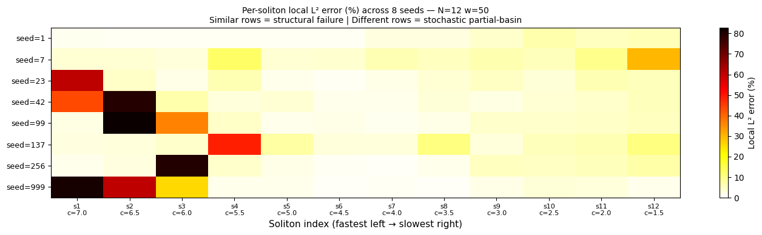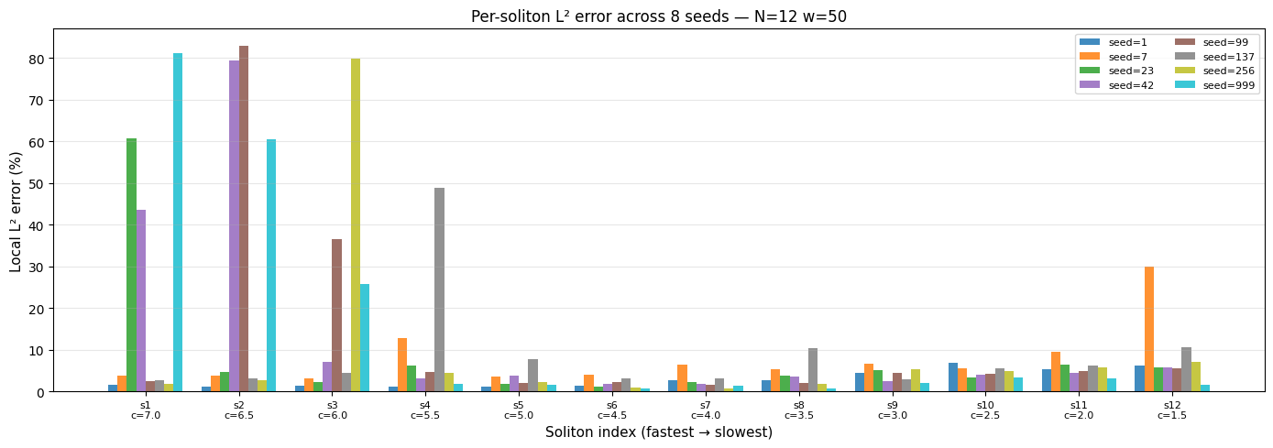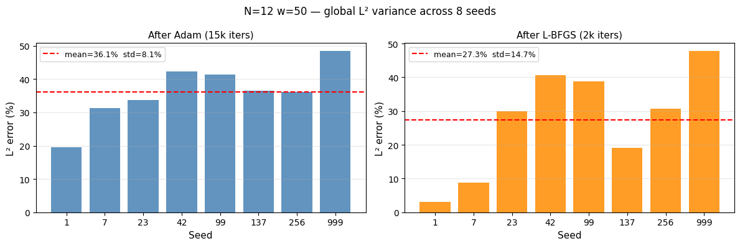

Global L2 stats:
After Adam: mean=36.13% std=8.08% min=19.52% max=48.39%
After LBFGS: mean=27.32% std=14.74% min=3.11% max=47.74%
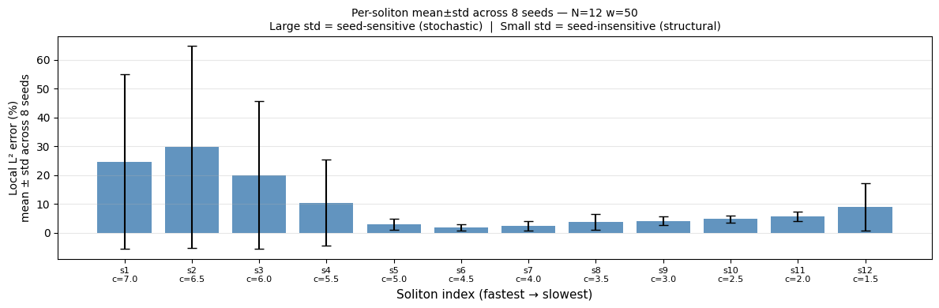Per-soliton mean ± std:
s 1 (c=7.0): mean= 24.7% std= 30.2%
s 2 (c=6.5): mean= 29.7% std= 35.0%
s 3 (c=6.0): mean= 20.0% std= 25.6%
s 4 (c=5.5): mean= 10.4% std= 14.9%
s 5 (c=5.0): mean= 3.0% std= 2.0%
s 6 (c=4.5): mean= 1.9% std= 1.0%
s 7 (c=4.0): mean= 2.5% std= 1.6%
s 8 (c=3.5): mean= 3.8% std= 2.8%
s 9 (c=3.0): mean= 4.2% std= 1.4%
s10 (c=2.5): mean= 4.7% std= 1.2%
s11 (c=2.0): mean= 5.7% std= 1.8%
s12 (c=1.5): mean= 9.0% std= 8.2%

Most variable : s2 (c=6.5) std=35.0%
Least variable: s6 (c=4.5) std=1.0%
seed l2_adam l2_final worst_soliton_idx worst_soliton_c worst_soliton_l2
1 19.523872 3.110406 10 2.5 6.946444
7 31.197041 8.750835 12 1.5 29.932290
23 33.714851 29.870605 1 7.0 60.637075
42 42.352108 40.591465 2 6.5 79.360723
99 41.315495 38.695229 2 6.5 82.868540
137 36.439476 19.158127 4 5.5 48.850113
256 36.135658 30.613422 3 6.0 79.878974
999 48.391895 47.740803 1 7.0 81.040782
============================================================
FINAL INTERPRETATION
============================================================
Worst soliton per seed: [10, 12, 1, 2, 2, 4, 3, 1]
Unique: [1, 2, 3, 4, 10, 12]
N seeds: 8
N unique patterns: 6

=> STOCHASTIC — BROKEN SYMMETRY CONFIRMED
6 distinct failure patterns across 8 seeds.
Loss landscape has many partial-basin attractors.
Which solitons get learned is determined by the random seed, not the config.
This is the broken-symmetry regime: multiple near-equivalent bad solutions.
Implication: data anchoring (n_data=2000) should select the correct basin
and collapse variance across seeds — a clean follow-up experiment.

Done. All outputs in /kaggle/working
multiseed_results.json
multiseed_results.csv
multiseed_heatmap.png
multiseed_bars.png
multiseed_global_l2.png
multiseed_mean_std.png
checkpoint_N12_w50_seed{seed}.pt (one per seed)

